Indices of Deprivation:

Sandwell 2015
The Department for Communities and Local Government (DCLG) updated the English Indices of Deprivation and published the most recent figures in September 2015. They offer a direct comparison to the deprivation figures published in 2004, 2007 and 2010. This briefing paper aims to raise awareness of the new data source, provide information on how relative positions have changed over time, and give an overview of the data for Sandwell Borough.
The new Index of Multiple Deprivation 2015 (IMD 2015) is a Lower layer Super Output Area (LSOA) level measure of multiple deprivation, and is made up of seven LSOA level domain indices. These relate to income deprivation, employment deprivation, health deprivation and disability, education skills and training deprivation, barriers to housing and services, living environment deprivation, and crime, which reflect the broad range of deprivation that people can experience. Summary measures of the IMD 2015 are presented at local authority district level.
There are also two supplementary indices: the Income Deprivation Affecting Children Index (IDACI) and the Income Deprivation Affecting Older People Index (IDAOPI).
The LSOA level domain indices, IMD 2015, IDACI and IDAOPI, together with the local authority district summaries, are collectively referred to as the English Indices of Deprivation 2015.

Local Authority Summaries

Each local authority has been assigned a score based on deprivation levels, and also a rank based on each of the scores. Scores and ranks are provided for the following: average score, average rank, extent, local concentration, proportion of LSOAs in most deprived 10% nationally, income scale and employment scale. This report focuses on the average score and average rank for the most deprived twenty local authorities nationally. However, there is no single summary that is preferred over another and the best way to compare the local authorities requires consideration of all the measures.
Local Authority | Rank of Average Score |  |  |  | Local Authority | Local Authority | Rank of Average Rank
 | 2015 | 2010 | 2007 | 2004 |  |  | 2015 | 2010 | 2007 | 2004
Blackpool | 1 | 6 | 12 | 24 |  | Manchester | 1 | 4 | 4 | 3
Knowsley | 2 | 5 | 5 | 3 |  | Hackney | 2 | 1 | 1 | 1
Kingston upon Hull | 3 | 10 | 11 | 9 |  | Barking and Dagenham | 3 | 8 | 11 | 21
Liverpool | 4 | 1 | 1 | 1 |  | Blackpool | 4 | 10 | 18 | 26
Manchester | 5 | 4 | 4 | 2 |  | Knowsley | 5 | 12 | 8 | 8
Middlesbrough | 6 | 8 | 9 | 10 |  | Tower Hamlets | 6 | 3 | 3 | 2
Birmingham | 7 | 9 | 10 | 15 |  | Liverpool | 7 | 5 | 5 | 5
Nottingham | 8 | 20 | 13 | 7 |  | Newham | 8 | 2 | 2 | 6
Burnley | 9 | 11 | 21 | 37 |  | Kingston upon Hull | 9 | 15 | 16 | 11
Tower Hamlets | 10 | 7 | 3 | 4 |  | Nottingham | 10 | 17 | 12 | 9
Hackney | 11 | 2 | 2 | 5 |  | Birmingham | 11 | 13 | 14 | 16
Barking and Dagenham | 12 | 22 | 22 | 42 |  | Sandwell | 12 | 9 | 10 | 14
Sandwell | 13 | 12 | 14 | 16 |  | Islington | 13 | 6 | 6 | 4
Stoke-on-Trent | 14 | 16 | 16 | 18 |  | Leicester | 14 | 22 | 23 | 29
Blackburn with Darwen | 15 | 17 | 17 | 34 |  | Waltham Forest | 15 | 7 | 15 | 25
Rochdale | 16 | 23 | 25 | 25 |  | Middlesbrough | 16 | 27 | 25 | 19
Wolverhampton | 17 | 21 | 28 | 35 |  | Burnley | 17 | 21 | 31 | 46
Hartlepool | 18 | 24 | 23 | 14 |  | Stoke-on-Trent | 18 | 18 | 20 | 20
Bradford | 19 | 26 | 32 | 30 |  | Wolverhampton | 19 | 20 | 28 | 40
Hastings | 20 | 19 | 31 | 38 |  | Hastings | 20 | 23 | 29 | 39
Table 1. Twenty most deprived English local authorities by rank of average score (DCLG, 2015). |  |  |  |  |  | Table 2. Twenty most deprived English local authorities by rank of average rank (DCLG, 2015).

Sandwell’s rank of average deprivation score has improved since 2010, falling one place to become the 13th most deprived local authority out of a total of 326 (where 1 is the most deprived). Sandwell’s neighbours Birmingham and Wolverhampton are also among the 20 most deprived Local Authorities by average score (ranked 7th and 17th respectively).
When deprivation is judged by average rank, Sandwell is ranked 12th most deprived, a fall of three places since 2010. Again, Birmingham and Wolverhampton also feature in this table.
However, this improvement in Sandwell’s ranking on these scores does not necessarily mean that deprivation in the borough has improved – only that it has improved relative to other areas.

Sandwell in the West Midlands Conurbation
Local Authority | Rank of Average Score | Rank of Average Rank | Rank of Extent | Rank of Local Concentration | Rank of proportion of LSOAs in most deprived 10% nationally | Rank of Income Scale | Rank of Employment Scale
Birmingham | 7 | 11 | 6 | 21 | 6 | 1 | 1
Coventry | 54 | 60 | 55 | 38 | 46 | 25 | 25
Dudley | 110 | 118 | 90 | 93 | 101 | 34 | 33
Sandwell | 13 | 12 | 10 | 55 | 28 | 9 | 12
Solihull | 178 | 216 | 124 | 66 | 77 | 100 | 102
Walsall | 33 | 41 | 20 | 59 | 39 | 21 | 27
Wolverhampton | 17 | 19 | 14 | 47 | 21 | 20 | 20
Table 3. Sandwell and the West Midlands Conurbation, local authority summaries. (DCLG, 2015)

Whilst Sandwell’s overall ranks of average score and rank have seen an improvement, the rank of income and employment scales have worsened (from 12 and 15 in 2010, respectively). These measures identify districts with large numbers of people experiencing deprivation – so Sandwell has a relatively high volume of people experiencing income and employment deprivation.

Sandwell’s rank of local concentration is lower than the other deprivation measures – this shows that deprivation in Sandwell is not concentrated in pockets, but more widespread across the borough than in other areas.

Sandwell in a National Context
England is made up of 32,844 Lower Super Output Areas (LSOAs), 186 of which are in Sandwell. By ranking the LSOAs on each of the domains of deprivation, each Sandwell LSOA has been positioned on the national deciles framework (where 1 = 10% most deprived LSOAs in England and 10 = 10% least deprived LSOAs in England). This shows how Sandwell fits into the national picture.
Table 4 overleaf shows percentages of Sandwell LSOAs in each of the deciles for all domains.
Clearly many of Sandwell’s LSOAs are in the most deprived national deciles and there are few cases when the borough’s LSOAs are in the least deprived deciles. In the income, employment and education domains over half of Sandwell’s LSOAs belong in the 20% most deprived nationally. Only the housing and crime domains show low proportions of LSOAs in the worst 20%.

National  Decile | IMD | Income | Employment | Education | Health | Crime | Housing | Environment | IDACI | IDAOPI
(most deprived)1 | 22.6% | 26.9% | 22.6% | 23.7% | 12.9% | 4.8% | 1.6% | 7.0% | 22.6% | 25.3%
2 | 32.3% | 32.8% | 32.3% | 28.0% | 36.0% | 11.8% | 8.1% | 17.7% | 24.2% | 35.5%
3 | 17.7% | 13.4% | 16.7% | 18.3% | 22.0% | 20.4% | 15.6% | 31.7% | 18.3% | 14.5%
4 | 5.9% | 5.9% | 9.7% | 9.1% | 11.8% | 26.3% | 28.0% | 25.8% | 11.8% | 8.1%
5 | 7.5% | 7.5% | 6.5% | 8.1% | 8.6% | 16.1% | 19.4% | 10.8% | 8.1% | 6.5%
6 | 7.5% | 5.9% | 6.5% | 4.3% | 7.0% | 10.8% | 10.2% | 3.8% | 3.2% | 4.8%
7 | 4.8% | 4.8% | 3.2% | 4.3% | 1.6% | 7.5% | 9.1% | 3.2% | 7.0% | 4.3%
8 | 1.1% | 2.2% | 2.2% | 3.8% | 0.0% | 1.6% | 7.0% | 0.0% | 4.8% | 0.5%
9 | 0.5% | 0.5% | 0.5% | 0.0% | 0.0% | 0.5% | 0.5% | 0.0% | 0.0% | 0.5%
(least deprived)10 | 0.0% | 0.0% | 0.0% | 0.5% | 0.0% | 0.0% | 0.5% | 0.0% | 0.0% | 0.0%
Table 4. Sandwell LSOAs (%) in national deciles for the deprivation domains 2015. (DCLG, 2015)

On the combined IMD domain, one in five of Sandwell’s LSOAs fall into the most deprived 10% nationally in 2015. A further third fall into the most deprived 10-20%, so overall 55% of Sandwell’s LSOAs fall within the worst 20% nationally, clearly displaying the high levels of deprivation prevalent in large parts of Sandwell. Over three quarters of Sandwell’s LSOAs are within the worst 40% nationally and no Sandwell LSOA’s are in the least 10% deprived.
Chart 1. Index of multiple deprivation in Sandwell by national deciles, 2004, 2007, 2010 and 2015. (DCLG).

Looking at Sandwell’s combined IMD over time, it can be seen that the percentage of Sandwell’s LSOAs in the most deprived 10% grew from 2004 to 2010, but has now fallen in 2015 to just over 20%. A further third of LSOAs fall into the most deprived 10-20%, clearly displaying the high levels of deprivation prevalent in large parts of Sandwell. However since 2007, there has been an overall fall in the proportion in the worst 20% nationally.
Map 1 shows the distribution of deprivation across the borough. The darkest shades indicate that these are amongst England’s most deprived LSOAs. Large areas of Smethwick, Tipton, Wednesbury and West Bromwich are heavily deprived. The less deprived Sandwell areas are represented by lighter shades and can be seen in the north east of West Bromwich, and the peripheries of Smethwick, Oldbury and Rowley Regis.

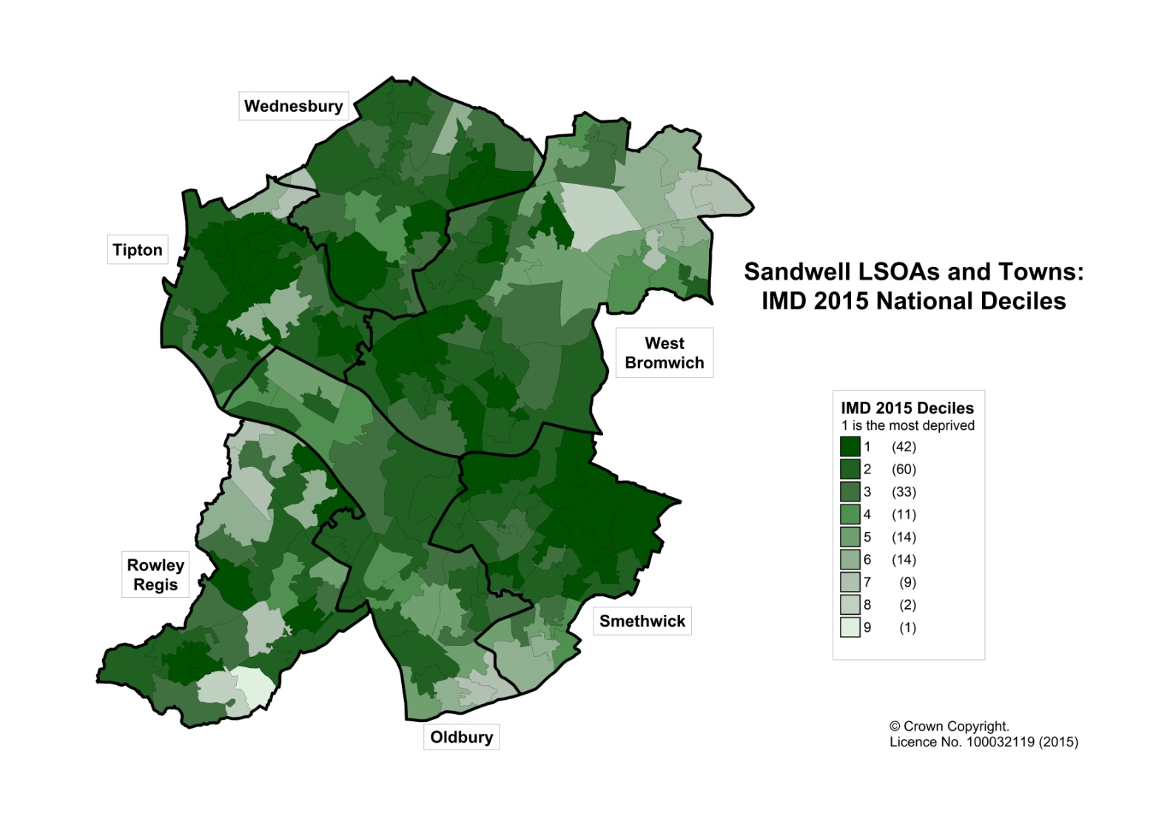
Map1. IMD 2015 National Deciles in Sandwell LSOAs. (DCLG, 2015).
In terms of individual domains, most have experienced a decrease in the proportion of LSOAs in the most deprived 10% nationally. All but income and housing have experienced a decline in LSOAs in the most deprived 10% nationally – although the increases in these two domains have been relatively small. The health deprivation and disability and living environment domains have seen the largest falls in the proportion of LSOAs in the most deprived 10% nationally.
Chart 2 shows the changes that have occurred in the health deprivation and disability domain since 2004. This domain measures poor health, early mortality, and disability for all age groups in an area. Since 2004 the proportion of Sandwell LSOAs forming part of the most deprived 10% nationally significantly increased from 7.5% in 2004 to over 34% in 2010, however there has been a substantial fall to 12.9% in 2015. The proportion of Sandwell LSOAs belonging to the 10-20% most deprived nationally has seen a rise, however the proportion overall in the worst 20% has declined to just under half (from 64.7% in 2010). The vast majority (71%) of Sandwell LSOAs are in the most deprived 30% LSOAs in England. Chart 2 shows the clear shifts that have taken place in this domain since 2004, but with many Sandwell LSOAs remaining in the more deprived national deciles.
Chart 2. Health Deprivation and Disability in Sandwell by national deciles 2004, 2007, 2010 and 2015. (DCLG).

With the growing importance placed on tackling child poverty it is beneficial to have a greater understanding of the income deprivation affecting children index for Sandwell. As can be seen in Chart 3, the percentage of Sandwell LSOAs belonging in the most deprived 10% nationally has increased since 2010, and at 22.6% is now higher than 2004 levels. Income deprivation affecting children is a significant problem in a large amount of Sandwell’s LSOAs – and since 2004 the proportion of LSOAs overall in both the worst 20% and worst 30% nationally has increased. In 2015, almost two-thirds of Sandwell LSOAs fall within the worst 30% nationally.

Chart 3. Income Deprivation Affecting Children Index in Sandwell by national deciles 2004, 2007, 2010 and 2015. (DCLG).

As can be seen in Chart 4 overleaf, there has been some improvement in the income deprivation affecting older people index. The percentage of Sandwell LSOAs belonging in the most deprived 10% nationally has fallen considerably since 2010, and is now even lower than the levels reported in 2004. However, a quarter of Sandwell LSOAs remain in the worst 10% nationally. Despite the falls in the worst 10% and 20%, there has been a rise in the proportion of LSOAs overall in the worst 30% nationally between 2004 and 2015, with over 75% of Sandwell LSOAs now within the worst 30%.

Chart 4. Income Deprivation Affecting Older People Index in Sandwell by national deciles 2004, 2007, 2010 and 2015. (DCLG).

Deprivation in Sandwell Towns
There is variation across the six towns for most of the deprivation domains. In terms of the employment domain, Oldbury fairs much better than the other towns, with only 3.6% of its LSOAs in the worst 10% nationally. Whilst in the health deprivation and disability domain almost 40% of Tipton’s LSOAs fall in the worst 10%, compared with none of those in Oldbury and Wednesbury. Tipton also fairs badly on the Income domain – half of the LSOAs in the town are within the worst 10% nationally. In the education, skills and training domain, over 60% of LSOAs in Tipton and Wednesbury fall in the worst 20% nationally, compared with only around 40% in Oldbury and West Bromwich. However, as in 2007 and 2010, there is little extreme deprivation in the barriers to housing and services, and crime and disorder domains.
Chart 5 overleaf shows the percentages of LSOAs in each national decile for the overall IMD. It can be seen that Tipton has by far the highest proportion of its LSOAs in the most deprived decile for the IMD 2015, 52% compared to none in Oldbury. When you consider the proportion of LSOAs in the 30% most deprived nationally, Wednesbury has by far the highest proportion at 92%, compared with 60% of LSOAs in Oldbury.
None of Sandwell’s towns have any LSOAs in the least deprived 10% nationally. Only Rowley Regis has LSOAs in the least deprived 20% nationally, and only Rowley Regis and West Bromwich have LSOAs in the least deprived 30%.

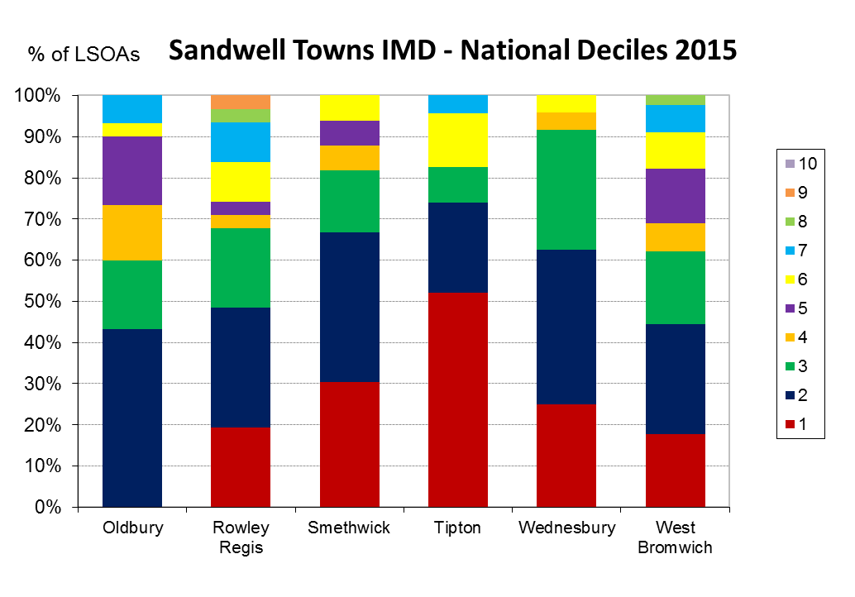
Chart 5. Sandwell towns IMD by National Deciles 2015. (DCLG, 2015)

Further Analysis
More analysis including a summary briefing note is available from the Indices of Deprivation page of Sandwell Trends.

Research Sandwell
6th June 2018
www.sandwelltrends.info

LSOA- are areas with between 1,095 and 2,757 people in Sandwell in the 2011 Census and Sandwell has 186 LSOA

