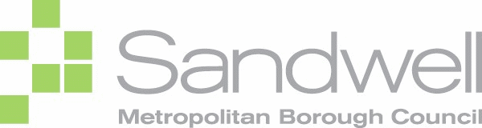



Sandwell 0-19/25’s JSNA   
2022

Section One: Sandwell 0-5’s JSNA

Pages 1-93

Section Two: Sandwell 5-19/25 JSNA

Pages 94 - 106

Section One:  
Sandwell 0-5’s JSNA   
2022

Published September 2020

# Acknowledgements

This document has been produced by Research Sandwell within Public Health on behalf of and in conjunction with Sandwell’s Early Years Transformation Academy members:

**Sandwell MBC**

Lesley Hagger

Sarah Farmer

Cindy James

Peter Forth  
Sara Baber

Alice Berry

**Sandwell & West Birmingham Hospitals NHS Trust**

Randeep Kaur

Nina Rabadia

Rebecca Fox

**Sandwell’s Children’s Trust**

Stephen Tedcastle

**Sandwell & West Birmingham CCG**

Karmah Boothe

Di Osborne

# Section One: Sandwell 0-5’s JSNA

Demographics 1

Pregnancy & birth 3

General fertility rate (GFR) 4

Live births 5

Maternal age 7

Teenage mothers 8

Maternal birthplace 9

Births to mothers from BAME groups in Sandwell 12

Perinatal mental health 13

Birthweight 15

Low birth weight – full term 15

Low birth weight – all babies 16

Very low birth weight of all babies 16

Still births 16

Community midwifery - late bookers 17

Smoking status at time of delivery 18

Hospital admissions of babies under 14 days 19

Early Years 21

Infant Mortality 22

Neonatal & Post-neonatal Mortality 23

Breastfeeding 24

Initiation 25

6-8 weeks 25

A&E attendances (0-4 years) 26

Emergency admissions (aged 0-4) 27

Population vaccination coverage 28

Child Development 28

Proportion of children aged 2-2½yrs receiving ASQ-3 29

Ready for School 30

Speech & Language 37

Literacy 38

Childcare provision 39

Weight of 4-5 year olds 41

Vulnerable Children 44

Introduction 45

Children’s safeguarding practice reviews 45

Early Help 47

Children in Need 51

Child Protection Plans 55

Children in care 57

Educational attainment of children in care 61

Child deaths 62

Unexpected deaths 63

Modifiable factors 63

Inclusion Support Early Years and Child Development Centre 64

Special Educational Needs & Disabilities in Sandwell 64

Education, Health & Care Plans 69

Counselling Psychology 71

Visual Impairment 72

Hearing Impairment 74

Autism Spectrum Disorder 76

Children’s Therapy Service 78

Current Service Provision 82

Maternity Services in Sandwell 82

Primary Care 82

Health Visiting Services 83

School Health Nursing Service 84

Children’s Centres 84

Inclusive Learning Services 85

Sandwell Library Service 88

Recommendations 90

# Demographics: 0-5 Years



Sandwell is a metropolitan borough in the Black Country, which is made up of six towns - Oldbury, Rowley Regis, Smethwick, Tipton, Wednesbury and West Bromwich.

Located in the West Midlands, Sandwell borders Birmingham city, Dudley borough, Walsall borough and Wolverhampton city.

* 27,738 children aged 0-5 live in Sandwell. Children aged 0-5 represent 8.4% of Sandwell’s total population (2020 ONS Estimates).
* ONS Population projections show that the number of 0-5s in Sandwell will fall by 1.5% between 2020 and 2025, and a further 0.2% by 2030. This follows a similar pattern nationally.
* Almost half of Sandwell’s 0-5-year olds live in either West Bromwich (23.7%) or Smethwick (21.1%) (2018 ONS Estimates). 10.1% of the population in Smethwick is aged 5 & under. Soho & Victoria ward has a particularly high proportion of children aged 0-5 (11.5%).
* Sandwell is a diverse borough with 30% of its population from BAME groups (2011 Census). Approximately 43.7% of those aged 0-5 are from BAME groups. Both of these figures are substantially higher than the national BAME population.
* 4.3% of Sandwell’s population cannot speak English well or at all. Nationally the rate is much lower at 1.7%. 0.8% of Sandwell’ population (aged over 3) cannot speak English at all. Within Sandwell wards, the rate varies with 2.7% in St. Pauls, 2.5% in Soho and Victoria and 2.1% in West Bromwich Central.
* Over half of Smethwick’s population is from BAME groups (54%), followed by West Bromwich (35.5%). For those aged 0-5, this rises to 69.5% for Smethwick and 50.2% in West Bromwich.
* Overall, Oldbury town has a lower proportion of its population from BAME groups (28.1%), however populations are varied within the wards. Oldbury ward has almost 43.8% of its population from BAME groups, whereas Langley has 22%, Bristnall 25.4%, Old Warley 21.2%. This pattern is mirrored for those aged 0-5.
* Sandwell was ranked the 12th most deprived authority in England in 2019 (2019 IMD). All wards in Sandwell have scores within the worst 40% in England. Two wards (Princes End and Greets Green & Lyng) are within the worst 10% nationally.
* 25.6% of all children in Sandwell are living in low income families compared to 17% across England and 18,495 0-4-year olds and 21,370 5-10-year olds live in low income families in Sandwell (HMRC 2016 data).
* Princes End has the highest proportion (35.3%) of 0-15 year olds living in poverty, followed by Soho and Victoria (32.0%).
* Life Expectancy at birth in Sandwell was 77.1 Males (England 79.6) and 81.3 Females (England 83.1) (ONS 2015-7 Data)

# Pregnancy & birth

## Key Points

* Estimated population of women of childbearing age (15-44 years) in Sandwell stood at 64,245 in 2020.
* Sandwell had 10.3 live births per 1000 women aged 15-44 compared to 13.1 in England in 2020, but birth rates are declining in line with national trends.
* The highest proportion of live births in Sandwell between 2016 and 2020 were among women aged 25-29 (29% in 2020).
* The proportion of live births to mothers aged 35 to 39 had decreased from 2016-2020 from 14.3% of live births in 2016 to 13.8% in 2020. The live births in mothers older than 45 has doubled in the same time period.
* In terms of teenage pregnancy, in 2020/21, the Sandwell rate of 0.8% is above England (0.6%), but this is not statistically significant.
* Percentage of births to non-UK born mothers in Sandwell has nearly doubled in 17 years.
* There is an increasing trend of deliveries to mothers from BAME groups in Sandwell, and in 2020/21 44.3% of births were to mothers from BAME groups.
* The proportion of babies born to term with a low birth weight in Sandwell (3.7% in 2020) remains higher than the England average.
* The 2018-2020 rate of still births per 1,000 live births and still births in Sandwell (5.3 per 1000) is higher than the average for England and West Midlands, and is the 2nd highest rate in West Midlands following Birmingham (5.6)
* In 2020/21 approximately 9.3% of local pregnant women in Sandwell smoked at time of delivery. This is a significant decrease since 2011 (15.8%). However, this data may not be accurate – not all women in 2020/21 would have been tested for CO levels, and around 40% of women give birth outside Sandwell. It is known however that smoking is an issue in Sandwell and more accurate processes have been put in place to capture data.

## General fertility rate (GFR)

Fertility rates are closely tied to growth rates for a local area and can be an indicator of future population growth or decline in an area.

* In 2020, Sandwell’s GFR is 67.2 per 1000 females aged 15-44.
* This is a higher rate than England at 55.3 and West Midlands at 57.3.
* Sandwell has a decreasing trend.

**Figure 1.1:**

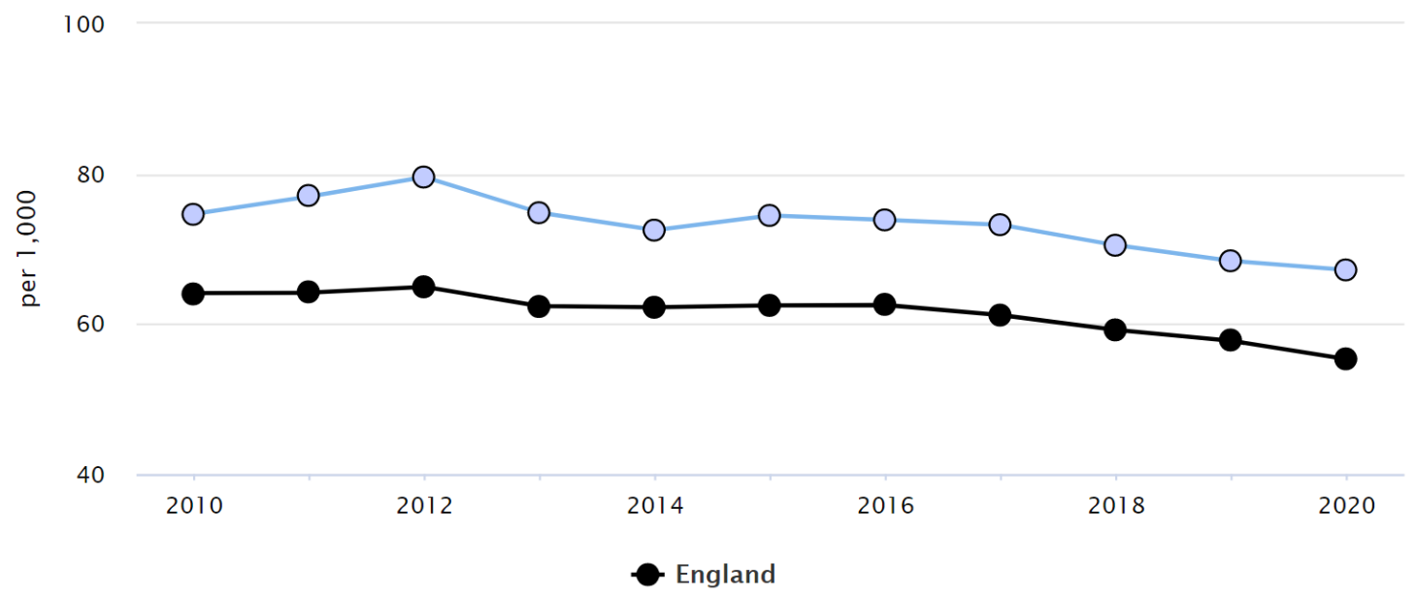

**Source:** Public Health England Profiles

**Figure 1.2** **General Fertility Rate (GFR) by Ward - Sandwell - 2012-16**

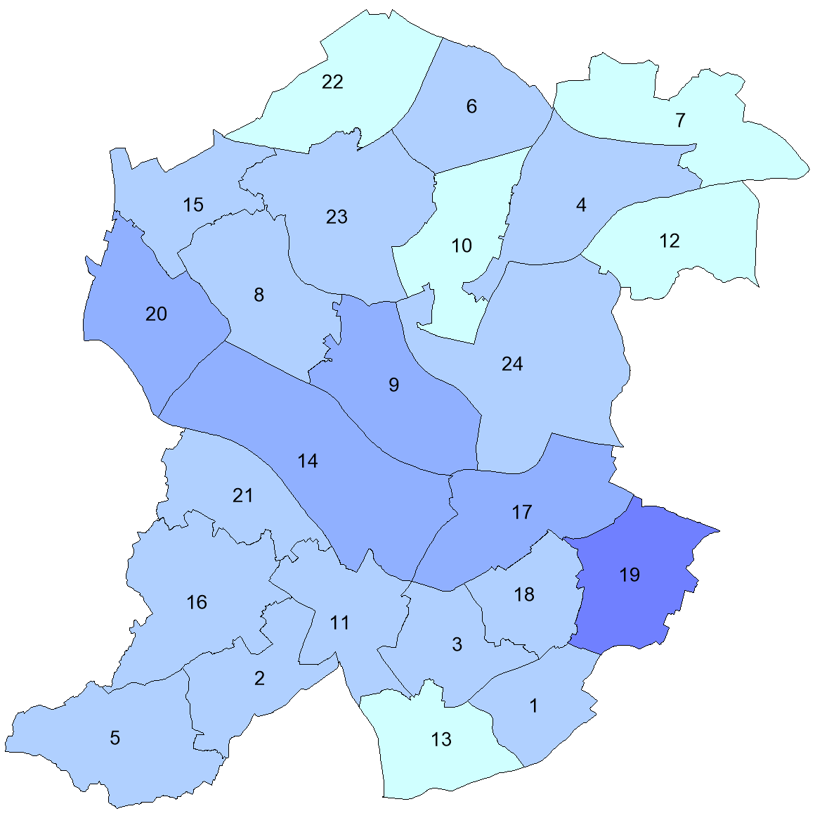**Key**

1. General Fertility Rate (GFR)= Birth rate per 1,000 females aged 15 to 44 years

2. The darker the shade of blue the higher the GFR

3. Figure 1.3 gives the ward names which the numbers on the map relate to e.g. 6 = Friar Park

**Source:** NHS Digital Births data and Office for National Statistics Population Data

© Crown copyright and database rights 2019 Ordnance Survey Licence No 100032119

At a ward level, for the period 2012-16, there is some variance between wards in Sandwell.

* Some variation may reflect differences in the number of women of child-bearing age by ward.
* Compared to the Sandwell average, six wards were statistically higher (the 6 highest rates in figure 1.2), thirteen were statistically similar and five were statistically lower (the lowest 5 rates in figure 1.2).
* Compared to the England average, two wards (Newton and Old Warley) were statistically similar, and twenty-two were statistically higher.
* The highest GFR was in Soho & Victoria (99.8 births per 1,000 females aged 15 to 44 years), whilst the lowest was on Newton (62.4 per 1,000).

**Figure 1.3**

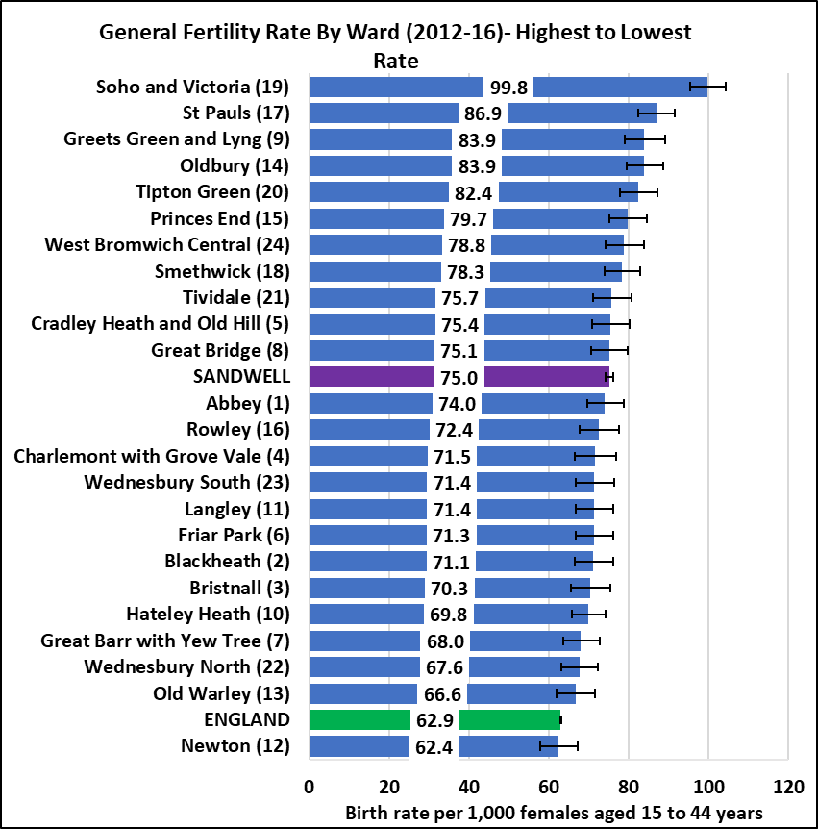

## Live Births

In Sandwell, the crude number of live births has increased slightly from 2008 to 2012. From 2013 till 2020 the number has gradually decreased as described in figure 1.4. However, between 2014 and 2015 there was a slight increase and a gradual decrease afterwards.

**Figure 1.4: Crude number of Live births in Sandwell 2008-2020**

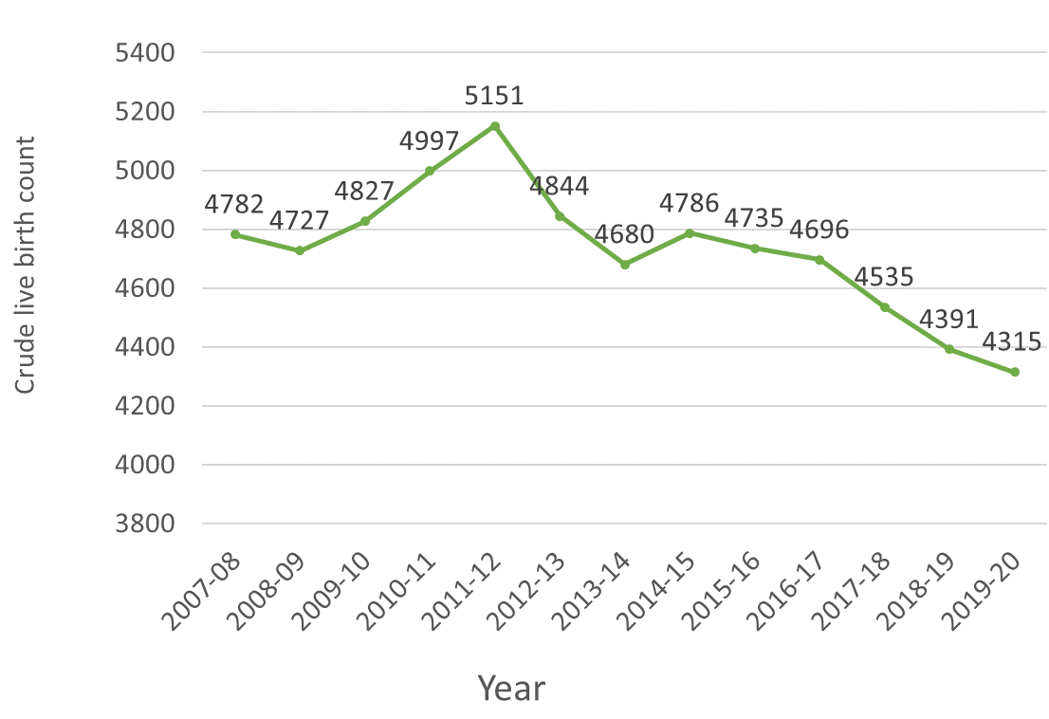

Source: Office for National Statistics

Table 1.1 shows the percentage change in the number of live births in Sandwell, West Midlands (met county) and England. In 2013, the steep decline of the live births in Sandwell doubled when compared with West midlands (Metropolitan county). Furthermore, the decline during this period in Sandwell was higher than the national rate until 2019-20, when Sandwell’s rate of decline fell below the national rate.

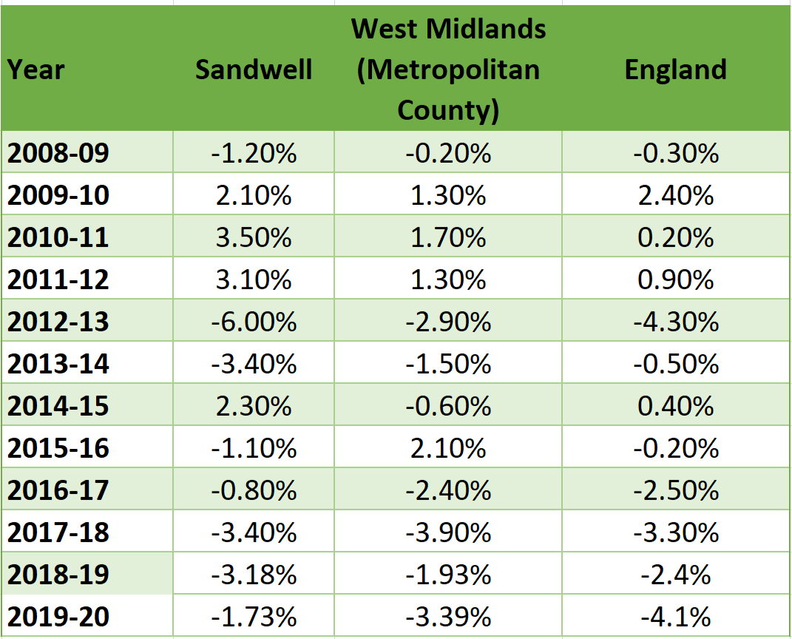**Table 1.1: Annual percentage change in the number of live births, 2009-20**

Source: Office for National Statistics

Figure 1.5 shows the percentage change between 2020 and 2041, based on live birth projections. This shows a predicted increase in live births for the West Midlands (Met County) and Sandwell from 2029 – around 3 years before there is an increase nationally. It is important that we recognise these changes to plan maternity and child services to meet anticipated needs.

**Figure 1.5: Projected annual percentage change in number of live births (2020-2041)**

Source: Office for National Statistics

## Maternal age

Pregnancy can be complicated at both extremes of maternal age. Complications associated with older maternal age include: ectopic pregnancy, gestational trophoblast disease, pre-eclampsia, gestational diabetes, myocardial infarction, cerebrovascular accidents, antepartum and postpartum haemorrhage, increased numbers of operative vaginal deliveries and caesarean sections, venous thromboembolism, increased stillbirth risk. For the foetus there are the following risks: greater risk of Downs syndrome, Intra uterine growth restriction (IUGR) and prematurity.

Children born to teenage mothers have 60% higher rates of infant mortality and are at increased risk of low birthweight which impacts on the child's long-term health. Teenage mothers are three times more likely to suffer from post-natal depression and experience poor mental health for up to three years after the birth. Teenage parents and their children are at increased risk of living in poverty (Public Heath England).

Young pregnant woman (aged under 20 years) may feel uncomfortable using antenatal services which are mainly used by older age groups. They may have difficulty getting to and from antenatal appointments and may be reluctant to recognise their pregnancy due to fear of parental reactions.

Table 1.2 shows the percentage of live births by maternal age from 2012 to 2020. In Sandwell, the highest proportion of live births between 2012 and 2020 were women aged 25-29 except in the years 2019-2021 when births were higher among women aged 30-34. The proportion of live births to women under the age of 20 has steadily declined from 6.1% in 2012 to 2.6% in 2020. The proportion of live births to mothers aged 35 to 39 had increased over this period from 10.7% percentage of Live births in 2012 to 16.5% in 2020. The live births in mothers older than 45 have remained static over time.

**Table 1.2: Percentage of live births by maternal age group 2012-2021 in Sandwell**

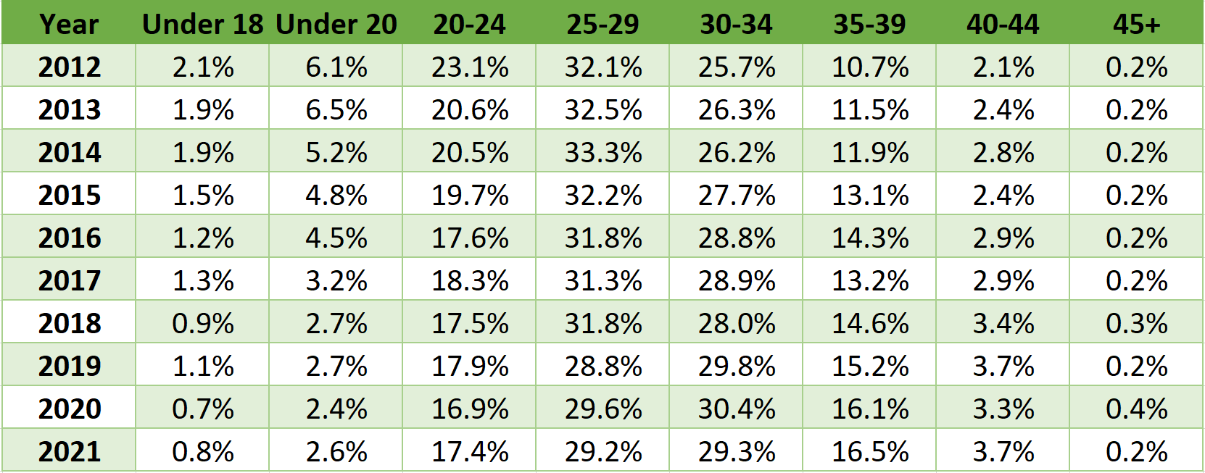

Source: Office for National Statistics

### Teenage Mothers

Percentage of delivery episodes, where the mother is aged under 18 years.

* In 2020/21, the Sandwell rate of 0.8% is above England (0.6%), but this is not statistically significant.
* There has been a declining trend over a number of years in Sandwell (see Figure 1.6).

**Figure 1.6:**

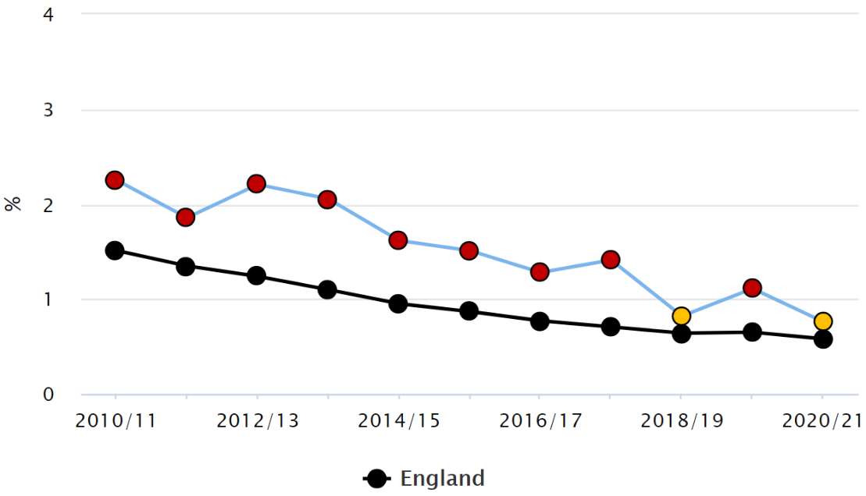

Source: Public Health England Profiles

Six Sandwell wards are significantly different from the Sandwell average on estimated under 18 conceptions 2015 to 2017 (aggregated):

* Wards with lower under 18 conception rates are Hateley Heath, Old Warley and St. Pauls.
* Wards with higher under 18 conception rates are Friar Park, Princes End and Tividale.

## Maternal Birthplace

Immigrant mothers face additional challenges because they face language difficulties and have a lack of familiarity with care systems which often results in late presentation to maternity services (Small et al, 2014). Depending on country of origin they may also be at increased risk of infectious diseases including HIV and Hepatitis B which may cause birth complications and also be transmitted from mother to baby.

Figures 1.7 and 1.8 demonstrate the live births in 2020 for Sandwell by birthplace of mother. The highest proportion of live births by birthplace in Sandwell is among women born in the UK (61% with 2,635 births). This trend is consistent with the national and regional average (figure 1.7). While mothers born in the rest of the world (this includes America, the Caribbean, Antarctica and Oceania) had the lowest proportion in Sandwell (2% with 75 births).

**Figure 1.7: Percentage of live births by birthplace of mother - 2020**

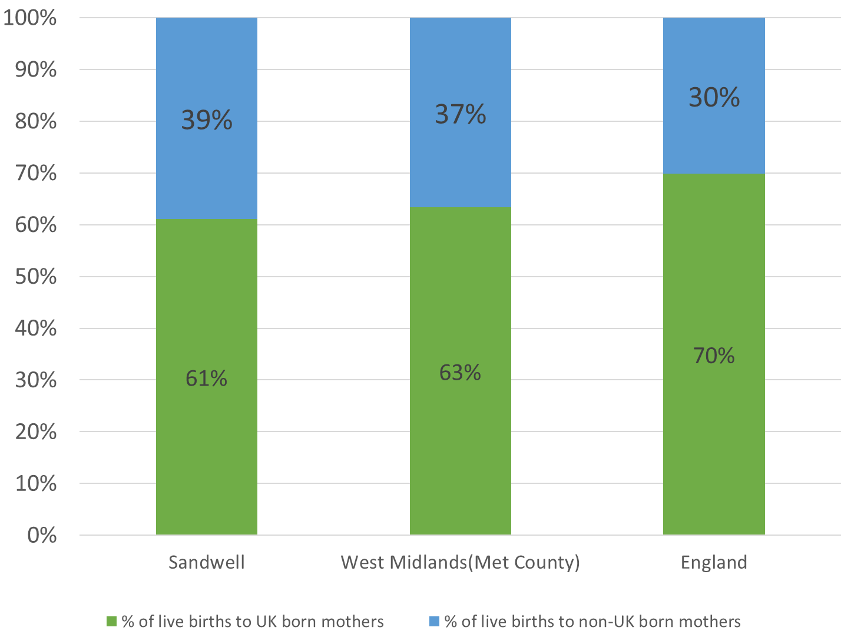

Source: Office for National Statistics

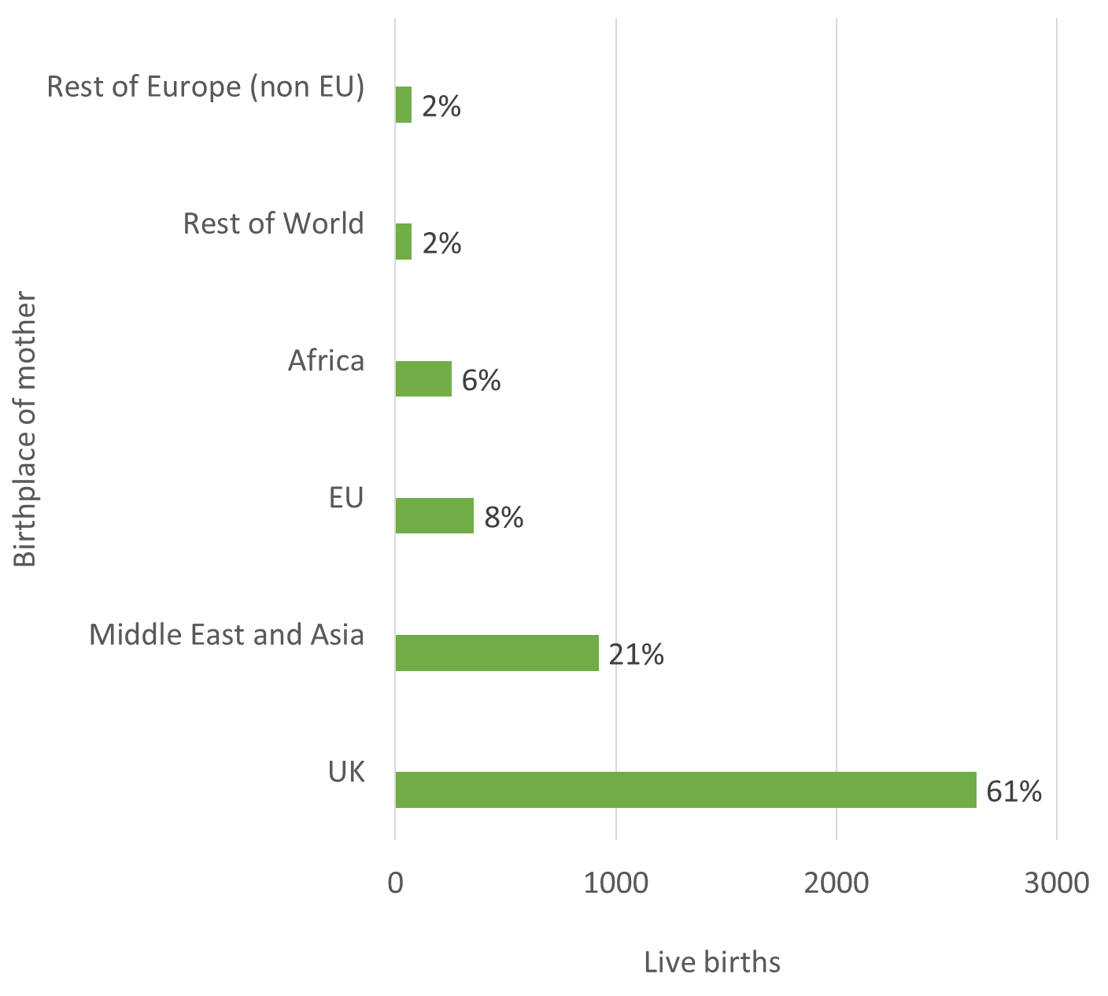**Figure 1.8: Percentage and crude number of live births by birthplace of mother: Sandwell, 2020**

Source: Office for National Statistics

The percentage of live births to non-UK born mothers increased from 18.3% (676 births) in 2001 to 37.3% (1,690 births) in 2018 as described in figure 1.9. Sandwell’s percentage of live births by non-UK born women was below the West Midlands (Met County) average but higher than England from 2001 till 2010. However, from 2016 there has been a gradual increase above England and West Midlands (met county).

**Figure 1.9: Percentage of live births to non-UK born mothers from 2001-2018**

Source: Office for National Statistics

Of the 1,690 births to non-UK born mothers in Sandwell for 2018, 51% (868) were to mothers born in the Middle East and Asia and 26% (437) were to mothers born in the European Union. The lowest proportion of live births for non-UK born mothers were Africa (16%) and Rest of the world (5%) (Figure 1.10).

**Figure 1.10: Percentage of live births for non-UK born mothers: Sandwell 2018**

Source: Office for National Statistics

## Births to mothers from BAME groups in Sandwell

Black, Asian and Minority Ethnic women and children have an increased risk of some poor outcomes:

* stillbirth – babies of Afro-Caribbean and African mothers have more than double the risk of stillbirth, and babies of Indian, Bangladeshi and Pakistani mothers have an increased risk, compared with babies of White mothers (CMACE, 2011; Gardosi, 2013)
* a study to compare mean birth weights and gestational age at delivery of infants born to mothers in Luton, UK, found important differences in adjusted mean birth weight between Indian, Pakistani, Bangladeshi and white British women. The results showed that white British babies weighed 307.65g more than Bangladeshi infants. A small difference (57.63 to 62.7g) was also identified between Indian, Bangladeshi and Pakistani infants (Garcia R, Ali N, Guppy A, *et al*. 2017)
* preterm birth – babies of Afro-Caribbean and African mothers are at increased risk compared to babies of mothers of other ethnic origins (Aveyard et al, 2002; Office for National Statistics, 2016)
* the Born in Bradford study found that congenital abnormalities were more common in babies born to mothers of Pakistani origin (5%) than in those born to white British mothers (2%) or mothers of other ethnicities (3%) (NICE, 2014)
* Black women are five times more likely to die during pregnancy and childbirth than white women, whilst Asian women twice as likely to die during pregnancy and childbirth than white women (Seals Allers, 2019)

**Figure 1.11: Percentage of deliveries to mothers from Black & Minority Ethnic (BME) groups for Sandwell**

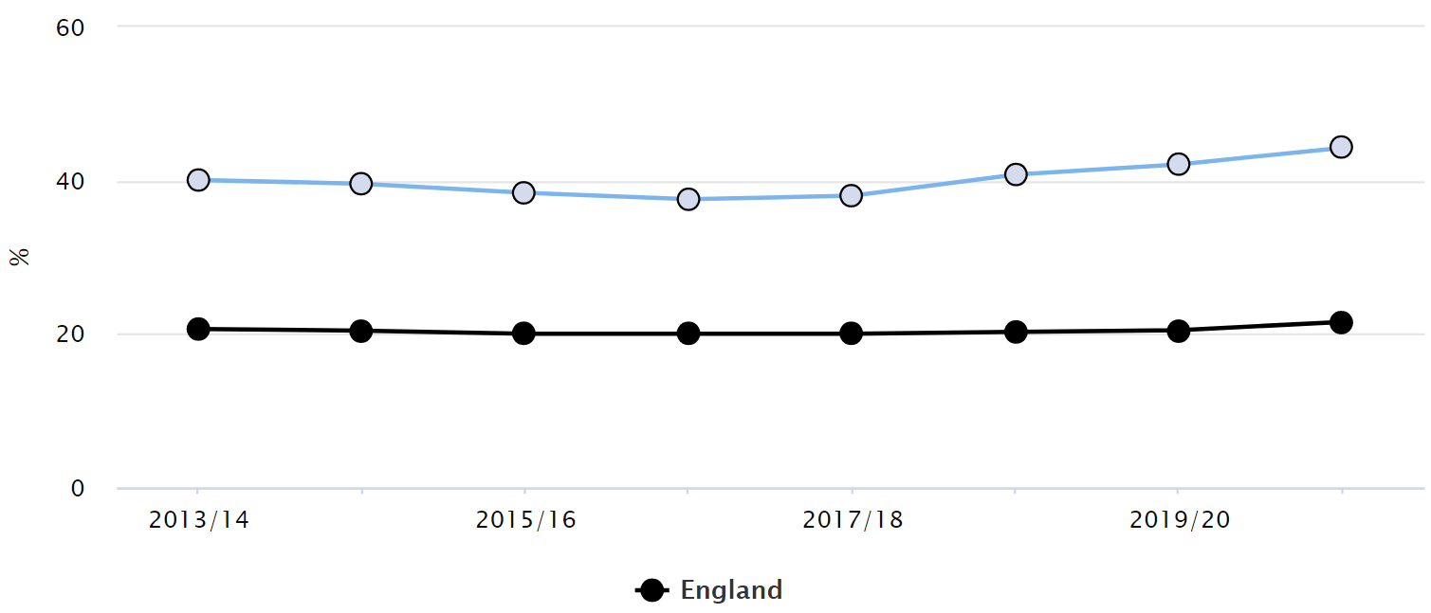

Source: Public Health England Profiles

There is an increasing trend of deliveries to mothers from BAME groups in Sandwell:

* This is statistically higher than England and West Midlands
* 2020/21 rates: Sandwell 44.3%; England 21.6%; West Midlands 26.5%
* In 2020/21 Sandwell had the 2nd highest rate in West Midlands, after Birmingham (52.4%)
* The Infant Feeding Survey 2010 found that mothers from all minority ethnic groups were more likely to breastfeed compared to White mothers.

Perinatal Mental Health

The mental health of children and young people in England, 2017 survey, identified that children of parents who had poor mental health were three and a half times more likely to be identified with a mental disorder than children whose parents showed little to no evidence of a mental disorder.

Research has shown that 3.9% of new or expectant mothers in 2017 were in contact with secondary mental health services, with young mothers (particularly those aged 16 or under) most likely to be in contact with these services (NHS Digital, 2018).

Public Health England (PHE) produce estimated numbers of women that might be expected to have certain mental health problems in pregnancy. These estimates are produced by applying national estimates for these conditions, to local delivery figures for Sandwell. PHE recognise that there are concerns about the quality of this data, but they do provide an indication of prevalence for these conditions within the borough. Mild-moderate depressive illness and anxiety, and adjustment disorders and distress indicators are presented as a range of figures, with upper and lower estimates. These have been calculated by applying the national estimate ranges to local delivery numbers. These estimates are presented in Table 1.3 below.

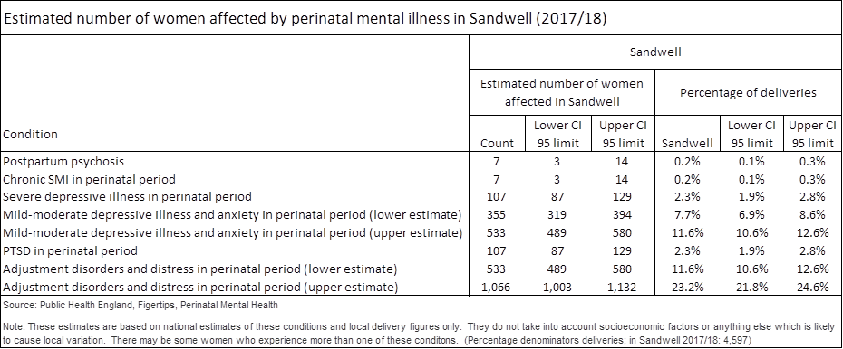**Table 1.3 Estimated number of women affected by perinatal mental illnesses (2017/18)**

* Women experiencing postpartum psychosis and chronic serious mental illness (SMI) are rare occurrences during or after childbirth, with only an estimated 7 women experiencing each of these conditions, 0.2% of the 4,597 deliveries in Sandwell in 2017/18.
* It is calculated that an estimated 107 mothers experienced post-traumatic stress disorder (PTSD) and that the same number may have experienced severe depressive illness in Sandwell, in 2017/18.
* It is estimated that between 355 and 533 women experienced mild to moderate depression and anxiety in Sandwell, 7.7% to 11.6% of the 4,597 childbirth deliveries in Sandwell, in 2017/18.
* It was estimated that between 553 and 1,066 women may have experienced this type of mental illness during or after childbirth in Sandwell. This is between 11.6% and 23.2% of the women who have given birth in 2017/18.

It is possible that some women may experience more than one of these perinatal mental health conditions. PHE comment that between 10% and 20% of women are affected by mental health issues at some point during pregnancy or in the first year after childbirth.

## Birthweight

Low birth weight (under 2,500 grams) is associated with an increased risk of infant mortality, developmental problems in childhood and poorer health in later life. A large proportion of babies will be born under 2,500 grams because they are preterm births (born before 37 weeks of pregnancy). Whether they are born prematurely or at full term, the risk of low birth weight is related to:

* smoking while pregnant
* substance and alcohol misuse
* pregnancy health and nutrition
* pregnancy-related complications
* a mother's young age

At a population level, a high proportion of low birth weight babies is primarily related to poorer antenatal maternal health.

### Low Birth Weight – full term

Live births with a recorded birth weight under 2500g and a gestational age of at least 37 complete weeks as a percentage of all live births with recorded birth weight and a gestational age of at least 37 complete weeks.

* No significant change in the trend for the past 5 years
* Still significantly higher than England, but similar rates to the West Midlands
* 2020 Sandwell 3.7%; England 2.86%; West Midlands 3.12%

**Figure 1.12: Low Birth Weight for Term Babies – Sandwell & England**

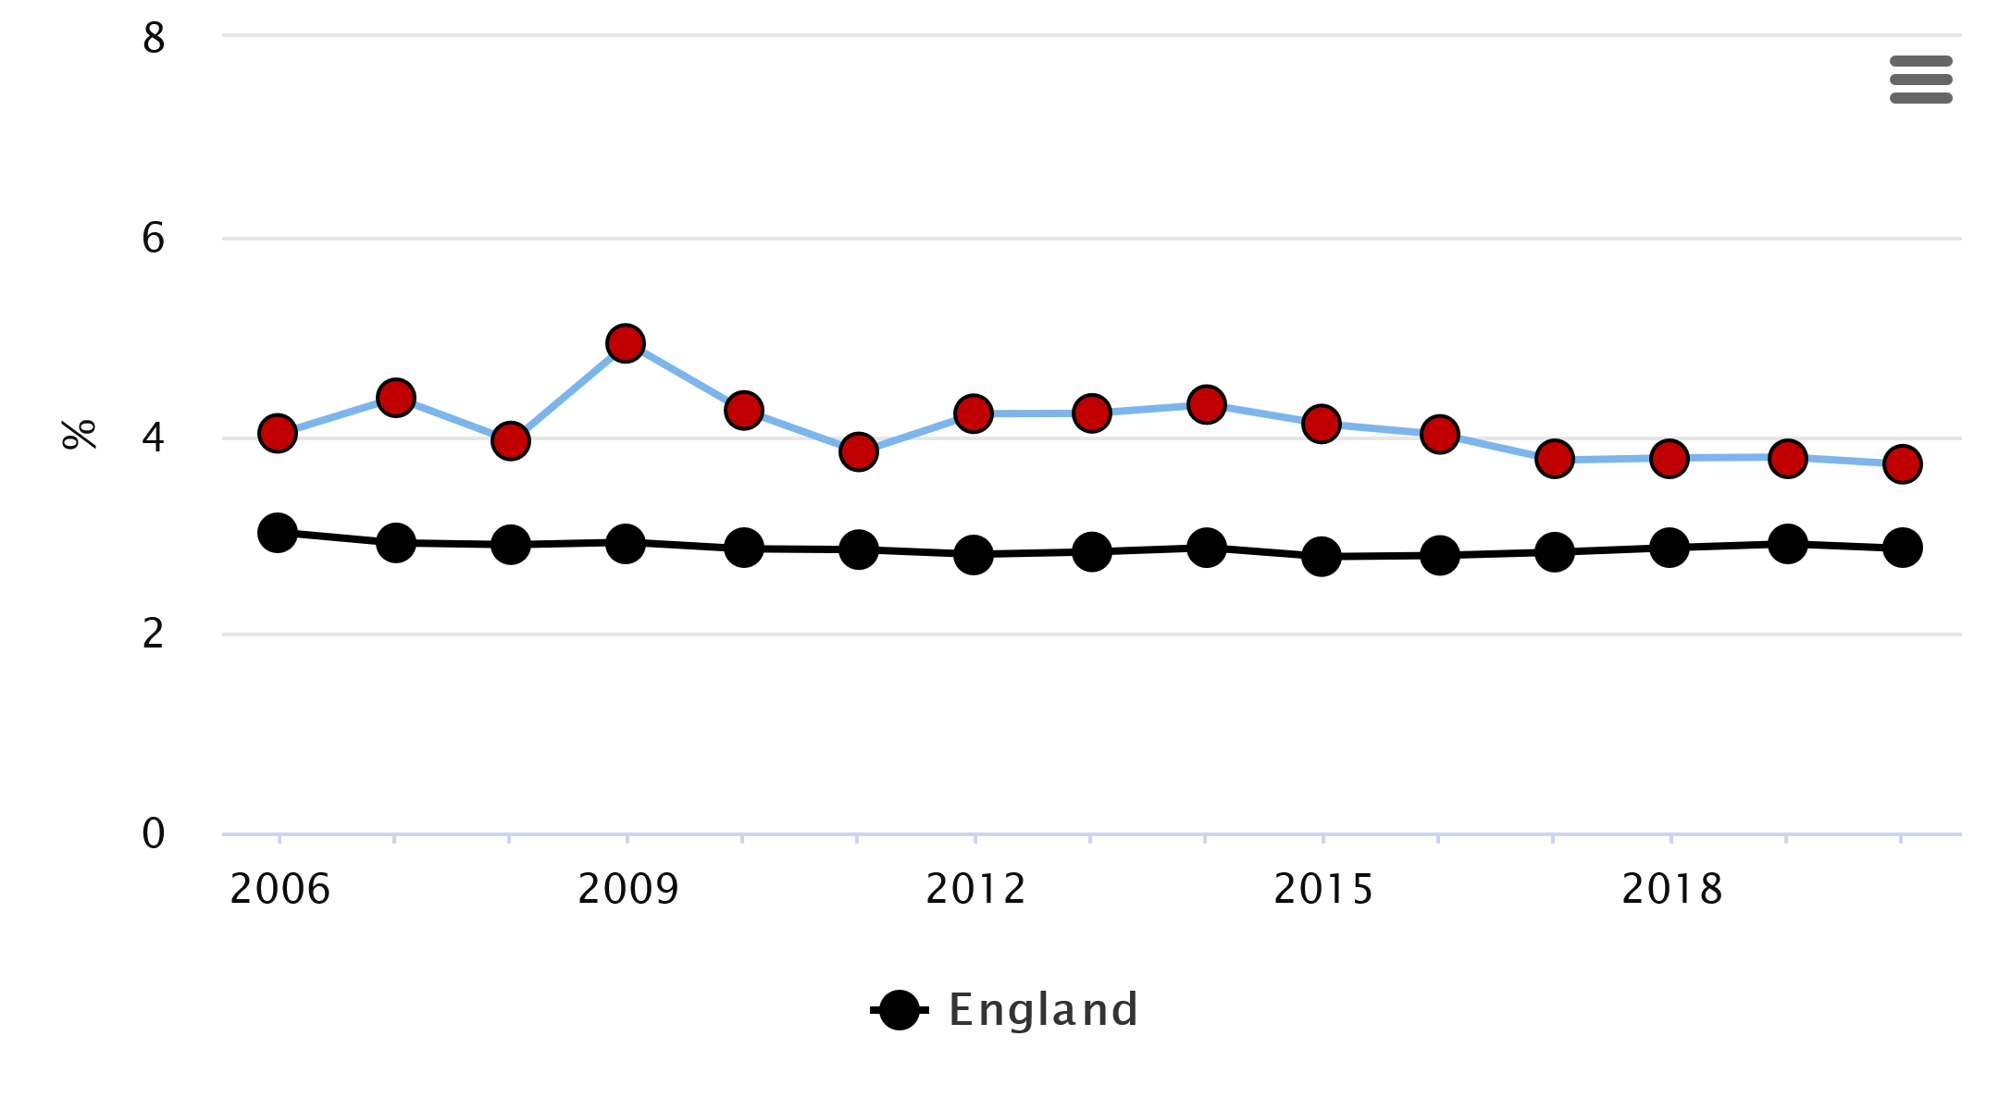

Source: Public Health England Profiles

### Low Birth Weight – all babies

All births (live and still births) with a recorded birth weight under 2500g as a percentage of all live births with stated birth weight.

* No significant change in the trend for the past 5 years
* Still significantly higher than England and West Midlands
* 2020 Sandwell 8.7%; England 6.9%; West Midlands 8.2%

### Very low birth weight of all babies

* No significant change in the trend for the past 5 years
* Still significantly higher than England
* 2020 Sandwell 1.46%; England 1.01%; West Midlands 1.38%

## Still Births

Over half (52%) of stillbirths in England and Wales in 2016 were unexplained. The remainder resulted from a lack of oxygen or trauma just before or during birth (19%), congenital anomalies (17%), other specific conditions (7%) and infections (2%).

Stillbirths and infant deaths are associated with a number of interrelating risk factors, some of which are modifiable. They include low birth weight, prematurity, maternal obesity, smoking in pregnancy, maternal age, and inequalities across different socioeconomic and ethnic groups.

The rate of stillbirths (foetal deaths occurring after 24 weeks of gestation) for all maternal ages per 1,000 births in Sandwell is significantly higher than England:

* 2018-20 Sandwell 5.3; England 3.9; West Midlands 4.3 per 1000 births
* 2nd highest rate in West Midlands following Birmingham (5.6)
* Between 2011-13 and 2014-16 the rate of still births decreased from 6.5 still births to 5.4 still births in every 1000 births. This was a similar level to the national rate. There is no significant change in the trend for the past 5 years.

**Figure 1.13: Stillbirth Rate for Sandwell & England**

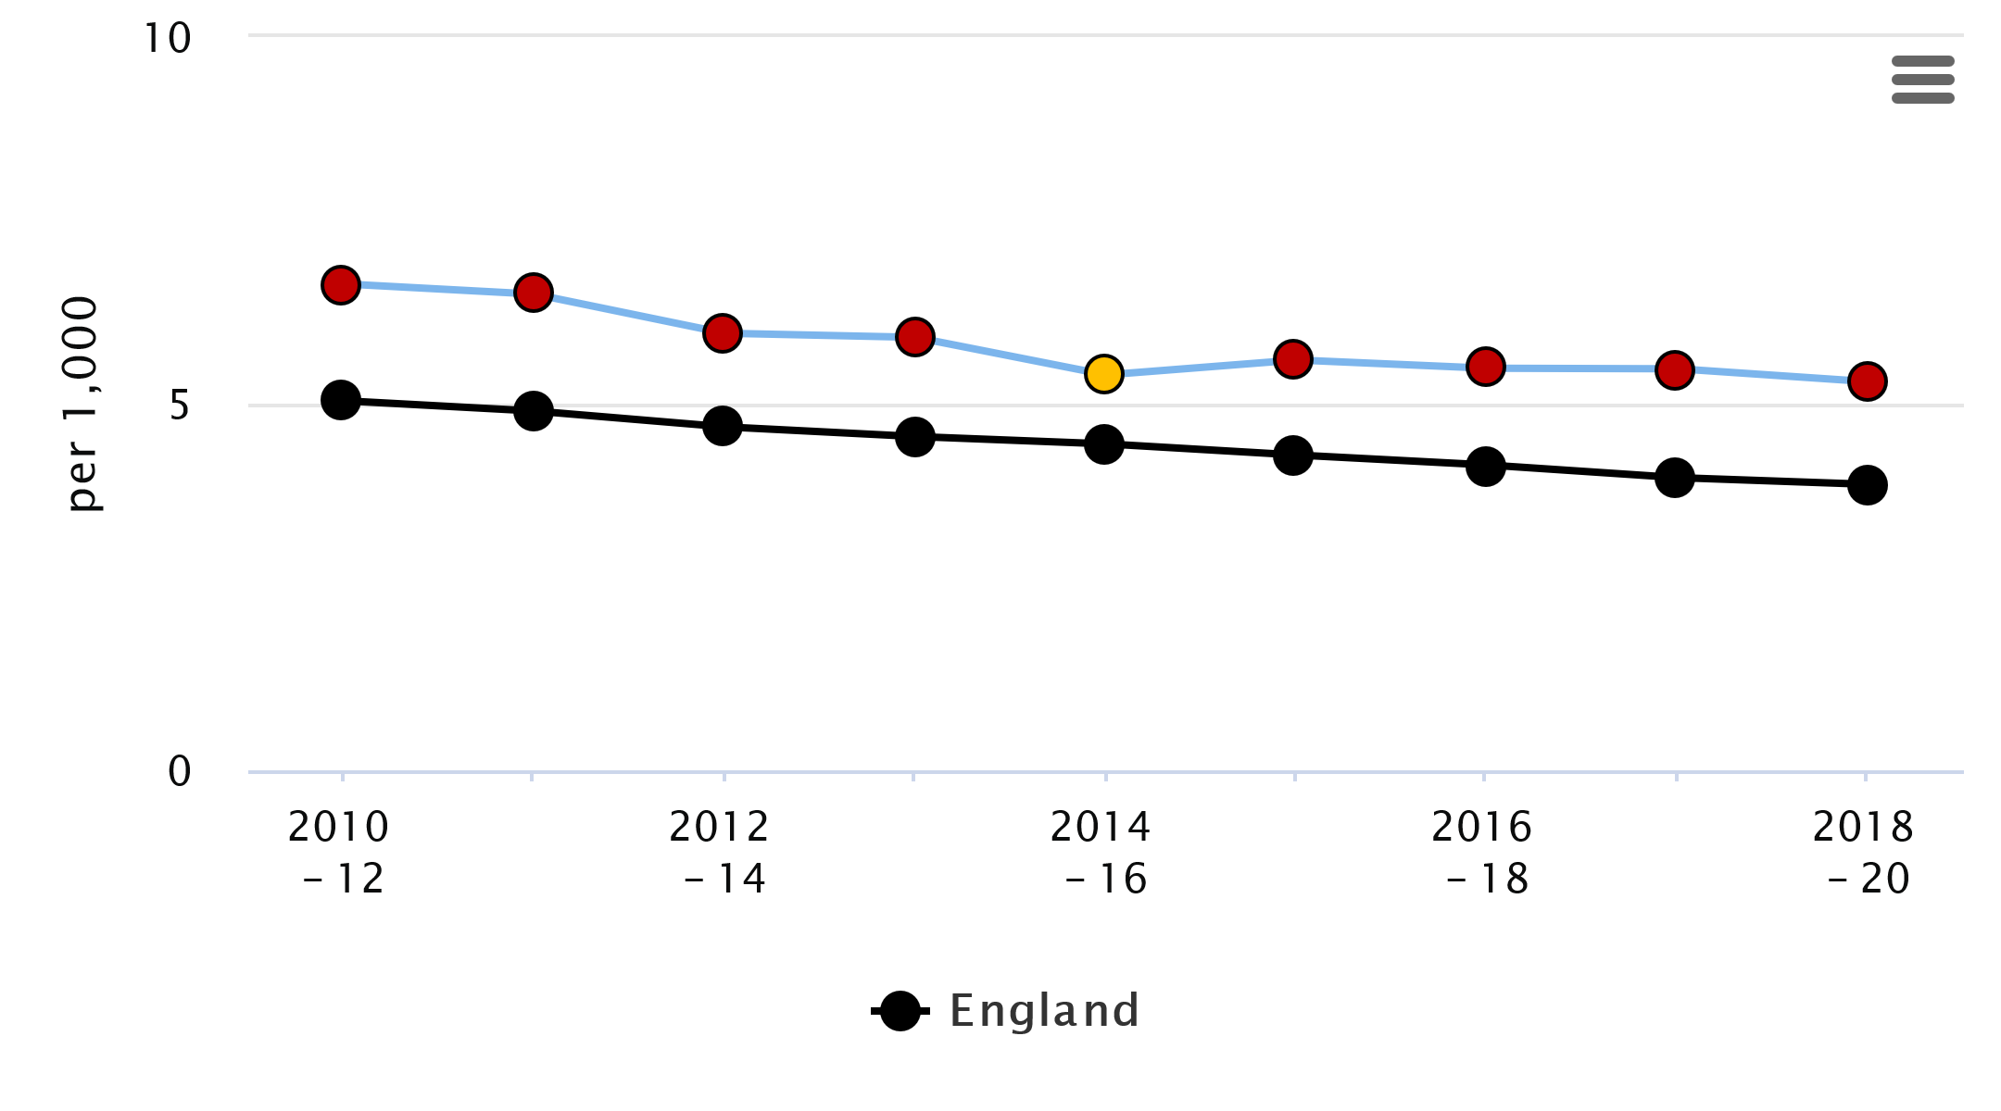  
Source: Public Health England Profiles

## Community Midwifery - Late Bookers

Delayed access to antenatal care ('late booking’) has been linked to increased maternal and fetal mortality and morbidity.

Over a period of 12 months (June 2017 – June 2018), 21% of pregnancies managed by Sandwell and West Birmingham Hospital Trust presented late for their first booking.

* 50% of those presenting late are from West Birmingham.
* 37% of those presenting late are from Sandwell.
* 13% of those presenting late are either young parents or residents outside of Sandwell and West Birmingham.

Table 1.4 shows late booking split by different area teams.

* For Sandwell, the proportion of late booking across all areas ranges from 12% in Rowley and Tipton and 16% in Smethwick and Oldbury.
* For West Birmingham, the proportion late booking is substantially higher than Sandwell and ranges from 18.8% in Great Barr and Kingstanding to 28.5% in Handsworth.
* Young parents and out of area bookings have the highest proportion of pregnancies booking late. For young parent, 4 out 10 pregnancies will be booked late.
* Half of all out of area pregnancies will be booked late.

**Table 1.4:** **Late Bookers 2017/18**

|  |  |  |
| --- | --- | --- |
|  | | **% Booking Late** |
| **Sandwell Team** | Rowley and Tipton | 12.3% |
| Smethwick and Oldbury | 16.2% |
| Wednesbury & West Bromwich | 15.0% |
|  | | |
| **Birmingham Team** | Aston | 25.5% |
| Great Barr & Kingstanding | 18.8% |
| Handsworth | 28.5% |
|  | | |
| **Young Parents and Out of Area** | Young Parents | 39.8% |
| Out of Area | 54.4% |

Source: Badgernet – Electron Patient Records SWBHT

## Smoking status at time of delivery

Smoking during pregnancy can cause serious pregnancy-related health problems. These include complications during labour and an increased risk of miscarriage, premature birth, stillbirth, low birth-weight and sudden unexpected death in infancy.

This indicator is defined as the number of mothers known to be smokers at the time of delivery as a percentage of all maternities.

* There has been a generally decreasing trend for a number of years (with the exception of 2019/20).
* 2020/21 Sandwell 9.3%; England 9.6%; West Midlands 10.6%.

**Figure 1.14: Smoking status at the time of Delivery**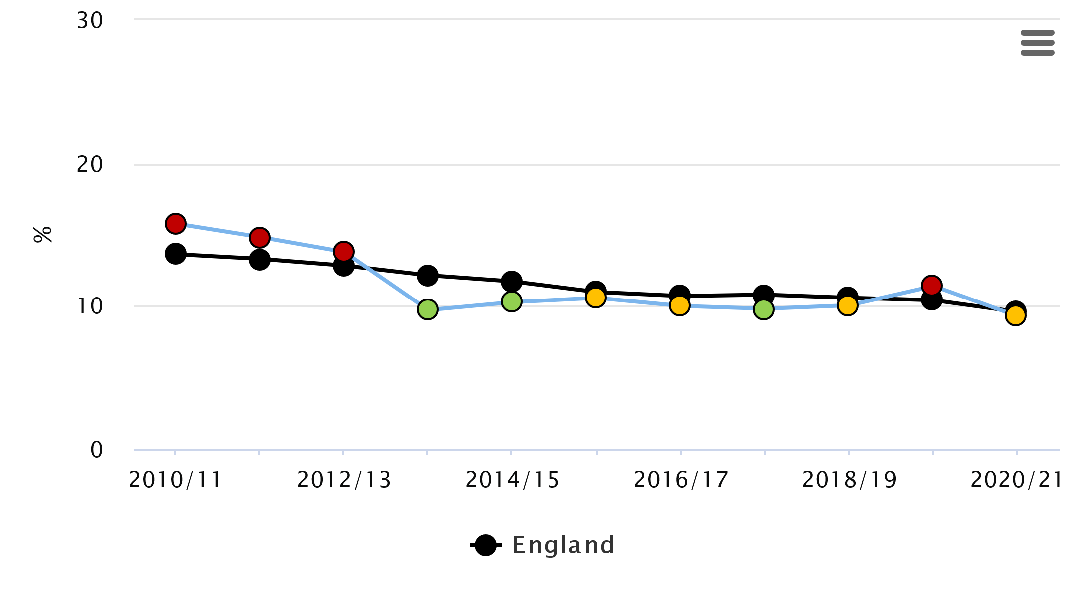

Source: Public Health Outcome Framework

In 2020/21 approximately 9.3% of local pregnant women in Sandwell smoked at time of delivery (figure 1.14). This is a significant decrease since 2011 (15.8%). Comparable data for CSSNBT (Children's Services Statistical Neighbour Benchmarking Tool) statistical neighbours for Sandwell is much higher, despite having a similar population. Prior to 2013-2014 the Sandwell percentage was higher than the average for England.

The percentage of women who smoke at the time of delivery in Sandwell remains lower than that of the West Midlands region, however the reliability of this data is questionable due to the variability of CO monitoring.

## Hospital admissions of babies under 14 days

High levels of admissions of either mother or babies soon after birth can suggest problems with either the timing or quality of health assessments before the initial transfer or with the postnatal care once the mother is home. Dehydration and jaundice are two common reasons for re-admission of babies and are often linked to problems with feeding (PHE).

* For 2016-17, the number of emergency admissions for babies aged 0-13 days (inclusive) expressed as a crude rate per 1,000 deliveries, in Sandwell is significantly higher than England and West Midlands (Sandwell 87.2 per 1000; England 71.0 per 1000; West Midlands 68.3 per 1000).

Further analysis of Hospital Episode Statistics (HES) for Sandwell, shows that for the period 2014/15 to 2018/19, there were 1840 emergency admissions of babies under 14 days.

* 21.3% of babies admitted were 5 days old.
* 43.1% were of White origin and 29.1% were Asian.
* 35.7% of babies were diagnosed with jaundice, and 19.7% had feeding problems.
* Around half of admissions were from the towns of West Bromwich or Smethwick (24.6% and 23.6% respectively). Soho & Victoria (8.0%), Oldbury (6.6%) and St. Pauls (6.4%) were the wards accounting for the highest proportion of admissions.

# Early Years

## Key Points

* Infant mortality (Infant deaths under 1 year of age per 1000 live births) is significantly higher for Sandwell than England and is the highest in the country. For 2018-20, Sandwell’s rate of 6.4 per 1,000 live births compares with England (3.9) and West Midlands (5.6).
* In 2019, post-neonatal was 0.9 for Sandwell, 1.5 for West Midlands and 1.0 for England per 1,000 live births
* In 2019 neonatal mortality was 3.6 for Sandwell, 4.0 for West Midlands and 2.7 for England per 1,000 live births
* The proportion of babies whose first feed is breastmilk stands at 63.5% in 2018/19 in Sandwell. This is significantly below the England average of 67.4%.
* In 2019/20 there were 604 A& E attendances per 1,000 0-4-year-olds in Sandwell and 108.6 emergency admissions per 1,000 0-4-year-olds (2020/21). Emergency admissions are significantly worse than England and the West Midlands.
* Sandwell health visiting teams are actively using the Ages & Stages Questionnaires (ASQ-3) as a tool to assess five domains of child development: communication, gross motor skills, fine motor skills, problem solving and personal-social development. In 2017/18, 96% of Sandwell children received their 2⅟**2** year check.
* A lower proportion of Sandwell children are school ready compared to than other parts of the West Midlands region and England. For 2018/19, 66.8% of Sandwell children achieved a good level of development. This is statistically lower than England (71.8%) and the West Midlands region (70.1%).
* In October 2019, there were 6960 active members of Sandwell libraries aged 0 to 5 (20.6% of all 0-5 year olds).
* All three and four year olds are entitled to 570 hours of free early education and childcare (NEF) a year. The take-up rates for NEF at 96% (DfE LAIT 2019) are good and are just above the national average, with 9186 Sandwell children taking up their free place.
* Early Learning for two year olds (ELT) was also introduced in 2013 and is targeted by government at the most disadvantaged families. The take-up for ELT in the borough has continued to grow. In 2019, 1471 children were taking up places, with a take-up rate of 68%.
* In terms of excess weight (children who are overweight or obese), at Reception age, Sandwell generally has a higher proportion of children who have excess weight, and this is significantly higher than the West Midlands and England averages. In 2019/20, 25.1% of Sandwell reception age children are overweight (including obesity).

## Infant Mortality

Conditions relating to premature birth, such as respiratory and cardiovascular disorders, and congenital abnormalities, are common causes of infant deaths. The three major causes of neonatal deaths worldwide are infections, premature birth and suffocation.

Measures that reduce poverty and mitigate the impact of poverty on the health of women before and during pregnancy will have a significant impact on the risk of stillbirth and death during infancy. Policies that are directed at improving the health of pregnant women (such as [Stop Smoking services](https://www.nuffieldtrust.org.uk/resource/smoking-in-pregnancy)), and early intervention services such as health visiting and midwifery, are likely to reduce infant and neonatal mortality rates.

Reducing infant mortality overall and the gap between the richest and poorest groups are part of the Government's strategy for public health (Healthy Lives, Healthy People: Our Strategy for Public Health November 2010).

* Infant mortality (Infant deaths under 1 year of age per 1000 live births) is significantly higher for Sandwell than England.
* 2020 Sandwell 13.1 per 1,000 live births; England 10.3; West Midlands 10.7.
* Sandwell currently has the highest rate in England.
* Deaths during the neonatal period (first 28 days) are the largest contributors to the infant mortality rate.

**Figure 2.1**

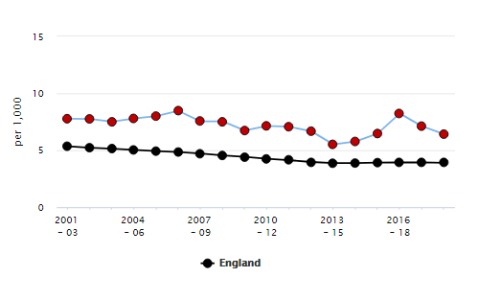

**Source:** Public Health England Profiles

## Neonatal and post-neonatal mortality

In 2019, post-neonatalmortality(deaths between 28 days and 1 year) and neonatal mortality (deaths under 28 days) Sandwell was higher than England but lower for West Midlands county per 1,000 live births for Neo natal mortality (Figure 2.2). For Postnatal mortality Sandwell was lower for both England and West Midlands.

**Figure 2.2: Post neonatal and neonatal Mortality per 1,000 live births: Sandwell, West Midlands and England 2019**

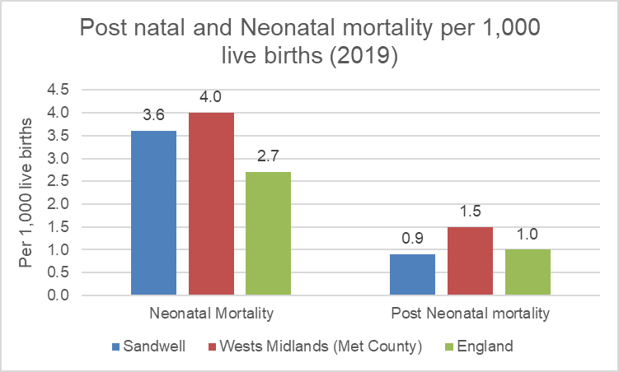

Source: Office for National Statistics

In 2019 Sandwell (3.6) had the 2nd highest neonatal mortality rate in the West Midlands following Birmingham (5.6), and is significantly higher than the England average.

**Figure 2.3**

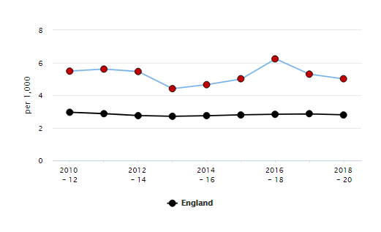

**Source:** Public Health England Profiles

For post-neonatal mortality, Sandwell has a similar rate to England.

* In 2018-20 the Sandwell rate of 1.40 per 1,000 live births compares with England (1.10) and West Midlands (1.30).
* Since 2016/18 the rate of post-neonatal mortality has decreased, from 2 to 1.4 per 1,000 live births in 2018-20.

**Figure 2.4**

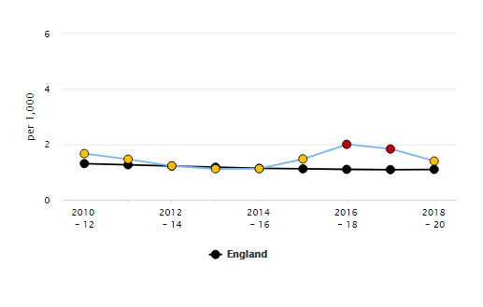

**Source:** Public Health England Profiles

## Breastfeeding

Breastfeeding has long-term benefits for a baby, lasting right into adulthood. Any amount of breast milk has a positive effect, and the longer a mother breastfeeds, the longer the protection lasts and the greater the benefits.

Breastfeeding reduces a baby's risk of:

* infections, with fewer visits to hospital as a result
* [diarrhoea and vomiting](https://www.nhs.uk/conditions/pregnancy-and-baby/diarrhoea-vomiting-children/), with fewer visits to hospital as a result
* [sudden infant death syndrome (SIDS)](https://www.nhs.uk/conditions/sudden-infant-death-syndrome-sids/)
* childhood leukaemia
* [obesity](https://www.nhs.uk/conditions/obesity/)
* [cardiovascular disease](https://www.nhs.uk/conditions/cardiovascular-disease/) in adulthood

### Initiation

The proportion of babies whose first feed is breastmilk stands at 63.5% in 2018/19 in Sandwell. This is above the West Midlands figure of 62.5%, but significantly below the England average of 67.4%.

**Figure 2.5**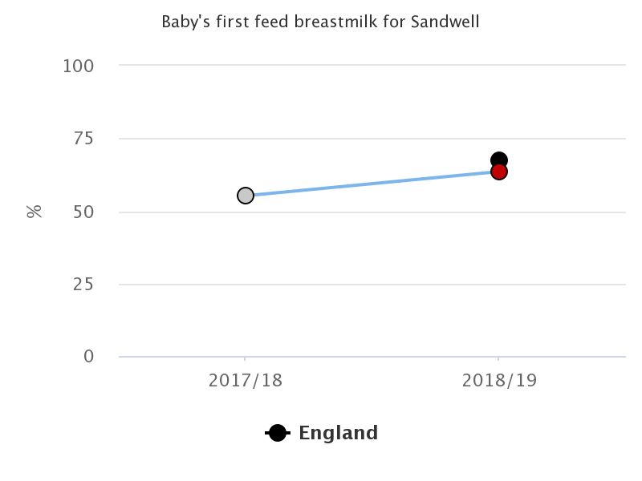

Source: Maternity Services Dataset (MSDS)

### At 6-8 weeks

This is the percentage of infants that are totally or partially breastfed at age 6-8 weeks. Totally breastfed is defined as infants who are exclusively receiving breast milk at 6-8 weeks of age - that is, they are not receiving formula milk, any other liquids or food. Partially breastfed is defined as infants who are currently receiving breast milk at 6-8 weeks of age and who are also receiving formula milk or any other liquids or food.

* The proportion of women who continue to breast feed at 6-8 weeks after birth in Sandwell (44.2%) in 2020/21 remains significantly lower than the England average (47.6%) (Fingertips).

## A&E attendances (0-4 years)

A&E attendances in children aged under five years are often preventable, and commonly caused by accidental injury or by minor illnesses which could have been treated in primary care.

* In 2019/20 there were 604 A& E attendances per 1,000 0-4-year-olds in Sandwell.
* Sandwell is better than England (659.8).
* The trend has been increasing over the past 7 years in Sandwell.

**Figure 2.6 A&E attendances (0-4 years old)**

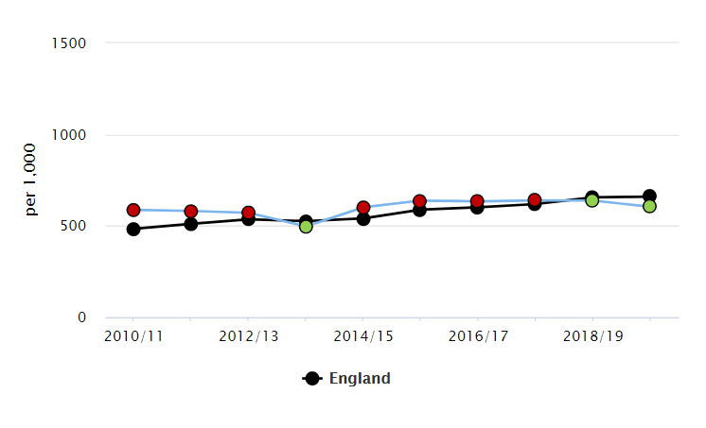

Source: Public Health England Profiles

Further analysis of Hospital Episode Statistics (HES) for Sandwell, shows that during 2019/20, there were 14,130 A & E admissions for Sandwell children aged under 5.

* Almost a third of admissions are aged 1 & under (31.8%).
* 51.3% are of White origin, whilst 22.8% are Asian.
* Diagnosis data is not complete, so it is difficult to determine the reason for admission.
* Around half of admissions were from the towns of West Bromwich or Smethwick (24.8% and 22.5% respectively). These towns are the largest in terms of population size, and are also within close proximity to hospitals.
* Soho & Victoria (7.7%), St. Pauls (6.0%) and Oldbury (5.7%) were the wards accounting for the highest proportion of admissions.

## Emergency admissions (aged 0-4)

Nationally, over a quarter of emergency hospital admissions in children aged under 5 years in 2014/15 was for respiratory infections. Factors such as smoking in the home and damp housing are known to increase the risk and severity of respiratory infections in young children.

* In Sandwell in 2020/21, there were 108.6 emergency admissions per 1,000 0-4-year-olds. There has been a decreasing trend in the last 3 years.
* This is statistically worse than England (91.2) but better than West Midlands (95.3).

**Figure 2.7 Emergency admissions (aged 0-4)**

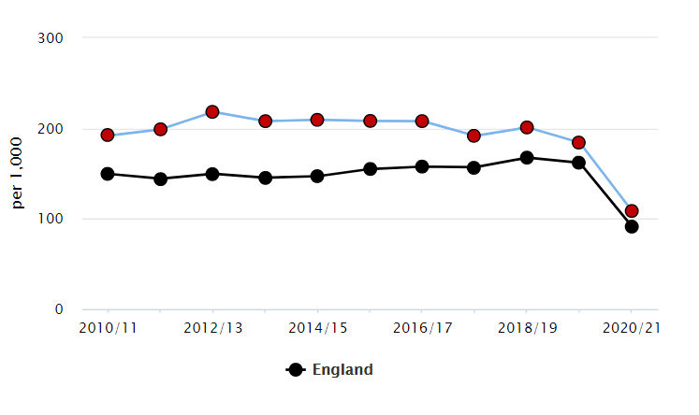

Source: Public Health England Profiles

Further analysis of Hospital Episode Statistics (HES) for Sandwell, shows that for the period 2016/17 to 2018/19, there were 8,116 emergency admissions for Sandwell children aged under 5.

* Over a third of admissions are aged 1 & under (37.2%).
* 44.9% are of White origin, whilst 30.7% are Asian.
* The most common reason for admission was viral infection of an unspecified site (22.8%), tonsillitis (9.0%), and acute upper and lower respiratory infections (8.0% and 7.9% respectively).
* Around half of admissions were from the towns of West Bromwich or Smethwick (24.3% and 21.4% respectively). These towns are the largest in terms of population size, and are also within close proximity to hospitals.
* Soho & Victoria (7.4%) and Oldbury (6.8%) were the wards accounting for the highest proportion of emergency admissions.

## Population vaccination coverage

The MMR vaccine gives protection against three serious diseases: [measles](https://vk.ovg.ox.ac.uk/vk/measles), [mumps](https://vk.ovg.ox.ac.uk/vk/mumps), and [rubella](https://vk.ovg.ox.ac.uk/vk/rubella). Before the introduction of vaccines, all three diseases were extremely common and most people had them at some point, usually as children. Although many people survived without long-term effects, others were left with serious disabilities and some children died. Complications of measles include fatal pneumonia and encephalitis (inflammation of the brain); mumps can cause deafness and meningitis, and in the past rubella caused many babies to be born with serious abnormalities (known as Congenital Rubella Syndrome).

Three years after the [measles virus](https://www.newscientist.com/article/dn27481-measles-leaves-you-vulnerable-to-a-host-of-deadly-diseases/) was eliminated from the UK, the country has lost its “measles-free” status with the World Health Organization, following 231 confirmed cases of the infection in the first quarter of 2019.

Public Health England have now urged parents to check their children had had the full set of vaccinations.

This vaccination indicator relates to all children for whom the local authority is responsible who received two doses of MMR on or after their first birthday and at any time up to their fifth birthday, as a percentage of all children whose fifth birthday falls within the period.

* For 2020/21 – the coverage for Sandwell (82.6%) compares with England (86.6%) and the West Midlands (85.6%) and is statistically worse than these comparators.
* Increasing trend over past 5 years.

## Child Development

Healthy pregnancy, good parenting and good early years provision are essential foundations for healthy development and achievement of a child. The early years are highly influential for a child’s future outcomes in life. Children who do not achieve a good level of development by the age of five will often struggle with reading, maths, social and physical skills leading to long term impacts on their educational attainment and health. Growing up in areas such as Sandwell where poverty and deprivation is ranked so high, makes it harder for children to reach their potentials.

## Proportion of children aged 2-2½yrs receiving ASQ-3

ASQ-3 is a set of questionnaires about children’s development from 2 to 60 months which can be self-administered by parents/caregivers. This screening provides a quick look at how children are doing in important areas, such as communication, physical ability, social skills, and problem-solving skills. ASQ-3 can help identify a child’s strengths as well as any areas where the child may need support. It helps to identify when a referral to health professionals is needed.

In 2020/21, 98.8% of Sandwell children received their 2⅟**2** year check. This compares with England (85.2%) and the West Midlands (92.3%).

* Sandwell’s coverage is significantly higher coverage than England and West Midlands.
* Herefordshire achieved a 100% coverage.

**Figure 2.8**

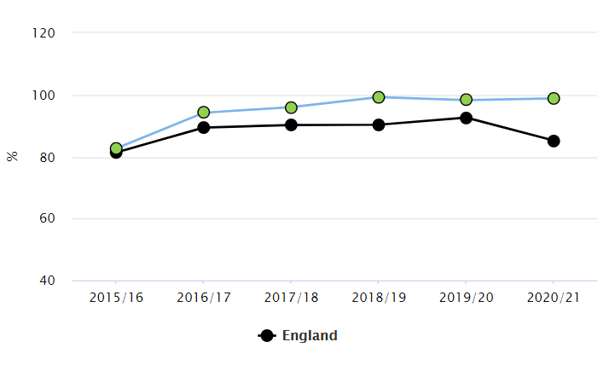

Source: Public Health England Profiles

Sandwell health visiting teams are actively using the Ages & Stages Questionnaires, Third Edition (ASQ-3) as a tool to assess five domains of child development: communication, gross motor skills, fine motor skills, problem solving and personal-social development.

## Ready for School

An Ofsted review of local authorities in 2014[1] reported that that there is no nationally agreed definition for the term ‘school readiness’.

As part of the Early Years Foundation Stage statutory framework[2], school readiness is a key measure of early years development across a wide range of developmental areas. As shown in Table 1 below, school readiness covers seven prime areas of learning and seventeen early learning goals. Not only do these prime areas impact on educational outcomes but also health and crime. The EYFS profile assessment is carried out for each child in the final term of the year in which a child reaches age five. Assessment is completed from a practitioner’s observation and interaction with the child in a range of daily activities and events.

**Table 2.1: School Readiness Areas of Learning**

|  |  |  |  |
| --- | --- | --- | --- |
|  | **Area of Learning** | **Early Learning Goal (ELG)** | **Good level of development** |
| **Prime Areas** | Communication and Language | 1: Listening and attention | ✔ |
| 2: Understanding | ✔ |
| 3: Speaking | ✔ |
| Physical Development | 4: Moving and handling | ✔ |
| 5: Health and self-care | ✔ |
| Personal, Social and Emotional Development | 6: Self-confidence and self-awareness | ✔ |
| 7: Managing feelings and behaviour | ✔ |
| 8: Making relationships | ✔ |
| **Specific Areas of Learning** | Literacy | 9: Reading | ✔ |
| 10: Writing | ✔ |
| Mathematics | 11: Numbers | ✔ |
| 12: Shape, space and measures | ✔ |
| Understanding the World | 13: People and communities |  |
| 14: The World |  |
| 15: Technology |  |
| Expressive arts and design | 16: Exploring and using media and materials |  |
| 17: Being imaginative |  |

Children achieving at least the expected level in the Early Learning Goals (ELGs) within the three prime areas of learning and within literacy and mathematics are classed as achieving a 'good level of development'.

For children to achieve at least an ‘expected’ level of development means that they achieved ‘expected’ or ‘exceeded’ levels within all three communication and language early learning goals (listening and attention, understanding, speaking) at the end of the Early Years Foundation Stage (EYFS).

**Table 2.2: School Readiness Indicators**

|  |  |  |  |  |  |  |
| --- | --- | --- | --- | --- | --- | --- |
| **School Readiness Indicators** | **Age** | **Time period** | **Sandwell %** | **Compared to England** | **Compared to West Midlands** | **Trend** |
| % of children achieving a **good level** of development at the end of reception | 5 yrs | 2018/19 | 66.8 | Worse | Worse |  |
| % of children with free school meal status achieving a **good level** of development at the end of reception | 5 yrs | 2018/19 | 57.7 | Similar | No data Available | - |
| % of children achievingat least an **expected level** of development across all learning goals in communication and language | 5 yrs | 2018/19 | 77.9 | Worse | Worse |  |
| % of children with free school meal status achieving at least an **expected level** of development across all learning goals in **communication and language** | 5 yrs | 2018/19 | 72.2 | Similar | Similar |  |

Source: PHE Profiles (2019)

A lower proportion of Sandwell children are school ready compared to than other parts of the West Midlands region and England. For 2018/19 66.8% of Sandwell children achieved a good level of development. This is statistically lower than England (71.8%) and the West Midlands region (70.1%).

For the past 5 years, the percentage of children in Sandwell achieving a good level has been increasing, however in comparison to the regional and national figures, the inequality gap is still large.

Ranking the levels of good development across the West Midlands Metropolitan Councils, Sandwell’s rank is the lowest.

The inequality gap for children who are eligible for free school meals in Sandwell compared to those that have more prosperous socio-economic environments in Sandwell is even larger. Only 57.7% of children who have free school meals are achieving a good level of development. Although this is a similar rate to the national and regional achievements for children with free school meals; when looking at performance of the learning and communication area which includes ELGs ‘listening and attention’, ‘understanding’ and ‘speaking’, Sandwell’s rates are statistically lower.

Similarly, to the national and regional trends, girls outperform boys considerably in achieving a good level of development. In 2019, 12% more girls achieved a good level of development than boys.

**Figure 2.9: Percentage achieving a good level of development by gender 2019**

# Source: Department for Education, Early years foundation stage profile results: 2018 to 2019

Figure 2.10 shows the proportion of children achieving at least expected for each of the individual ELGs. The ranking of the ELGs by proportion of children achieving at least expected is similar between Sandwell and the West Midlands.

Some of the lowest performing ELGs, have the largest percentage point differences, with Sandwell proportions being up to 5% lower than the West Midlands.

In addition to the prime areas, reading is one of the goals that contributes to the ‘good level of development’ measurements. However, this is the 2nd lowest performing ELGs for Sandwell.

**Figure 2.10**

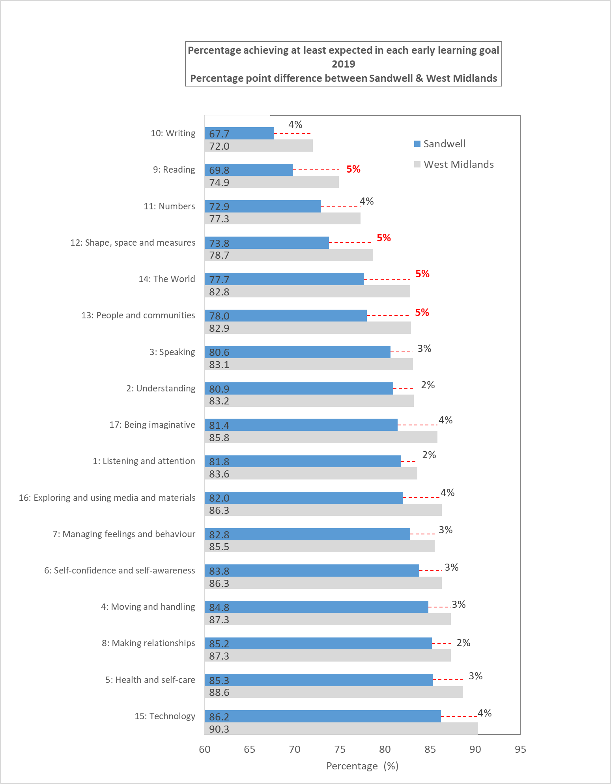

# Source: Department for Education, Early years foundation stage profile results: 2018 to 2019

National data suggests inequalities within certain ethnic groups. This is particularly important and relevant for Sandwell, due to its ethnically diverse population - 30% of Sandwell’s population is from minority ethnic groups (Census 2011). However, the available data for Sandwell does not show any statistically significant differences in achievement between the different ethnicities within Sandwell.

Figures 2.11, 2.12 and 2.13 show some statistically significant differences between the outcomes for pupils depending on their first language. The 2018 school census has identified that 33% of Sandwell primary school children’s first language is not English, suggesting a strong mix of ethnicities and backgrounds amongst Sandwell children. The 2011 census also highlighted that there are some wards, such as St. Pauls in Smethwick, where 13% of its population do not speak English well or at all.

**Figure 2.11: Proportion of pupils reaching a good level of development by first language 2017-9**

# Source: Derived from the Department for Education, Early years foundation stage profile results: 2017 to 2019

* The proportion of pupils in Sandwell, the West Midlands Region and England with “Other Language” as a first language reaching a good level of development (GLD) was statistically significantly lower than pupils with English as a first language.

**Figure 2.12: Proportion of female pupils reaching a good level of development by first language 2017-9**

**Figure 2.13: Proportion of male pupils reaching a good level of development by first language 2017-9**

# Source: Department for Education, Early years foundation stage profile results: 2017 to 2019

* A statistically significantly lower proportion of both male and female pupils whose first language was “Other Language” reached a good level of development in Sandwell, the West Midlands region and England than pupils whose first language was English.

**Figure 2.14:** **Proportion of pupils reaching a good level of development with and without special educational needs (SEN) - 2017-9**

# Source: Derived from the Department for Education, Early years foundation stage profile results: 2017 to 2019

* A statistically significantly lower proportion of pupils with no Special Educational Needs (SEN) reached a good level of development in Sandwell (72.3%) than the West Midlands region (75.8%) and England (77.2%).
* The proportion of pupils with SEN Support, a SEN Statement or an Education, Health and Care (EHC) plans in Sandwell (23.8%) reaching a good level of development was statistically no different than the West Midlands region (23.1%) and England (24.4%).
* A statistically significantly higher percentage of female pupils reach a good level of development than male pupils in Sandwell, the West Midlands region and England with and without Special Education Needs.

## Speech and Language

For children to have achieved at least the expected level of development means that they achieved ‘expected’ or ‘exceeded’ levels within all three communication and language early learning goals (listening and attention, understanding, speaking) at the end of the Early Years Foundation Stage (EYFS).

In 2018/19, 77.9% of Sandwell children achieved a good level of development compared with an England rate of 82.2% and a West Midlands region rate of 79.8%.

* Sandwell has an increasing trend based on the past 5 years.
* The Sandwell rate is significantly lower than England and West Midlands.

**Figure 2.15**

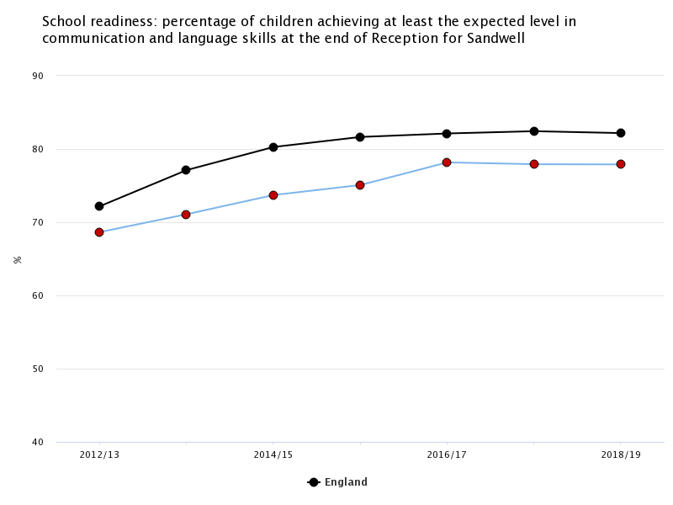

Source: Office for Health Improvement & Disparities Profiles

The Wellcomm speech and language screening tool (developed within the borough) is used to assess children’s speech and language development. Completion of the tool enables the assessor to grade as red, amber or green. Assessors can use the associated ‘book of ideas’ to tailor support for individual children and where appropriate, they can assist parents with making a referral to the Speech and Language Therapy service. Early Years Practitioners are asked to use the tool both at the beginning and end of the academic year for 3 and 4 year olds.

* In summer 2018, 23.3% of pupils were assessed as “red”, and 59.3% as “green”. This has shown an improvement since 2014. 5,814 nursery children were assessed in total (at schools/settings where information was returned to the authority).
* When considering the progress of only those pupils who were assessed both in the autumn and summer of 2017/18 academic year, the proportion scoring “green” increased from 46.5% in the autumn term to 61.6% in the following summer.
* During 2017/18, 10% of children (470) assessed did not make any progress over the term.

**Figure 2.16: Welcomm Screening Tool Assessment Progress 2014/15 – 2017/18**

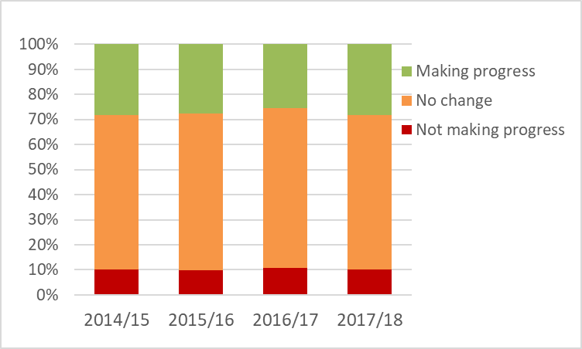

Source: Education, Skills and Employment, Sandwell MBC

## Literacy

Libraries are a key service in engaging parents and children with early literacy. Sandwell’s network of 19 community libraries co-ordinate the ‘Book Start’ programme:

* A baby pack is distributed by the Health Visiting service to encourage early literacy and reinforce the view that it is never too early to start reading to children. A Treasure Bag is then distributed to three and four year olds through school nurseries or pre-school settings.
* The ‘Booktastic’ scheme was launched in October 2014. This provides universal library membership for all reception children in Sandwell schools, and has led to an increase in active membership since 2014.
* In October 2019, there were 6,960 active members (defined as a child who has a minimum of two withdrawals in a 12 month period) of Sandwell libraries aged 0 to 5 (20.6% of all 0-5 year olds).

Figure 2.17 provides an analysis of library membership over a 12 month period. This shows active members aged 5 and under by ward, based on home address. The lowest levels of active library membership amongst 0 to 5s are in the wards of Greets Green & Lyng (15.1%) and Cradley Heath & Old Hill (15.5%). The highest levels of active library membership amongst 0 to 5s are in the ward of Abbey (28.9%).

**Figure 2.17: Active members (0-5 years) in Sandwell libraries October 2019**

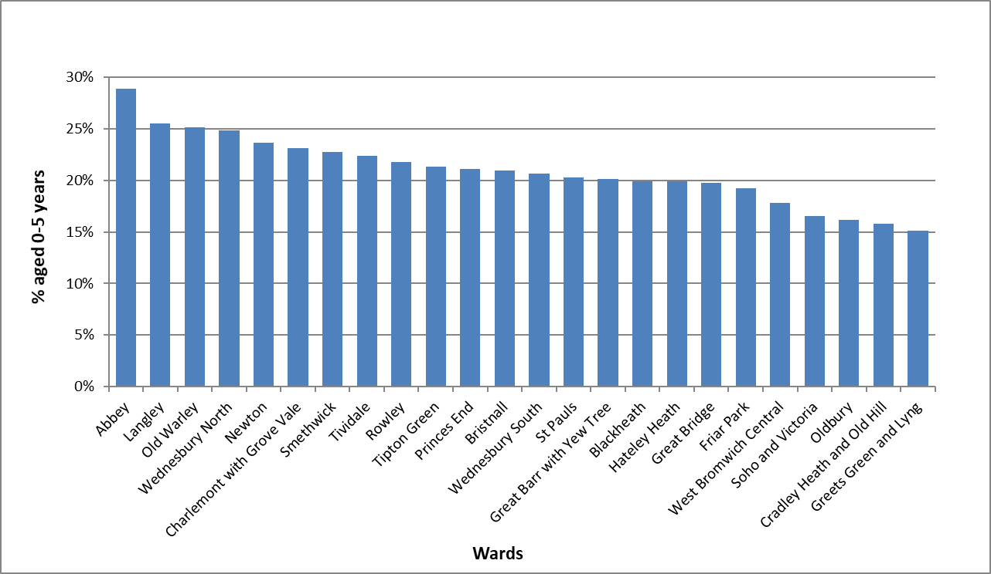

Source: Sandwell Library Service

## Childcare Provision

Childcare in Sandwell is delivered by a range of provider types and is a mixture of local authority-funded and self-funded provision. All three and four year olds are entitled to 570 hours of free early education and childcare (NEF) a year. Early Learning for two year olds (ELT) has also been introduced and is targeted at the most disadvantaged families (those on specific benefits and with an income below a certain level; where children are looked after by the local authority; or where children with SEN have been identified through our services).

The take-up rates for NEF at 96% (DfE LAIT 2019) are good and are just above the national average, with 9186 children taking up their free place. This indicates that the concept of nursery education for three and four year olds is well-embedded across the borough. The wards with the lowest level of take-up are Wednesbury South and Tipton Green. A number of wards have a higher level of take-up than eligibility – this is because children from other wards take up available places within that ward.

**Figure 2.18: Take up rates of NEF for 3-4 year olds in Sandwell by ward**



Source: Sandwell Family Information Service

Early Learning for two year olds (ELT) was also introduced in 2013 and is targeted by government at the most disadvantaged families (those on specific benefits and with an income below a certain level; where children are looked after by the local authority; or where children with SEN have been identified through our services). The take-up for ELT in the borough has continued to grow. In 2014, 716 children were taking up places and this had grown to 1471 by 2019, with a take-up rate of 68%. The wards with the lowest levels of take-up (less than 30%) are Tividale and Cradley Heath & Old Hill. The estimated number of eligible children is derived from data supplied to the Dept. for Education by DWP, on the number of children believed to meet benefit and tax credit eligibility criteria.

**Figure 2.19: Take up of Early Learning for Two’s (ELT) funding in ward by Sandwell**



Source: Sandwell Family Information Service

## Weight of 4-5 Year Olds

Obesity is caused by a complex set of personal, social and environmental factors. Being overweight or obese can bring physical, social, emotional and psychosocial problems, which can lead to the onset of preventable long-term illness, stigma, discrimination, increased risk of hospitalisation and reduced life expectancy.

The National Child Measurement Programme (NCMP) is an annual measure of the height and weight of school children which provides a detailed picture of the prevalence of child excess weight (overweight and obese) and obesity in children at reception age (4-5 year olds) and Year 6 (10-11 year olds).

In terms of excess weight (children who are overweight or obese), at Reception age, Sandwell generally has a higher proportion of children who have excess weight, and this is significantly higher than the West Midlands and England averages.

* 2019/20 – 25.1% of Sandwell reception age children are overweight (including obesity); England (23.0%); West Midlands (24.6%).

**Figure 2.20** Reception: Prevalence of overweight (including obesity)

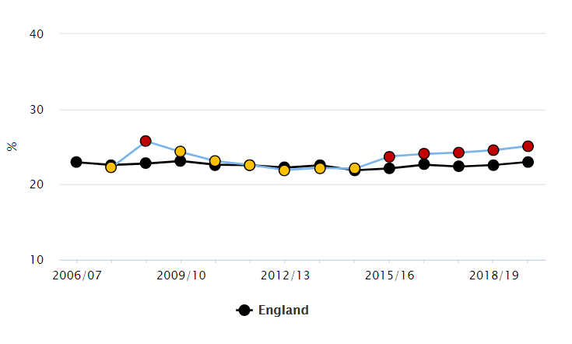

Source: Public Health England Profiles

The difference between Sandwell and the West Midlands and England averages is much wider when considering obesity. There has been a steady increase in the level of obesity among Reception age children in Sandwell. In 2019/20, the Sandwell figure now stands at more than 2.1 percentage points higher than England, and higher than West Midlands.

Children living in the most deprived areas of Sandwell are generally more likely to be obese than those living in the least deprived areas, although there does appear to be an anomaly to this for children of Reception age. For 2013/14 - 2017/18, there is an unexpectedly high proportion of obese children living in the least deprived quintile of Lower Super Output Areas (the LSOAs within the best 20% nationally on the Index of Multiple Deprivation). Further work may be needed to find out what is happening in these areas.

Black children are more likely to be obese than Asian or White children:

* In 2013/14 – 2017/18, 13.9% of Black children in Reception are obese compared to 11.8% of White children and 11.5% Asian. However, there is a more marked difference for England overall, where there is a 6 percentage point difference between the figures for Black and White groups.

Figure 2.21 provides data on children with excess weight at a ward level. The wards with the highest levels of excess weight in Sandwell are Friar Park and Princes End, whilst the lowest is Abbey.

**Figure 2.21: Proportion (%) of children with Excess Weight: Reception year by Ward (2015/16 - 17/18)**

*compared to Sandwell compared to England*

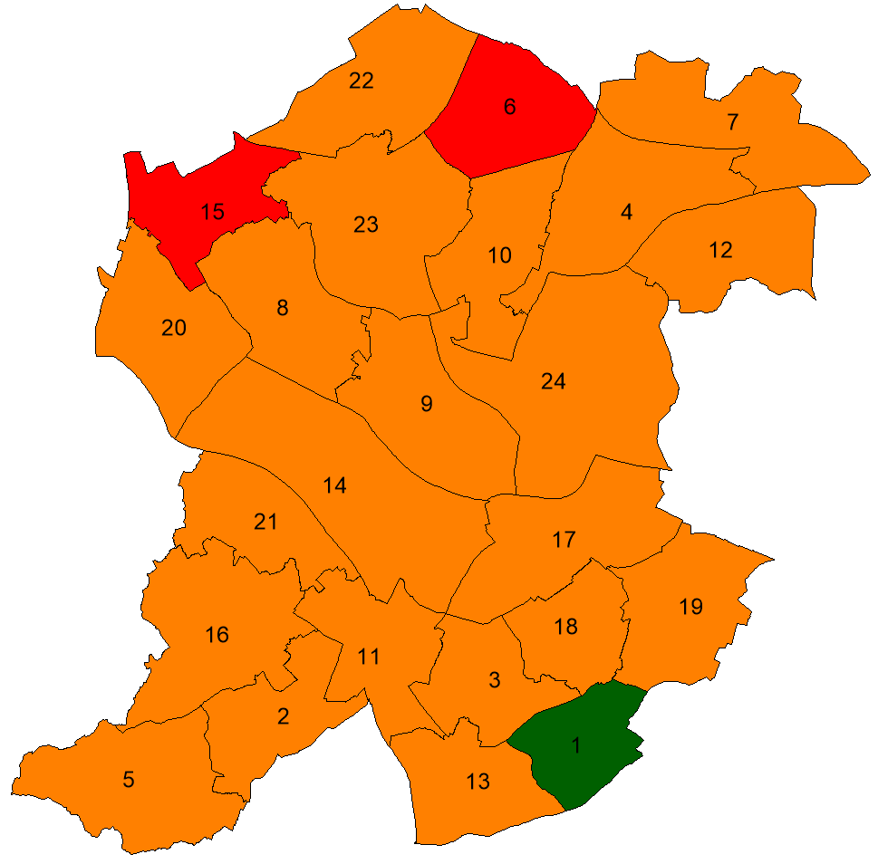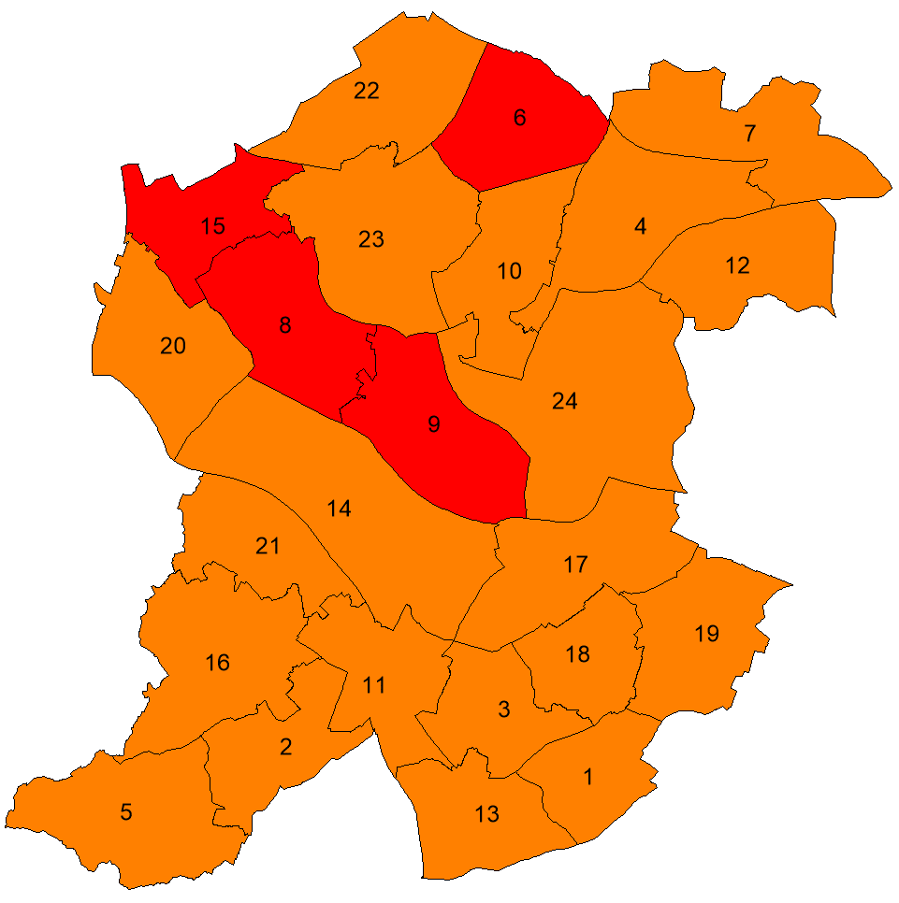

**Source:** Public Health England Local Health Profiles

© Crown copyright and database rights 2019 Ordnance Survey Licence No 100032119

**Key:** the maps above show if the proportion of children with excess weight by ward is significantly different from either Sandwell or England averages - Red shading – ward significantly worse, Amber shading - ward not significantly different & Green shading - ward significantly better. The chart below gives the key to the ward numbers on the map e.g. 6= Friar Park.

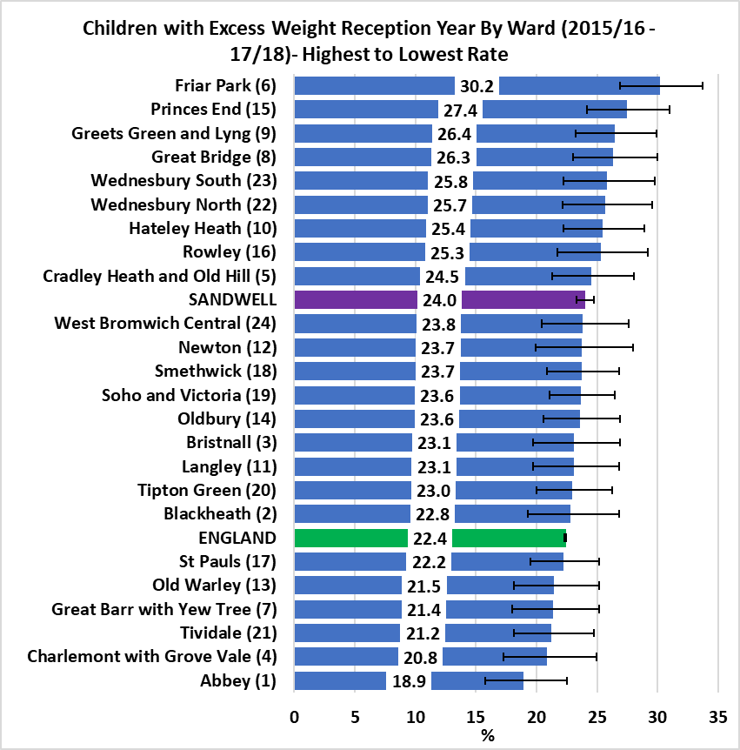

In 2015/16-17/18, in all Sandwell wards almost a fifth of Reception age children were an excess weight.

* Compared to the Sandwell average, two Sandwell wards (Friar Park & Princes End) were statistically worse, 21 wards were statistically similar and one ward (Abbey) was statistically better.
* Compared to the England average, four Sandwell wards (Friar Park, Great Bridge, Greets Green & Lyng, and Princes End) were statistically worse and the rest (20 wards) were statistically similar.

**Source:** Public Health England Local Health Profiles

# Vulnerable Children

## Key Points

* In total there were 3485 Early Help Episodes in 2018/19 in Sandwell - of these, 1090 (376.2 per 10,000) were for 0-5 year olds. [The Early Help System records data in an episodic format. A family can have multiple Early Help episodes but only one at any given point in time].
* Sandwell had a rate of 473.5 children in need per 10,000 children (age 0-17) as at 31st March 2019.
* Sandwell had a rate of 71 per 10,000 children (age 0-17) on a child protection plan in March 2019. This rate has increased since 2014/15, but there was a large fall over the most recent year. As at March 2019, 259 children aged 5 & under were subject to a Child Protection Plan.
* In 2018/19, Sandwell has 109.0 per 10,000 children in care age under 18 years, and there has been a 18.5% increase since 2017/18.
* There were 50 child deaths reported to Sandwell Child Death Overview Panel (CDOP) in 2018-2019. 8 of these were deemed as unexpected.
* 389 children aged 0-5 were known to Sandwell Inclusion Support Early Years (ISEY) and Child Development Centre (CDC) services with two thirds of the ISEY caseload for boys. Over 50% of the children known to ISEY aged 0-5; have speech, language or communication needs.
* In 2018-19 Tipton town had the highest rate in Sandwell for SEND. Oldbury has continued over the past five years to have higher rates than Sandwell overall.
* Tipton has the highest rate of children with Education Health Care Plans in Sandwell.
* In 2018-2019, there were 37 children aged 0-5 referred for visual impairments. Data from the last 4 years shows a decline in the number of children being referred from 55 in 2015-2016 to 37 in 2018-19. The majority of the referrals for vision impairment are for children aged under 2 years, and most are received from health services.
* Sandwell has had an increase in the number of children being referred for hearing impairment. Hearing impairment is more prevalent in boys than girls in Sandwell. Recent years have seen a change in the age groups being referred with a higher proportion of referrals coming for children aged 3-5 years old.
* 1.9 children aged 0-5 per every 1000 child is diagnosed with Autism Spectrum Disorder (ASD). ASD is more prevalent in boys than girls. The highest rate is seen in Rowley Regis town.
* In 2018/19, there were 4,818 referrals to the Children’s Therapy Service in Sandwell. Of these, 1,252 (26%) were for children aged 0-5.

## Introduction

Nothing is more important than children’s welfare. Children who need help and protection deserve high quality and effective support as soon as a need is identified.

Whilst it is parents and carers who have primary care for their children, local authorities, working with partner organisations and agencies, have specific duties to safeguard and promote the welfare of all children in their area. The Children Acts of 1989 and 2004 set out specific duties: section 17 of the Children Act 1989 puts a duty on the local authority to provide services to children in need in their area, regardless of where they are found; section 47 of the same Act requires local authorities to undertake enquiries if they believe a child has suffered or is likely to suffer significant harm.

These duties placed on the local authority can only be discharged with the full co-operation of other partners, many of whom have individual duties when carrying out their functions under section 11 of the Children Act 2004. The local authority is under a duty to make arrangements to promote co-operation between itself and organisations and agencies to improve the wellbeing of local children - this co-operation should exist and be effective at all levels of an organisation, from strategic level through to operational delivery.

The Children Act 2004, as amended by the Children and Social Work Act 2017, strengthens this already important relationship by placing new duties on key agencies in a local area. Specifically the police, clinical commissioning groups and the local authority are under a duty to make arrangements to work together, and with other partners locally, to safeguard and promote the welfare of all children in their area. In Sandwell, this is done through the Sandwell Children’s Safeguarding Partnership.

Everyone who comes into contact with children and families has a role to play.

Safeguarding is the action that is taken to promote the welfare of children and protect them from harm. Safeguarding means:

* protecting children from abuse and maltreatment
* preventing harm to children’s health or development
* ensuring children grow up with the provision of safe and effective care
* taking action to enable all children and young people to have the best outcomes.

## Children’s Safeguarding Practice Reviews (previously Serious Case Reviews)

In Sandwell, most of the cases in recent years which have met the criteria for a case or practice review concern babies and children under 5 years old. The 3 most recently published SCRs were about children aged 0-5 years. These reviews have highlighted some key themes and issues for service improvements:

* **Missing men –** Failure to engage with fathers or other significant men.
* **Lack of effective communication between agencies** – Not always sharing information, absence from multi-agency meetings, lack of clarity about escalation procedures.
* **Lack of recognition of the need for a multi-agency response -** Confusion at times over which agency/professional was taking the lead and who was doing what to support the family.
* **Lack of recognition of safeguarding thresholds and procedures -** Some agencies/professionals not following their own procedures resulting in missed opportunities. Professionals needed greater confidence in applying safeguarding procedures and in their understanding of the threshold document. Further Safeguarding training and greater professional curiosity were also recommended.
* **The need for robust, holistic assessments -** A need for assessments to be more holistic, taking into account the backgrounds and experiences of both parents/significant extended family members and their vulnerabilities. Professional were sometimes over optimistic about parents’ capacity to change and understand the impact of their lifestyles on their children. Disguised compliance by parents, which often led to drift and delay in cases, was another common feature.
* **Recognising, recording and responding to neglect-** The issue of prolonged, entrenched neglect is an ongoing feature across the reviews completed in Sandwell and there are elements of neglect across each case whether current or historic. This is a common national theme also, with the CSPR National Panel stating that neglect featured in ¾ of cases referred to them over a three year period. One SCR identified the challenges practitioners faced in recognising and evidencing neglect and that a tool was needed for all agencies to use to assist with this – this led to the introduction of the Graded Care Profile 2 (GCP2).
* **Unexplained injuries/bruising in non mobile babies -** This is a factor that is also of national importance, with the CSPR National Panel announcing they will produce a report on this issue. Some agencies did not follow appropriate procedures when presented with a non-mobile baby with an unexplained injury, leading to missed opportunities for further exploration and consideration in the wider context.

## Early Help

Early Help, also known as early intervention, is support given to a family when a problem first emerges. It can be provided at any stage in a child or young person's life.

Statutory guidance in each individual nation of the UK highlights the importance of providing early intervention, rather than waiting until a child or family’s situation escalates (Department for Education (DfE), 2018). Early help services can be delivered to parents, children or whole families, but their main focus is to improve outcomes for children. For example, services may help parents who are living in challenging circumstances provide a safe and loving environment for their child. Or, if a child is displaying risk-taking behaviour, early help practitioners might work with the child and their parents to find out the reasons for the child's behaviour and put strategies in place to help keep them safe.

Providing timely support is vital. Addressing a child or family's needs early on can reduce risk factors and increase protective factors in a child's life (Early Intervention Foundation (EIF), 2018). Protective factors can reduce risk to a child's wellbeing. They include:

* developing strong social and emotional skills
* having a strong social support network for the family
* support for good parental mental health
* income support, benefits and advice
* good community services and facilities

(EIF, 2018; Cleaver, Unell and Aldgate, 2011).

Early intervention can also prevent further problems from developing – for example, as part of a support plan for a child and their family when a child returns home from care (DfE, 2018).

Early help can offer children the support needed to reach their full potential (EIF, 2018). It can improve the quality of a child’s home and family life, enable them to perform better at school and support their mental health (EIF, 2018). Research suggests that early help can:

* protect children from harm
* reduce the need for a referral to child protection services
* improve children's long-term outcomes (Haynes et al, 2015).

Early help can also support a child to develop strengths and skills that can prepare them for adult life (EIF, 2018).

Sandwell has 28,971 children aged 0-5 (ONS, mid-year estimate 2018). Some of these children are more vulnerable than others and as a local authority we have a responsibility to identify and intervene in support of their health and wellbeing needs as early as possible.

In Sandwell, the Early Help System records data in an episodic format. A family can have multiple Early Help episodes but only one at any given point in time. An Early Help episode would include an Early Help Assessment which would be conducted with the family.

In total there were 3485 Early Help Episodes in 2018/19, of these, 1090 (376.2 per 10,000) were for 0-5 year olds.

* There has been 46% increase in the number of episodes from 2017/18 to 2018/19. There continues to be a significant amount of work taking place to build relationships between the Trust and key stakeholders such as Health and Education with a focus upon Early Help and Lead Practitioners. In addition, Community Operating Groups (COGs) are becoming more visible in their communities, advising on and building confidence for universal services navigating their way through Early Help processes and threshold application.

The number of early help episodes by age and ward of residence are presented in Figures 3.1-3.3 and referrals by ethnicity is shown in Table 3.1.

**Figure 3.1: Sandwell Early Help Assessments 2014/15 to 2018/19 (0-5 year olds)**

Source: Sandwell Children’s Trust

**Figure 3.2: Early Help episodes by age of child per 10,000 Sandwell population, 2018/19**

Source: Sandwell Children’s Trust

Children under the age of one have the highest early help episode rates amongst the 0-5 population in Sandwell. Ward, Brown and Westlake (2012) have also identified that infants under the age of one are more likely than others to be subjects of child protection plans due to physical abuse and more than twice as likely to be subjects of child protection plans due to neglect. They are also the subject of 45% of serious case reviews (following child death or serious incident), as well as being at eight times the average risk of child homicide. 3% of the referrals were for unborn children. It is positive that this cohort of children are receiving Early Help intervention, ensuring the right service is offered early enough to have positive impact. The Sandwell Unborn Baby Network, which is attended by SCT, Young Parents service, Midwifery, Mental Health and Health Visitors (and other partners when required for specific instances) focuses on ensuring early help is offered at the earliest opportunity.

**Figure 3.3: Early Help episodes by ward of residence 2018/19**

Source: Sandwell Children’s Trust

The proportion of 0-5s with early help episodes is greatest from Princes End, Tipton Green and Tividale wards. Several other wards also have a proportion of 0-5s episodes higher than the Sandwell average, as shown in Figure 3.3. Other wards in Sandwell have similar levels of deprivation as Princes End (such as Smethwick and St. Paul’s) but much lower episode levels, however these tend to be areas with a greater ethnic diversity, and particularly a large Asian population.

**Table 3.1: Early help episodes by ethnicity**

|  |  |  |  |  |  |
| --- | --- | --- | --- | --- | --- |
| Ethnic Group | White | Mixed | Asian | Black | Other |
| Age 0-5 Population (2011 Census) | 15,104 | 2,448 | 6,836 | 1,904 | 554 |
| 0-5 episodes – 2018/19 | 486 | 122 | 99 | 72 | 10 |
| Rate per 10,000 children aged 0-5 | 321.8 | 498.3 | 144.8 | 378.2 | 180.6 |

Source: Sandwell Children’s Trust

**Figure 3.4: Early Help episodes by ethnicity per 10,000 Sandwell population, 2018/19**

Source: Sandwell Children’s Trust

The rates for White, Black and Mixed groups are all over 300 per 10,000 – the main difference in terms of ethnicity is that for the Asian & “Other” group. At 144.8 and 180.6 per 10,000 respectively, this is considerably lower than the other ethnic groups. As the difference in episode rate is so stark between groups, it is important that we investigate this further to understand if the low number of episodes reflects under-presenting among these groups which is masking unmet need. However, there are 300 further cases where ethnicity data has not yet been obtained – this will affect final rates for individual groups.

## Children in Need

Based on the legal definition of ‘children in need’ under Section 17 of the Children Act 1989, a child in need is one who has been assessed by children’s social care to be in need of services and is unlikely to maintain a reasonable standard of health or development and whose health and development is likely to be significantly impaired without the provision of services by a local authority. This includes children who have a substantial or permanent disability. This measure counts the number of children subject of a child protection plan, children who are looked after, care leavers and children with a child in need plan or undergoing an assessment under Section 17 of the Children Act 1989.

* Sandwell had a rate of 473.5 children in need per 10,000 children (age 0-17) as at 31st March 2019.
* Sandwell’s rate in this measure has been continuing to increase since 31st March 2015, and in 2018/19 there was a 4.9% increase in its rate from 2017/18.
* In previous years, Sandwell’s rate has been lower than its statistical neighbours, West Midlands and England. However, as at 31st March 2019, Sandwell’s rate was higher at 473.5; statistical neighbours (422); England (334); West Midlands (352).

**Figure 3.5: Rate of children in need as at 31st March per 10,000 children (0-17 year olds)**

Source: Sandwell Children’s Trust

**Table 3.2: Age Breakdown of Children with a child in need plan or undergoing an assessment - as at 31/3/2019 (excluding Children in Care and children with a child protection plan) with an open referral on LCS**

|  |  |  |  |
| --- | --- | --- | --- |
| Age Group | Number | Percentage | CIN Census England average 2019 |
| Under 1 | 163 | 7.9% | 4.9% |
| 1 to 4 | 436 | 21.2% | 16.9% |
| 5 to 9 | 586 | 28.5% | 23.3% |
| 10 to 15 | 680 | 33.1% | 31.9% |
| 16 + | 192 | 9.3% | 21.2% |
| Total | 2057 | 100.0% | 100% |

* England averages produced by DfE are likely to include CP & CiC  
Source: Sandwell Children’s Trust

Of the 2057 children with a child in need plan or undergoing an assessment as at 31st March 2019, 29.1% were under the age of five years. In both the under one and one to four age groups the percentage in Sandwell is above that nationally.

**Table 3.3: Need Code for Open CIN Episodes as at 31st March 2019 by Age (excludes care leavers, LAC and CP AND Unborns. But DOES include those undergoing a Single Assessment)**

|  |  |  |  |  |  |  |
| --- | --- | --- | --- | --- | --- | --- |
| Need Code | AGE GROUP | | | | TOTAL | % |
| 0-4 year olds | | 5-17 year olds | |
| No. | % | No. | % |
| N0 - Not Stated | 15 | 3% | 190 | 13% | **205** | **10%** |
| **N1 - Abuse or Neglect** | **508** | **90%** | **1084** | **74%** | **1592** | **79%** |
| N2 - Disability | 8 | 1% | 69 | 5% | **77** | **4%** |
| N3 - Parental Illness or Disability | 1 | 0% | 1 | 0% | **2** | **0%** |
| N4 - Family in Acute Stress | 4 | 1% | 19 | 1% | **23** | **1%** |
| N5 - Family Dysfunction | 7 | 1% | 53 | 4% | **60** | **3%** |
| N6 - Socially Unacceptable Behaviour | 1 | 0% | 4 | 0% | **5** | **0%** |
| N7 - Low Income | 5 | 1% | 2 | 0% | **7** | **0%** |
| N8 - Absent Parenting | 14 | 2% | 36 | 2% | **50** | **2%** |
| **Total** | **563** | 100% | **1458** | 100% | **2021\*** | 100% |

*Excludes 36 unborns

Source: Sandwell Children’s Trust

The category of need is recorded at referral stage of a child’s case. As table 3.3 shows, as at 31st March 2019, “abuse or neglect” was by far the highest cause for a child being classed as “in need” - 90% of those aged 0-4 were categorised as suffering abuse or neglect, compared with 74% of those aged 5 & over.

Assessment factors are recorded at the conclusion of a Single Assessment (over 45 days) and so give a better picture of the presiding issues associated with a case. More than one Assessment Factor can be recorded at the end of an assessment. As at 31st March 2019, “domestic violence” was the highest concern for a child’s welfare – 25.6% of those aged 0-4 were categorised with concerns over domestic violence, compared with 18.9% of those aged 5 & over. “Abuse or neglect” was the second highest concern given for assessment (21.9% for under 5s) – the largest factor within this category is emotional abuse (10% of all assessments), followed by neglect (6%) and physical abuse (5%).

**Table 3.4: Assessment Factors for CIN as at 31st March 2019 by Age**

|  |  |  |  |  |  |  |
| --- | --- | --- | --- | --- | --- | --- |
| Assessment Factor | AGE GROUP | | | | Total | % |
| 0-4 year olds | | 5 & over | |
| No. | % | No. | % |
| Alcohol misuse | 315 | 7.6% | 769 | 7.6% | 1084 | 7.6% |
| Drug misuse | 257 | 6.2% | 582 | 5.7% | 839 | 5.9% |
| Domestic violence | 1065 | 25.6% | 1915 | 18.9% | 2980 | 20.9% |
| Mental health | 562 | 13.5% | 1376 | 13.6% | 1938 | 13.6% |
| Learning disability | 106 | 2.5% | 373 | 3.7% | 479 | 3.4% |
| Physical disability or illness | 96 | 2.3% | 338 | 3.3% | 434 | 3.0% |
| Young carer | 21 | 0.5% | 99 | 1.0% | 120 | 0.8% |
| Abuse or neglect | 911 | 21.9% | 1953 | 19.3% | 2864 | 20.0% |
| Other | 233 | 5.6% | 1298 | 12.8% | 1531 | 10.7% |
| No factors identified | 595 | 14.3% | 1425 | 14.1% | 2020 | 14.1% |
| Total | 4161 |  | 10128 |  | 14289* |  |

*Excludes 681 unborns

Source: Sandwell Children’s Trust

**Table 3.5: Ethnic Group Breakdown of Children in Need (under 18s) - as at 31/3/2019 (excluding Children in Care and CP Cases) with an open referral on ICS**

|  |  |  |  |  |
| --- | --- | --- | --- | --- |
| Ethnic Group | Cases | | Children aged under 18 by ethnicity (2011 Census) | |
| Number | % | Number | % |
| Asian or Asian British | 378 | 19.1% | 18,337 | 24.7% |
| Black or Black British | 224 | 11.3% | 5,194 | 7.0% |
| Mixed | 261 | 13.2% | 5,786 | 7.8% |
| White | 1091 | 55.2% | 43,724 | 58.8% |
| Other ethnic background | 21 | 1.1% | 1,335 | 1.8% |
| Not recorded/ information not obtained | 82 |  |  |  |
| Total | 2057 | 100.0% | 74,376 | 100.0% |

Source: Sandwell Children’s Trust

As Table 3.5 shows, the proportion of children in need is greatest from ‘mixed’ ethnic backgrounds and Black or Black British population, with these groups being over-represented in the proportion of cases compared to the ethnicity profile of Sandwell.

## 

## Child Protection Plans

If a child is considered to be suffering, or likely to suffer, significant harm the local authority will make them the subject of a child protection plan.

**Figure 3.6: Rate of children who were the subject of a child protection plan as at 31st March per 10,000 children (0-17 year olds)**

Source: Sandwell Children’s Trust

Sandwell had a rate of 71 per 10,000 children (age 0-17) on a child protection plan in March 2019. This rate has increased since 2014/15, but there was a large fall over the most recent year.

* Between March 2018 and March 2019 there was a fall of 30.3% in the rate of children subject to a child protection plan.
* In previous years, Sandwell’s rate has been lower than its statistical neighbours. However, in 2017/18 Sandwell saw a substantial increase and moved to a higher rate than statistical neighbours – this has continued in March 2019 (Sandwell’s rate of 71 per 10,000 compares to the average for statistical neighbours of 54 per 10,000).
* The increase during 2017/18 is due to the complex interplay between many factors, that include: working in a more robust way with families where neglect is a concern and managing the confidence of our partners and staff.

**Figure 3.7: Sandwell Child Protection Plans by age as at 31st March 2017 to 2019**

Source: Sandwell Children’s Trust

The number of child protection plans by age is presented in Figure 3.7. The age breakdown for the figure below is defined by the Department for Education.

**Table 3.6: Child protection plans by gender (age 0-5) as at 31st March**

|  |  |  |  |
| --- | --- | --- | --- |
| Child Protection Plans | **2017** | **2018** | **2019** |
| CP Cases aged 0-5 - Number of cases 0-5 years (% of All Cases) | | | |
| Number (% of all cases) | 133 (30.6%) | 366 (44.0%) | 259 (44.3%) |
| CP Cases aged 0-5 by sex - Number of cases 0-5 years (% of all 0-5 cases) | | | |
| Male | 64 (48.1%) | 205 (56.0%) | 114 (44.0%) |
| Female | 63 (47.4%) | 146 (39.9%) | 128 (49.4%) |
| Unborn | 6 (4.5%) | 15 (3.5%) | 17 (6.6%) |

Source: Sandwell Children’s Trust

Table 3.6 shows the percentage of child protection cases which are for children aged 0-5 years and the proportion of all cases which are male, female and unborn. As at 31st March 2019, 259 children aged 5 & under were subject to a Child Protection Plan, 44.3% of all cases.

**Table 3.7: Ethnic breakdown of Child Protection Plans aged 0-5 as at 31st March**

|  |  |  |  |
| --- | --- | --- | --- |
| Ethnic Group | Rate per 10,000 population of the ethnic population (Aged 0-5) | | |
| 2017 | 2018 | 2019 |
| White | 58.9 | 126.5 | 99.3 |
| Asian or Asian British | 17.6 | 87.8 | 65.8 |
| Mixed ethnicity | 57.2 | 294.1 | 200.1 |
| Black or Black British | 47.3 | 189.1 | 57.8 |
| Other | 0.0 | 18.1 | 36.1 |
| **Total** | 49.5 | 136.3 | 96.5 |

Source: Sandwell Children’s Trust

Table 3.7 shows the number of cases per 10,000 population for each ethnic group for 0-5s. This table shows that the number of cases are particularly high among children of mixed ethnicity and lowest among children from “other” ethnic groups. Further investigation is required to determine if this is a true reflection of need or represents under-referral from specific ethnic groups.

## Children in Care

Looked after children come from a range of different backgrounds and have varied experiences of care. Each child has their own different and specific sets of needs. However research can give us an insight into how their experiences before and during care makes them a particularly vulnerable group of young people.

* **Previous experiences of abuse**

Many children enter care because they have been abused or neglected. These experiences can leave children with complex emotional and mental health needs, which can increase their vulnerability to abuse (Bazalgette, Rahilly, and Trevelyan, 2015; Luke et al, 2014).

* **Placement instability and disrupted relationships with caregivers**

Many children move repeatedly in and out of care, or between placements. Placement breakdowns can have a detrimental impact on a child's emotional wellbeing and mental health and can prevent them forming stable relationships with the adults who could help protect them (Rahilly and Hendry, 2014).

* **Peer violence and abuse**

Many looked after children have previous experiences of violence, abuse or neglect. Often they display behavioural problems and attachment difficulties which are associated with their negative life experiences. This means that some find it hard to develop positive peer relationships.

The care system can struggle to provide effective management and interventions to address these problems (Bazalgette, Rahilly, and Trevelyan, 2015).

* **Comparisons with other groups of children**

Research suggests that when looked after children are compared with children in the general population, they tend to have poorer outcomes in a number of areas such as educational attainment and mental and physical health (Rahilly and Hendry, 2014). They are also more likely to end up NEET at the age of 16 (not in employment, education or training).

However, this is not necessarily the case when they are compared with other groups of children who are likely to have had similar experiences, such as children in need. One study, which analysed Government data, found that looked after children who were continuously in care in England had better educational attainment than children in need (Sebba et al, 2015).

**Figure 3.8: Rate of children in care as at 31st March per 10,000 children aged under 18 years**

Source: Sandwell Children’s Trust

In 2018/19, Sandwell has 109.0 per 10,000 children in care age under 18 years, and there has been a 18.5% increase since 2017/18. There has been a gradual increase of the rates per 10,000 of children in care in Sandwell when compared to England and West Midland averages, and in 2018/19 Sandwell had higher rates than all comparators - Sandwell (109); Statistical Neighbours (93); England (65); West Midlands (82). Whilst entries into care were higher immediately after the Trust went live (relating to addressing the children with a Child Protection Plan), this stabilised after some months. Our challenge has been, and continues to be children who remain in our care until 18.

*Targeted work to effectively and appropriately manage demand*

We have a significantly more children in care and within high cost external placements than our comparators. In addition, we have historically utilised connected carers as a means of permanence rather than Special Guardianship. Our challenge is to ensure that children and young people in care are so appropriately, and are in the most appropriate placement; while balancing the need to make the best use of our limited resources. Alongside a myriad of activity to be as efficient as possible, we have invested in specialist staff to ‘free’ capacity from certain teams, and also to directly support in safely ‘exiting’ children from care. The work undertaken by this temporary peripatetic team has led to 35 children exiting care safely, by January 2020.

**Table 3.8: Children in Care (31st March 2019) by Age**

|  |  |  |  |  |  |  |
| --- | --- | --- | --- | --- | --- | --- |
|  | Aged Under 1 | | Aged 1 to 4 | | Aged 5 to 17 | |
|  | Persons | Rate per 10,000 | Persons | Rate per 10,000 | Persons | Rate per 10,000 |
| Sandwell | 52 | 113.6 | 198 | 103.2 | 654 | 112.5 |
| England | 4,090 | 61.1 | 10,490 | 36.9 | 63,520 | 70.0 |

Source: Sandwell Children’s Trust

More detailed data for Sandwell shows that in March 2019, there are 278 children aged 5 & under in care. The highest rate of cases is among 1 year olds and babies under 1 – these are perhaps the times when families are under the greatest strain and in need of additional support, or there may be early recognition and management of safeguarding needs. In March 2019, the rate of 127.6 per 10,000 1 year olds compares with an average for all 0-5s of 96.0 per 10,000.

**Table 3.9: Children in Care by Age – March 2019**

|  |  |  |
| --- | --- | --- |
|  | Number of Cases | Rates per 10,000 |
| All Cases (0-5 years) | 278 | 96.0 |
| 0 | 56 | 122.3 |
| 1 year | 61 | 127.6 |
| 2 years | 50 | 102.6 |
| 3 years | 37 | 76.9 |
| 4 years | 36 | 76.2 |
| 5 years | 38 | 73.1 |

Source: Sandwell Children’s Trust

In March 2019, boys made up 52.9% of all 0-5s in care, with a rate of 98.4 per 10,000.

**Table 3.10: Children in Care (aged 0-5) by gender 31st March 2019**

|  |  |  |
| --- | --- | --- |
|  | Number of cases | Rate per 10,000 |
| All cases | 278 | 96.0 |
| Female | 131 (47.1%) | 93.3 |
| Male | 147 (52.9%) | 98.4 |

Source: Sandwell Children’s Trust

In March 2019, over 60% of children in care are from White groups, which is above the expected proportion compared to the population overall. The highest rate is among those of mixed ethnicity, at 26.3% of cases in comparison to 9.1% in Sandwell’s 0-5 population – however, this may be a reflection of the changing ethnicity of Sandwell’s population since the 2011 Census. The lowest proportion is among those of Asian or “other” origin.

|  |  |  |  |  |
| --- | --- | --- | --- | --- |
| **Ethnic Group** | Cases | | 0-5s by ethnicity *(2011 Census)* | |
| Number | % | Number | % |
| White | 171 | 61.5% | 15,104 | 56.3% |
| Asian or Asian British | 12 | 4.3% | 6,836 | 25.5% |
| Mixed Ethnicity | 73 | 26.3% | 2,448 | 9.1% |
| Black or Black British | 20 | 7.2% | 1,904 | 7.1% |
| Other | 2 | 0.7% | 554 | 2.1% |

**Table 3.11: Children in Care (aged 0-5) by Ethnicity 31st March 2019**

Source: Sandwell Children’s Trust

**Figure 3.9: Children in Care (aged 0-5) by Town March 2019**

Source: Sandwell Children’s Trust

Considering the geographical spread of children in care (based on the home address prior to being moved into care), Tipton town has the highest rate of children in care, at 128.2 per 10,000 in March 2019. West Bromwich and Rowley Regis also have rates above the Sandwell average (100.5 and 98.4 per 10,000 respectively). At a ward level, the highest rates are in Tividale and Charlemont with Grove Vale, whilst the lowest are in Wednesbury North and Friar Park.

### Educational Attainment of Children in Care

In 2018/19 there were 12 children in the EYFS (Early Years Foundation Stage) cohort in Sandwell. Of this cohort 4 children (33%) had a SEN EHCP/Statement or SEN support. Attainment outcomes have risen since 2017/18, with the percentage of children achieving Good Levels of Development rising by 15 percentage points to 58%; with sharp increases in children’s Literacy and Maths skills.

Sandwell’s children in care cohort are rapidly closing the attainment gap to All Sandwell and National All pupils. Now only 9 percentage points below All Sandwell peers (28 pp below in 2017) and 14 percentage points below All national peers (35 pp below in 2017).

At Key Stage 1, in 2018/19 there were 26 children in the cohort. Of this cohort 10 (38%) children received SEN support. Although there is still a gap between the attainment of KS1 Sandwell CIC and all children nationally, attainment outcomes have risen since 2017/18 with the percentage of children achieving the Expected Standard + rising by 9 percentage points in reading, 13 in Writing and 21 in Maths.

**Table 3.12: KS1 - % of pupils achieving the expected standard or above**

|  |  |  |  |  |  |  |  |  |  |
| --- | --- | --- | --- | --- | --- | --- | --- | --- | --- |
|  | **Reading** | | | **Writing** | | | **Mathematics** | | |
| **Expected +** | | | **Expected +** | | | **Expected +** | | |
| **2016/17** | **2017/18** | **2018/19** | **2016/17** | **2017/18** | **2018/19** | **2016/17** | **2017/18** | **2018/19** |
| CIC Sandwell | 38 | 41 | 50 | 38 | 33 | 46 | 44 | 37 | 58 |
| CIC National | 51 | 51 | 52 | 39 | 42 | 43 | 46 | 49 | 49 |
| ALL Sandwell | 71 | 71 | 71 | 64 | 66 | 66 | 71 | 73 | 74 |
| ALL National | 76 | 75 | 75 | 68 | 70 | 69 | 75 | 76 | 76 |

Source: Sandwell Virtual School Sandwell LAC Validated Outcomes 2018-19

## Child Deaths

There were 50 child deaths reported to Sandwell Child Death Overview Panel (CDOP) in 2018/2019. 8 of these were deemed as unexpected. An unexpected child death is defined as ‘the death of an infant or child which was not anticipated as a significant possibility, for example, 24 hours before the death, or where there was an unexpected collapse or incident leading to or precipitating the events which lead to the death’, (Working Together 2018, Chapter 5).

**Figure 3.10: Age of Child at Time of Death 2018/19**

Source: Sandwell Child Death Overview Panel (CDOP) Annual Report 2018-19

In 2018/19, 92% of all Sandwell child deaths occurred within the first four years of life, accounting for 46 of 50 deaths reported and 54% of all child deaths happened within 7 days of birth.

Deprivation continues to feature in child death numbers. 80% of reported deaths in 2018/19 are in the top 3 deprived areas and continues to be an area of concern not only in Sandwell, but nationally as outlined in the Health Profile for England, 2021.

### Unexpected Deaths

The 11 deaths classified as unexpected accounted for 32.4% of the Sandwell child deaths (34) notified to the Black Country Child Death Overview Panel in 2020/21. In 2018/19, the majority of the 8 unexpected deaths occurred in children aged 1 year and under (62.5%) below the average for all child deaths (84%).

**Figure 3.11: Age of Child at Time of Death - Unexpected Deaths 2018/19**

Source: Sandwell Child Death Overview Panel (CDOP) Annual Report 2018-19

### Modifiable Factors

It is a primary function of CDOP to identify areas of practice, both operationally and strategically, to be developed as a result of reviewing child deaths. Within the 44 child deaths reviewed during 2018/19, 12 were identified as having modifiable factors by the CDOP panel members. Advice given with the aim of preventing similar deaths included; smoking in pregnancy and in the home, alcohol abuse in parents/carers, co-sleeping and consanguinity.

## Inclusion Support Early Years and Child Development Centre - Special Education Needs & Disabilities

### Introduction The ‘[Special educational needs and disability code of practice: 0 to 25 years 2015’](https://assets.publishing.service.gov.uk/government/uploads/system/uploads/attachment_data/file/398815/SEND_Code_of_Practice_January_2015.pdfhttps:/assets.publishing.service.gov.uk/government/uploads/system/uploads/attachment_data/file/398815/SEND_Code_of_Practice_January_2015.pdf) provides statutory guidance for organisations which work with and support children and young people who have special educational needs or disabilities. This code of practice provides guidance to fulfil the requirements set out in the Children and Families Act 2014, The Equality Act 2010 and the Statutory Framework for the Early Years Foundation Stage and the Special Educational Needs and Disability Regulations 2014.

Special educational needs and disabilities (SEND) can affect a child or young person’s ability to learn. It can affect their behavior or ability to socialise; reading and writing abilities; ability to understand things; concentration levels and physical ability.

Inclusion support is a service that works across Sandwell to improve the education, learning, development and mental health and wellbeing of all children and young people (ages 0-25) with a focus on those who are vulnerable and / or have special educational needs. It is a multi-agency service that provides assessment and intervention, specialist teaching, advice, consultation, information and support for parents, carers, schools and other educational settings.

The services covered by the multi-agency team are outlined in Chapter 5.

## Special Educational Needs & Disabilities (SEND) in Sandwell

In 2018-19, 389 children aged 0-5 were known to Sandwell Inclusion Support Early Years (ISEY) and Child Development Centre service with SEND. 346 from Sandwell and 43 out of Sandwell. This is a rate of 11.8 children for every 1000 children in Sandwell aged 0-5 years old.

Although not a continuous increase over the past five years, 2018-19 has seen an increase of 29% since the previous year.

**Figure 3.12: Sandwell ISEY & CDC: No. of children with Special Educational Needs (0-5 years old)**

Source: Sandwell MBC ISEY & CDC

Like national trends[3], boys have historically been known to inclusion support services more than girls. 69% of the caseloads consist of boys and 31% girls. Similar proportions have been seen in previous years (see figure 3.12 above).

### 

**Figure 3.13: Sandwell ISEY & CDC: % of Children with SEN by Sandwell Town (0-5 year olds)**

Source: Sandwell MBC ISEY & CDC

As shown in figure 3.12 above, for the past three years; 2016-17, 2017-18 and 2018-19, the largest proportion of the children accessing or being referred to Sandwell ISEY services have been from West Bromwich. However, it can be seen from figure 3.13 below, that the rate of children accessing ISEY in 2018-19 is the highest in Tipton where there is a rate of 17.0 children in every 1,000 children aged 0-5 years. This is followed by Wednesbury and Oldbury where the rate is higher than Sandwell’s overall rate of 11.8. As a trend Oldbury and Tipton continue to have higher rates than Sandwell.

**Figure 3.14: Sandwell ISEY & CDC: Children with SEN by Sandwell Town (Rate per 1,000 children)**

Source: Sandwell MBC ISEY & CDC; ONS 2017 mid-year population estimates

Nationally, for children aged 0-25, special educational needs are most prevalent in travellers of Irish heritage and Gypsy/Roma pupils with 30% and 26% respectively[4]. For Sandwell, almost half of the children aged 0-5 accessing services are from a White British ethnic background, this is followed by Pakistani, Indian and Black African background.

**Figure 3.15: ISEY & CDC Primary Area of Need**

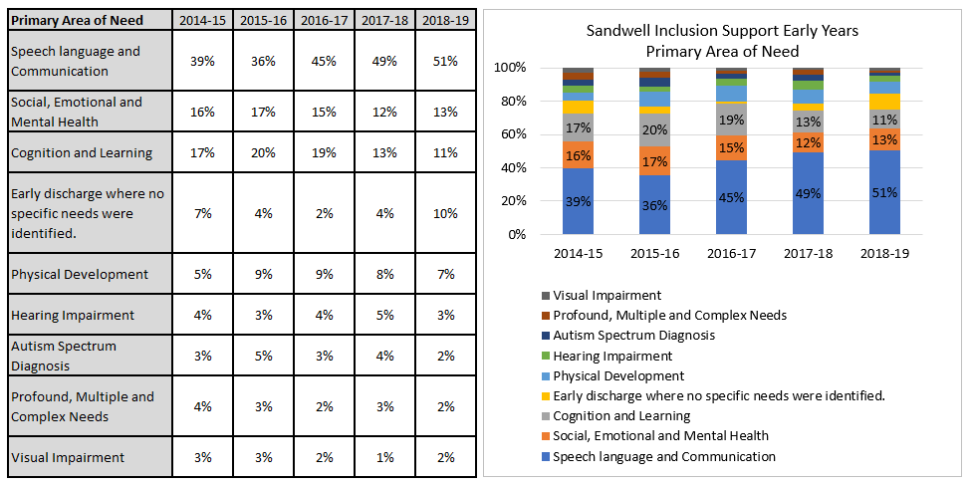

Source: Sandwell MBC ISEY & CDC

Similarly, to the national trend[5], the largest primary areas of need for children accessing ISEY services are ‘Speech language and Communication’. Half of the children accessing ISEY services required Speech language and Communication support as their primary need. 49% (149) in 2017-18 and 51% (197) in 2018-19. The proportion of children requiring speech language and communication’ support is increasing.

Historically the second highest proportion of children accessing ISEY services have required cognition and learning support. This proportion has been declining from 20% in 2015-16 to 11% in 2018-19.

**Figure 3.16: 2018-19 Age at referral into Inclusion Support Early Years**

35% of the children referred/ accessing the Inclusion Support Early Years’ service are aged 2 and 32% are aged 4.

## Education, Health and Care Plans

An Education, Health and Care (EHC) plan sets out the education, health and care support that is to be provided to a child or young person aged 0-25 years who has Special Educational Needs or a Disability (SEND). It is drawn up by the local authority after an EHC needs assessment of the child or young person, in consultation with relevant partner agencies, parents and the child or young person themselves.

The Department for Education commissioned a national survey in 2016[6], with the aim of understanding recipient’s experiences of the EHC processes across local authorities. Local provisions should be reviewed with considerations to this research findings.

There were 2503 children and young people with Education, Health and Care plans maintained by Sandwell local Authority in the 2021 calendar year[7]. This is an increase of 45.8% since 2018 for ages 0-25. 2.1% (52) of the total EHC plans are for children aged under 5 years of age. This is a lower proportion than England at 3.8% and the West Midlands region at 3.3%.

**Figure 3.17: Number of Education, Health and Care Plans by gender (0-5 year olds)**

Source: Sandwell MBC SEN Service – ONE system

* For 2018-19, Sandwell SEN Services had 120 children aged 0-5 years with a EHCP.
* 53% of the 120 EHCPs in 2018-19 were first issued at age 4; 28% at age 3; 18% at age 5 and 2% at age 2 years.
* Similarly, to the national trend, there are more boys than girls with an EHCP. 67% of the EHCPs in 2018-19 are for boys.
* Using the 2018 mid-year population estimates for Sandwell, for every 1000 boys aged 0-5; 5.4 have a EHCP and for every 1000 girls; 2.9 have a EHCP.
* There has been a large increase in numbers since 2014-15, but between 2015-16 and 2018-19 there has not been any substantial change.

**Figure 3.18: Prevalence of Education, Health and Care Plans by town (0-5 year olds)**

Source: Sandwell MBC SEN Service - ONE system; 2017 ONS Mid-Year Population Estimates

* The highest proportion of children known to SEN services with ECHPs are from West Bromwich. In 2018-19, 26% of children with EHCP were from West Bromwich. However, the rate is the highest in Tipton with a rate of 5.5 children in every 1000 aged 0-5 known to SEN services with EHCP.
* Tipton has the highest rate followed by Wednesbury.
* As can be seen from figure 3.18 above, Tipton and Wednesbury have historically had higher rates than Sandwell.

42%[8] of the children aged 0-5 known to SEN services with a EHCP are from a White British ethnic background, this is followed by Pakistani, Indian and Black African background.

**Figure 3.19: SEN Primary Area of Need**

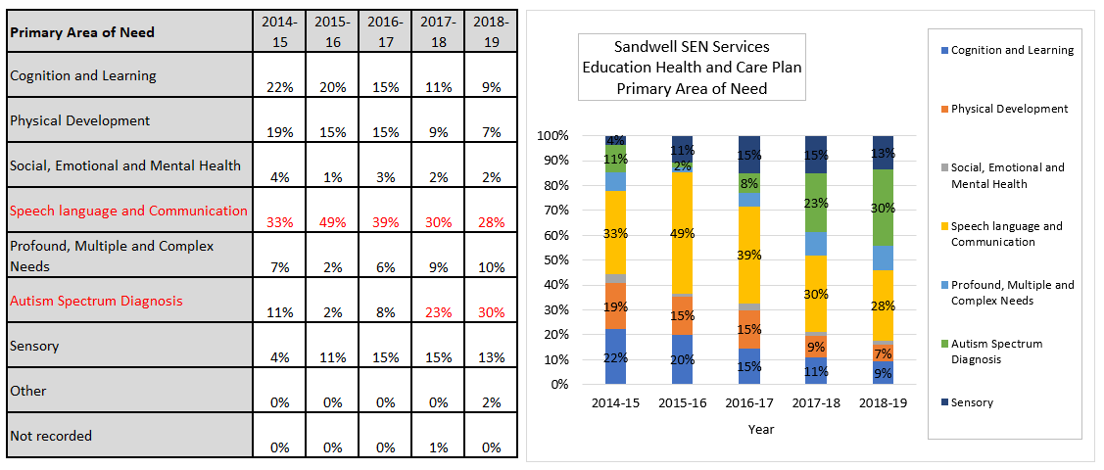

Source: Sandwell SMBC SEN services

* Historically, the majority of the children aged 0-5, accessing SEN services with a EHCP have had speech language and communication as their primary need. Over the past five years, this has been steadily declining. In 2018-19, 28% (33) of the total children with EHCP had speech language and communication as their primary need.
* 8% (11) of the children accessing SEN services with a EHCP had their primary need as Autism Spectrum Diagnosis in 2016-17. The proportion of children known to SEN services with Autism Spectrum Diagnosis as primary need has increased to 30% (36) in 2018-19.

## Counselling Psychology

This a new 0-5 early years service for Sandwell and forms part of the early years Multi-agency Assessment for Autism (MAA) pathway. The service is supported by Paediatricians, Counselling Psychology, Therapy Services, Inclusion Support services, and ISEY/CDC Service. Between August 2018 to November 2019, 66 referrals were made to Counselling Psychology services from ISEY/CDC.

* 31 children received a psychology assessment and did not require an MAA to be initiated.
* 35 Multi Agency Assessments for Autism were initiated - of those, 7 received a diagnosis of Autism and 28 are undergoing an assessment for Autism and have a date for outcome of assessment.
* Data shows 31 children were referred to Counselling Psychology within 12 months of a referral into ISEY, 4 within 12-24 months and 3 within 25-30months.
* The majority of the children referred were referred at age 2 years old.
* Whilst children receive support post diagnosis from ISEY/CDC and Psychology this is an area for development.

## Visual Impairment

In 2018-2019, there was a total of 37 children aged 0-5 referred for visual impairments. Data from the last 4 years shows a decline in the number of children being referred from 55 in 2015-2016 to 37 in 2018-19. Historically there have been more boys than girls referred, however figure 3.20 below, shows that in the most recent year there has been almost an even split between boys and girls being referred.

**Figure 3.20: Sandwell Inclusion Support - Vision Impairment Referral - 0-5 years old**

Source: SMBC Inclusion Support – Sensory Team

Figure 3.21 shows that the majority of referrals are made in the very early years. Majority of the referrals for vision impairment are made for children under 2 years old.

**Figure 3.21: Age at referral Inclusion Support Services - Vision Impairment services**

Source: SMBC Inclusion Support – Sensory Team

* 41%[9] of the children aged 0-5 referred to vision impairment services are from a White British ethnic background, this is followed by Indian, Pakistani, and Other White ethnicity.
* Although data is collected on child’s town of residence, due to small numbers the full analysis is not provided here for each town. 2018–2019 shows Tipton as having the highest rate at 2.1 per 1,000 children, followed by Oldbury at 1.9 per 1,000 children aged 0-5. This is higher than the overall rate for Sandwell at 12.6.

Figure 3.22 shows a substantial decline in the number of referrals from Health Services, from 30 (55% of total referrals received) in 2015-16 to 11 (30% of the total number of referrals) in 2018-2019. In comparison, the referrals from ISEY have been steadily increasing since 2015-2016 at 12 (22% of total referrals) to 10 (41% total referrals) in 2018-2019.

**Figure 3.22: Vision Impairment Services - Child Referral Point**

Source: SMBC Inclusion Support – Sensory Team

## Hearing Impairment

There has been a steady increase over the past 5 years in the number of referrals received for children aged 0-5 years old with hearing impairments. Since 2014-15 to 2018-19, there has been a 45% increase in the number of referrals. In 2018-19, there was 55 referrals; a rate of 2.1 children for every 1,000 0-5-year olds in Sandwell.

**Figure 3.23: Inclusion Support - Number of Hearing Impairment Referrals (0-5 year olds)**

Source: SMBC Inclusion Support – Sensory Team

Figure 3.24 below shows that there are more boys than girls being referred with hearing impairments.

**Figure 3.24: Hearing Impairment Referral - 0-5 years old**

Source: SMBC Inclusion Support – Sensory Team

Over the past five years there has been a change in the age groups being referred for hearing impairment. Figure 3.24 below shows that hearing impairment services previously had a high proportion of children under the age of 1 year old. More recently, there are more children aged 3-5 years old.

**Figure 3.25: Age at referral Inclusion Support Services - Vision Impairment services**

Source: SMBC Inclusion Support – Sensory Team

Similar to referrals for vision impairments, 33% of the children aged 0-5 referred for hearing impairment are from a White British ethnic background, this is followed by Indian, Pakistani, and Other White ethnicity.

Although data is collected on child’s town of residence, due to small numbers the full analysis is not provided here for each town. 2018-2019 shows Smethwick as having the highest rate at 2.5 per 1,000 children, followed by Oldbury at 2.4 per 1,000 children aged 0-5. This is higher than the overall rate for Sandwell at 2.1 per 1000 children.

Figure 3.26 below, shows that most referrals are made by through health services. This is followed by referrals from the Newborn Hearing Screening Programme.

**Figure 3.26: Hearing Impairment - Child Referral Point**

Source: SMBC Inclusion Support – Sensory Team

## Autism Spectrum Disorder

Children with Autism Spectrum Disorder (ASD) have a combination of difficulties with verbal communication and interaction. Diagnosis is particularly difficult for children aged 0-5 due to the development stages that a child aged 0-5 would still be going through.

In Sandwell, 1.9 children per 1000 aged 0-5 have an ASD diagnosis. The rate has been increasing since 2016/17.

**Figure 3.27: Sandwell Autism Spectrum Disorder Prevalence (0-5 year olds)**

Source: SMBC Inclusion Support: Complex Communication and Autism

Boys in Sandwell have a higher rate of diagnosis. The rate is substantially higher than the rate for girls. In 2018-19, 3.0 boys were diagnosed with ASD in every 1,000 boys aged 0-5. In comparison the rate for girls is much lower at 0.6.

In comparison to the previous year; 2017-18, the rate for boys has increased from 1.7 to 3.0.

**Figure 3.28: Sandwell** **Autism Spectrum Disorder Prevalence by Gender (0-5 year olds)**

Source: SMBC Inclusion Support: Complex Communication and Autism

Figure 3.29 below shows that Rowley Regis[10] had the highest rate of referrals at 3.2 diagnosis per 1000 children aged 0-5. This is substantially higher than Sandwell’s overall rate. The second highest rate is seen in Oldbury.

**Figure 3.29: Sandwell Autism Spectrum Disorder Prevalence by Town**

Source: SMBC Inclusion Support: Complex Communication and Autism

## Children’s Therapy Service

Speech and Language therapists work with children who may have difficulties with speech sounds, language, stammering, feeding difficulties or their voice. Physiotherapists work with children who may have difficulties with mobility, muscle weakness, balance, or development. Occupational therapists work with children and young people who have a physical disability that affects participation in everyday activities. The difficulties may impact upon play, leisure and/or access to education. Physical conditions that might affect the child include cerebral palsy and dyspraxia.

In 2018/19, there were 4,818 referrals to the Children’s Therapy Service in Sandwell. Of these, 1,252 (26%) were for children aged 0-5. There has been an 8.9% increase in the number of 0-5 referrals since 2017/18. The majority of these children are from within Sandwell – however a small number may be out-of-borough as data is gathered on the basis of GP rather than home address.

The highest number of referrals among 0-5 year olds is for speech and language therapy.

**Figure 3.30: Referrals to Sandwell Children’s Therapy Service by service area: Aged 0-5**

Source: Sandwell & West Birmingham NHS Trust

The greatest number of referrals is for children aged 2, 3 or 4, although there has been an increase in the number of referrals aged 1 or under 1 since 2017/18 (+53.5% and +20.1% respectively).

**Figure 3.31: Referrals to Sandwell Children’s Therapy Service by age: Aged 0-5**

Source: Sandwell & West Birmingham NHS Trust

Boys make up a much larger proportion of referrals than girls. In 2018/19, 60.1% of referrals were boys (aged 0-5).

**Figure 3.32: Referrals to Sandwell Children’s Therapy Service by ethnicity: Aged 0-5**

Source: Sandwell & West Birmingham NHS Trust

In terms of ethnicity, the largest proportion of referrals in 2018/19 was from White and Asian groups (35% and 27% respectively). This is a similar pattern to 2017/18.

**Figure 3.33: Referrals to Sandwell Children’s Therapy Service by source: Aged 0-5**

**\*** Only sources where there were more than 10 referrals in 2018/19

Source: Sandwell & West Birmingham NHS Trust

The most common source of referral in 2018/19 is “self-referral”, with 740 (59.1%) referrals from this source. The second most common source of referral is “hospital/consultant referral”, with 205 referrals from this source in 2018/19 (16.4%).

# Current service provision

Maternity Services in Sandwell

Maternity services are defined as the provision of care to women and their partners who are pregnant or have recently given birth. The lead health professional is either the midwife or the consultant Obstetrician. The service has three distinct areas:

* **Antenatal care**: predominantly provided in community settings
* **Intra partum care**: the birth episode - in Sandwell women can access home birth, hospital birth or birth within a Midwife Led Unit
* **Postnatal care**, including the health and well-being of newborn babies: normally provided for 10 days within the family home

Additionally, Perinatal mental health services are available across the whole maternity pathway in conjunction with mental health services.

Sandwell and West Birmingham Clinical Commissioning Group (CCG) are responsible for commissioning maternity care in Sandwell. The CCG ensures that Sandwell & West Birmingham Hospital Trust provide a high quality, clinically safe, and cost-effective maternity service which offers choice to women and their partners (choice of how to access the service, choice of type of antenatal care, choice of birth place and choice of postnatal care), with a key focus on normalising birth and promoting healthy lifestyles during pregnancy and in the early years, appropriate to their clinical condition. Maternity care in Sandwell is provided in accordance with the requirements of the latest national policy guidance, evidence and best practice and reflects the local needs and priorities of women and families within Sandwell.

City Hospital located in Birmingham is the current provider of maternity services for women in Sandwell. The choice agenda allows women to choose their place of birth, and currently approximately 40% of women residing in Sandwell are choosing to deliver their babies in a hospital located in the Black Country (Walsall, Wolverhampton or Dudley).

Maternity services are available 24 hours a day 365 days a year, including an ‘out of hours’ service for community concerns. Arrangements are in place to ensure women can access advice/services 24 hours a day 365 days a year.

## Primary Care

Sandwell and West Birmingham Clinical Commissioning Group currently commission services for the Sandwell population, and are part of the wider Black Country and West Birmingham STP area.

There are 53 GP Practices in Sandwell itself, that are grouped together into 10 Primary Care Networks. There is an identified clinical lead for Children and Maternity Services along with a lead GP in each network.

Sandwell Care Alliance (which includes commissioners and providers within Primary Care, NHS Trusts, Local Authority and VCS) has been established to create integrated care systems. School Readiness has been identified as a priority area for service improvement.

In addition to their general appointments, GP practices are contracted to provide ante and post-natal primary medical services alongside the care provided through Maternity Services. At 6-8 weeks post-delivery they carry out a newborn infant physical examination. They also provide immunisations, Child Health Surveillance and management of chronic conditions. In common with all professionals working directly with families they have an important role in safeguarding children and sharing information where children are identified as being at risk. From 2020/21 the GP Contract will also include a universal 6-8 week postnatal check for mothers. There will also be a bigger emphasis on pre-conceptual advice and care, specifically an annual review of women of childbearing age being prescribed Valproate, because of the risk of neurodevelopmental disorders and birth defects.

With the recent development of the Primary Care Networks, there has been additional national funding to develop new ‘Social Prescribing’ link worker roles. This development is at an early stage in Sandwell, but presents an opportunity to support young families in a different way, by helping them to access community-based opportunities to help maintain their health and wellbeing and reduce social isolation.

## Health Visiting Service

The Health Visiting service work in partnership to deliver services to children, young people and families. The service works alongside all stakeholders/agencies to deliver the health visiting service offer at 4 levels;

* **Your community** offers a range of services, including some Sure Start Children’s Centre services and the services families and communities provide for themselves. Health visitors work to develop these and make sure local families know about them.
* **Universal services** from the health visitor team working with general practice to ensure that families can access the Healthy Child Programme, and that parents are supported at key times and have access to a range of community services. The Universal offer from the service includes:
* Antenatal contact
* New birth visit at 10-14 days
* 6-8 weeks review
* 9-12 month development review
* 2-2.5 years development review
* **Universal plus** offers rapid response from the local health visiting team when specific expert help is needed for example with postnatal depression, a sleepless baby, weaning or answering any concerns about parenting.
* **Universal partnership plus** provides ongoing support from the health visiting team and a range of local services to deal with more complex issues over a period of time. These include services from Sure Start Children’s Centres, other community services including charities and, where appropriate, the Family Nurse Partnership

The health visiting service aims to support positive outcomes for children, young people and families. Health visitors lead and deliver the Healthy Child Programme ensuring all children get essential support and services. Health visitors provide ongoing support as part of range of local services working together with all families, including those with complex issues. Best Start are part of the health visiting service delivering services to vulnerable families within Sandwell.

## School Health Nursing Service

The School Health Nursing Service in Sandwell is currently provided by Sandwell and West Birmingham Hospital NHS Trust.

To support transition to school reception, the school nurses work with schools to identify opportunities to engage with parents (e.g. at introductory parents’ meetings), offering advice and brief intervention where necessary in the summer prior to children starting reception so that any outstanding concerns can be addressed.

All parents of children starting primary school in their reception year are provided with information about the role of the service and the process for self-referral to access further information and advice.

Children that have been identified by the Health Visiting Service as having additional health needs should have an active handover to the School Health Nursing Service, including a detailed transfer of care plan and review schedule, within the first term of children starting school. This includes a face to face handover between the health visitor and school nurse for those children and families most at risk.

All children are weighed and measured by the School Health Nursing Service in their reception year as part of the National Child Measurement Programme (NCMP).

## Children’s Centres

Sandwell has 7 core children’s centres across the borough with one in each town and two in West Bromwich. Core centres have a broad role:

* Providing information and advice to parents about local services.
* Running antenatal education classes in conjunction with midwives and health visitors.
* Offering a venue for community-based midwife clinics.
* Providing a venue for local Health Visitor clinics.
* Offering a range of early years activities both in the children’s centres but also at other venues in the community.
* Working with parents on the Play, Talk, Read programme which promotes the importance of early language development and home learning.
* Offering speech and language clinics for children and parents to identify delay and support language development.
* Provide parenting programmes at centres and other venues. The principal courses offered are Changes, the Solihull approach and Positive Parenting.
* Offering a comprehensive support service for families who are experiencing problems on a range of issues.
* Centres work in conjunction with Sandwell Consortium to offer welfare rights advice and support to individual families with appointments at children’s centres.
* Supporting parents to take steps towards further education and employment when they are ready. Many parents as a first step put themselves forward as a volunteer for the service to gain valuable experience and training.
* Many of the centres offer access to childcare services run by third party agencies on site.

The core centres in Rowley and Tipton are currently managed on behalf of the local authority by Murray Hall Community Trust, whilst those in Oldbury, Smethwick, Wednesbury and West Bromwich are currently managed on behalf of the local authority by Action for Children.

There are other centres in the borough which largely provide childcare places for preschool children although some are also venues for other community activities.

## Inclusive Learning Services

1. **Inclusion Support Early Years (ISEY) and Child Development Centre (CDC)**

This is a specialist service jointly commissioned with Health and Education, and is a multidisciplinary team providing a range of education and health services in the home, in the community and at the Coneygree Early Years Centre in Sandwell to children with Special Educational Needs and Disability (SEND). Paediatric Clinics, therapy sessions and specialist playgroups are held at the Coneygree Centre as part of the work of the Child Development Centre. An open referral pathway is operated, and support should commence within 4 weeks of referral - a waiting list is not held. The service provides a range of assessments, support and strategies to children 0-5 years who are not accessing a Local Authority Nursery or Reception class, who have difficulties with their cognitive development and at least one other area.

Four areas of need are:

* Cognition and Learning (C&L)
* Social, Emotional and Mental Health (SEMH)
* Physical Development to include Sensory Impairment (Hearing and/or Vision) (PD, HI, VI)
* Speech, language and communication needs (SLCN)

Successful transition planning into school is an important aspect of the work, and 0-5 Children Adolescent, Mental Health Service (CAMHS) Counselling Psychology forms part of the early years work within the Multiagency Assessment of Autism (MAA) pathway.

The service provides Early Years Intervention Grant (EYIG) funding for children with SEND in early years settings where appropriate, and provides training to a wide range of early years providers such as Children Centres, early years childcare and nursery settings and schools.

1. **Sensory Support Team**

The Sensory Support Team work with children/young people and their families in Sandwell, who have a hearing or visual impairment.

There is a statutory responsibility to provide specialist advice, support and teaching to children and young people with disabilities. The role of the service includes; giving advice, direct teaching, offering support, monitoring access/provision and training staff in settings. New born screening for hearing is carried out in line with other new born screening. When a baby fails the screening, consent is obtained by parent/carers to refer into the Sensory Support Team. Referral usually takes place the same day by telephone and followed up by a letter. The Sensory Support Team, who respond within 48 hours in line with best practice guidance [National Sensory Impairment Partnership (NATSIP)], arrange a visit at the family’s convenience to commence support. For other referrals which may require support during a child’s early years, a referral is made to Inclusion Support via an open referral pathway. Upon acceptance support should commence within 3 months.

1. **Educational and Child Psychologists**

The Educational and Child Psychology Service has a statutory responsibility to provide specialist advice, assessment and support to children and Young People with SEND. A referral is by consent from parents/carers. It can be made internally, by professionals within Inclusive Learning Services and schools. Upon acceptance support should commence within 3 months.

1. **Social, Emotional and Mental Health Team**

The Social, Emotional and Mental Health Team provide advice and support to children and young people who present with SEMH difficulties in schools and Academies in Sandwell. They also offer training and support to schools and Academies, and liaise with Inclusion Support Early Years where children with SEMH needs have been identified, providing support following transition into school as required. A referral is by consent from parents/carers. It can be made internally, by professionals within Inclusive Learning Services and schools. Upon acceptance support should commence within 3 months.

1. **Complex Communication and Autism Team**

The Complex Communication and Autism Team provide advice and support to children and young people who attend schools and Academies in Sandwell. They also provide training to schools. The team are partners in the Autism Spectrum Disorder (ASD) Multi-Agency Assessment (MAA) process for children and young people who live in Sandwell aged up to 16, or 18 if they attend a school or Academy. A referral is by consent from parents/carers. It can be made internally, by professionals within Inclusive Learning Services and schools. Upon acceptance support should commence within 3 months.

1. **Advisory Teachers for Learning**

Advisory Teachers for Learningprovide support for pupils and young people who attend Schools and Academies in Sandwell; supporting in a variety of ways including assessing the learning of pupils and young people identifying specific learning difficulties, delivering training advising school staff and other school strategic developments. A referral is by consent from parents/ carers. It can be made internally, by professionals within Inclusive Learning Services and schools. Upon acceptance support should commence within 3 months.

1. **Special Educational Needs Department**

The Statutory SEN Service are responsible for delivering some of the statutory responsibilities of Sandwell Local Authority in regard to special educational needs for children and young people aged 0 to 25. This includes, but is not limited to Education, Health and Care needs assessments and annual reviews.

Local authorities (“**LAs**”) have legal duties to identify and assess the special educational needs (“**SEN**”) of children and young people for whom they are responsible. LAs become responsible for a child or young person in their area when they become aware that the child or young person has or may have SEN.

Under the Children and Families Act 2014, the LA must always think about how the child or young person can be supported to facilitate their development and to help them achieve the “***best possible educational and other outcomes***”.

If a child is educated in an early years setting, a school or a post-16 institution, then that setting has duties to support that child – in particular, through SEN Support. If a child or young person needs, or may need, more support than their school or other setting can give them, then the LA must carry out an Education, Health and Care (EHC) Needs assessment. This assessment may lead to an EHC plan being produced for them. An EHC plan will set out the additional support the child or young person needs and the school or other institution they will go to.

Once special educational provision has been specified in an EHC plan, the LA has a **legal duty to provide it**. This cannot be overruled by the LA’s SEN funding policy or other internal funding arrangements.

## Sandwell Library Service

Libraries are safe, accessible, conveniently located community hubs with a strong family and community focus. They offer opportunities for learning and improving health and wellbeing, give access to creative arts and heritage, and support the local economy.

* Libraries provide spaces for formal and informal learning, and offer opportunities to improve life skills through volunteering, work experience and apprenticeships. They support digital inclusion and work innovatively with partners to deliver service transformation.
* Libraries are safe community hubs at the heart of their communities and are used by all sections of those communities. They provide family activities and creative arts that bring different groups together. They support social cohesion and preserve and celebrate the diverse heritage and distinctiveness of Sandwell’s towns and neighbourhoods.
* Libraries work in partnership with health providers to deliver services, resources, and activities that improve health and wellbeing.
* Libraries are accessible to all, conveniently located, delivering free or low-cost services. They promote reading for pleasure as an essential skill to improve life chances and work closely with parents and schools to offer services and activities that support the curriculum and improve literacy levels.

Libraries support the child’s journey from pre-natal to birth, preschool to primary school and the transition beyond. They do this by:

* Engaging with children both in school/nursery (through regular class/nursery visits) and out of school. They host regular Under 5’s activities which are free of charge. Through regular Storytime activities, they inspire parents to read and rhyme with their child.
* Libraries co-ordinate and gift free Bookstart packs to every child between 0-12 months and 3-4 years. Libraries do this through working in partnership with health visitors, speech and language therapists, schools and nurseries.   
    
  Bookstart aims to encourage a love of books, stories and rhymes in children (from newborn+). Bookstart packs come in various formats; Newborn and Baby (0-12 months); Treasure (3-4 years); Dual Language; and Additional needs packs (which includes Bookshine for children who are deaf, Booktouch for children who are blind or partially sighted, and Bookstart Star for children with conditions affecting their fine motor skills). Through the Bookstart scheme:
* Libraries increase parental involvement in their child’s reader development.
* Support language / communication development, early literacy and school readiness.
* Build children’s resilience and character - supporting attachment, resilience, emotional health and wellbeing.

# Recommendations

## Preconception and Pregnancy

* Develop an overarching strategy for preconception, maternity and early years interventions and services, in order to improve outcomes and reduce inequalities, with a focus on the first 1001 days of a child’s life.
* Promoting maternal health in the preconceptual period, ensuring that healthy pregnancy advice is delivered through targeted Primary Care clinics, Contraceptive Services, Health Visiting and promoted via all media channels. This should include advice about nutrition and exercise, substance misuse, sexual health, mental health and wellbeing, vaccinations, medical and hereditary conditions.
* Promote the importance of planned and spaced pregnancies, in particular improving access to contraception for young and/or vulnerable women or families where there are safeguarding concerns.
* Ensure women with existing medical needs are supported and advised throughout their care on how to prepare for future pregnancy.
* Promoting and supporting early access to maternity care by developing a self-referral system for families to book directly.
* Ensure that maternity advice and provision is accessible and appropriate to meet the needs of non-UK mothers and mothers from BAME communities who are at higher risk of poor pregnancy outcomes, taking into account differences in language and levels of health literacy.
* Improve consistency of CO monitoring in the maternity and post-natal pathways, making sure that we are doing everything possible to make it easy for pregnant women and their families to give up smoking and reduce tobacco exposure in the home. (Saving Babies Lives 2)
* Improve brief advice and referral for alcohol and substance misuse during pregnancy, taking into account both the clinical and safeguarding risks involved.
* Provide tailored support for teenage mothers and their partners in line with best practice guidance.
* Support families to prepare for the emotional and practical demands of parenthood.
* Review interventions, pathways, and services to promote maternal wellbeing and mental health, including access to community-level support to reduce social isolation.
* Develop pathways that link families to support and services that help with welfare benefits, housing, immigration, food poverty, education and employment etc.
* Continue with implementation of ‘Saving Babies Lives’ in order to reduce risk of poor perinatal outcomes as part of the Local Maternity Strategy.
* Undertake detailed local analysis of Infant Mortality data in order to better understand drivers behind Sandwell’s high rates and where we need to focus our resources and improve services and practice.
* All services to move beyond ‘advice-giving’ to develop more psychologically-informed approaches to promoting health lifestyles and safe parenting practices.

## Early Years

* Review changing needs and current and future provision of childcare and early years education in the light of the impact of COVID-19.
* Continue to promote breastfeeding and improve the rate of breastfeeding at 6 to 8 weeks.
* Monitor A&E attendances and admissions for 0-4 year olds. Encourage parents to avoid unnecessary attendances by making more appropriate use of Primary Care services.
* Increase understanding of child development by the early years workforce and families themselves, and the opportunities to promote that development through everyday interactions and play.
* Develop and implement and monitor an agreed local multi-agency pathway to improve the speech, communication and language of babies and children, identifying opportunities for early intervention through screening and evidence-based interventions. In order to reduce inequalities, particular attention needs to be made to the needs of boys and children whose first language is not English. (Universal, Blackcountry and SEND)
* Agencies should work alongside families to provide a secure environment that lays down the foundations for emotional resilience and good mental health. In particular, secure attachment, positive parental and child emotional wellbeing, parenting skills, and an active, healthy lifestyle should be supported.
* Encourage healthy eating, cooking skills and physical activity in the home, early years and community settings as part of a ‘whole community’ approach that recognises the challenges of food poverty, access to safe green space, and the impact of fast food outlets.
* Continue to promote oral health and ensure children are registered with a dentist.
* Increase awareness and uptake of early years vaccinations focusing particularly on MMR.
* Support families to connect with and contribute to their local community, through the development of social networks and engagement with education, training, volunteering and employment opportunities.
* Undertake a workforce mapping exercise to gain better understanding of capacity within the whole system of prevention and early intervention for families.
* develop a multi-agency training strategy that will ensure the priority areas for action are understood and delivered consistently.

## Vulnerable Children and Families

### Early Help

* Continue to build relationships between the Trust and key stakeholders such as Health and Education with a focus upon Early Help and Lead Practitioners, so that all agencies have a clear grip on their role within Early help and families receive the right intervention at the earliest opportunity.
* Sandwell Unborn Baby Network, to be embedded with all partners to ensure Early Help is offered at the earliest opportunity.
* Work with partners across the borough to ensure children for all ethnicity’s have access to services as required and there are no barriers to participation. Meetings have already commenced to look at Over and Under representation across the partnership in Sandwell.
* Continue to embed and grow the links with SCVO colleagues who can enhance and support services available to 0-5 across the borough and look to use more community based assets.

### SEND – Early Identification and Support

* Promote the health, well-being, resilience and independence of vulnerable families living in Sandwell, helping to raise aspirations, break cycles of intergenerational deprivation and poor outcomes.
* Review and strengthen pathways of care and partnership working for families with complex and social needs.
* Continue to focus on ensuring that that there are robust pre-birth assessments for vulnerable and complex families so that the right level of support and intervention can be put in place at the earliest possible stage.
* Further research and investigation is required to understand the reasons behind inequalities in the intervention rates for different ethnic groups in the social care system, and whether this is a reflection of need or over/under identification. This is a complex issue which requires analysis of the interaction between racism, ethnicity, socio-economic circumstances, service provision and wider policies.
* Improve multi-agency safeguarding practice in relation to the key themes identified through case audits and practice reviews.
* Maintain as a priority, sufficient social care staffing resource to work towards enabling more children to safely exit from Care.

Section Two:  
Sandwell 5-19/25’s JSNA   
2022

# Section Two: Sandwell 5-19/25’s JSNA

Demographics 96

Population 96

Growing Diversity Amongst our Young People 97

5-19/25: Overview 99

Child Health and Behaviours 100

Healthy Weight 100

Children’s Physical Activity 101

Teenage Conceptions 102

Substance Misuse 104

Hospital Admissions Caused by Injury 105

Homelessness 105

Low Income Families 106

Not in Education, Employment or Training (NEETS) 107

Crime 108

# Demographics: 5-19/25 Years

Population:



* 67,475 children and young people aged 5-19 live in Sandwell and 90,566 aged 5-25.
* The 5-19 age group represent 20.5% of Sandwell’s total population and 5-25 age group, 27.5%.
* Almost half of Sandwell’s 5-19 year olds live in either West Bromwich (23.8%) or Smethwick (21.4%). The town with the highest proportions of 5-19 year olds is Smethwick town (23.5%), and the lowest proportion live in Rowley Regis (19.2%).
* Ward proportions for 5-19 year olds vary from 16.9% in Charlemont and Grove Vale to 26.1% in Soho and Victoria ward.
* Sandwell has higher proportions of both the 5-19 and 5-25 year age groups, than the England proportions. 20.5% of Sandwell residents are aged 5-19 years and 27.5% aged 5-25, compared to 17.8% and 25.3% for England.

Source: (2020 ONS Estimates)

Growing Diversity Amongst our Young People:

Sandwell is a diverse borough and this is reflected in our young population. In fact, there is greater diversity amongst our young population than our older population. This is demonstrated in figure 4.1 below, where the 2011 census data shows Sandwell’s 5-19 year olds to be the most diverse with an increase in the Asian, Mixed and Black ethnic groups compared to the 2001 census. The black 5-19 year old population had almost doubled since 2001.

In 2011 England and West Midlands had a proportion of 84.3% and 81.0%, respectively, of young people (0-19 years) that are White. However, Sandwell had 59.6%, many of whom are non-white British. Therefore, more than 40% of Sandwell young people population were from Mixed, Asian, Black or other groups. Further, the Asian population actually represented a quarter of Sandwell’s young people (0-19 years) population (24.2%).

Analysis of the 2011 Sandwell’s total population (all ages) religion showed the population as:

55% Christian (2001 census = 68%)

9% Sikh (2001 census = 7%)

8% Muslim (2001 census = 5%)

2% Hindu (2001 census = 2%)

19% as having no religion (2001 census = 11%)

7% as Unknown (2001 census = 6%)

As mentioned above, Sandwell has become more diverse and this was also reflected in the changes to the proportions of religion. From 2001 to 2011; Christianity had reduced by 13% and those having no religion had increased by 8%. Sikhs and Muslims had also increased.

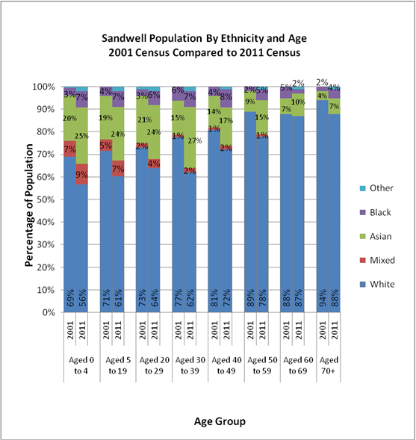**Figure 4.1: Sandwell Population by Ethnicity and Age**

5 – 19/25 Years: Overview

**Figure 4.2: Sandwell Overview - Indicators**

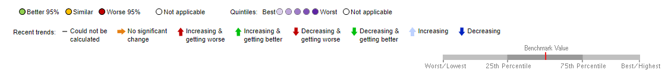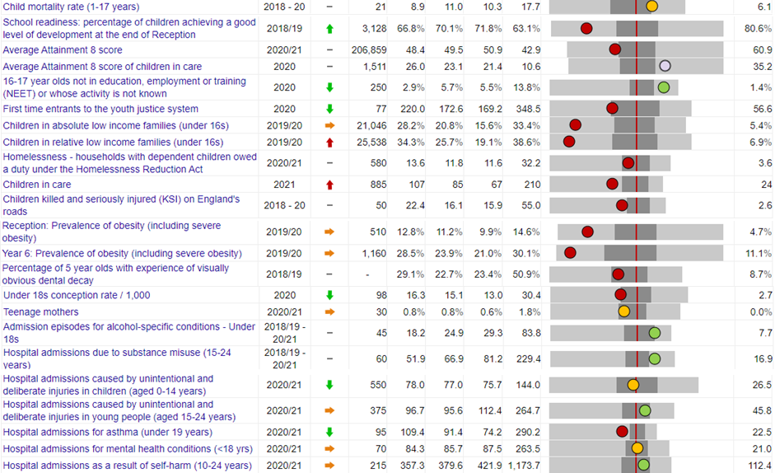

Source: Office for Health Improvement and Disparities, Fingertips

For Sandwell to become prosperous, the children who become young adults need to achieve in school or work placement, and be supported to develop wider skills and aspirations, leading to being healthy both physically and mentally.

For Sandwell Council to nurture these aspiring young adults, there needs to be good quality education and enabling environments against risk factors.

School readiness reception to year 1 (4-5yrs):

As mentioned previously, in 2018/19 in Sandwell only 2 in 3 (66.8) of children achieved a good level of development at the end of reception year. This is lower than the national average of 71.8%, this 5% difference is the equivalent of 156 less children in Sandwell than at national levels.

## Child health and behaviours

Healthy weight:

Children who are obese having a tenfold risk of being an obese adult, there is national concern about the rise of childhood obesity. The risk of obesity in adulthood increases with age, an obese child at 13 is more likely to become an obese adult than an obese 5 year old. The health consequences of childhood obesity include; glucose intolerance, Type 2 diabetes, hypertension, exacerbation of conditions such as asthma and psychological problems such as social isolation, low self-esteem, teasing and bullying.

The proportion of children who are overweight or obese in Sandwell is slightly higher than the national average in both reception year and year 6. In reception year in Sandwell the proportion of children who are overweight (including obese) at reception and year 6 are 12.6% and 28.5% compared to 9.9% and 21.0% nationally. Locally the proportion of children who are overweight (inc obese) in reception have remained stable fluctuating between 11.1% and 13% increasing slightly in year 6. This is similar to the national trend.

Public Health Commission the school nursing programme which is mandated to measure children in reception and year 6. This service supports families with advice and sign posting for those that are found to be overweight or obese. In addition to school nursing Public Health commission a lead who supports the development of health content in the Personal Health and Social education (PHSE).

There are also a number of funded activity programmes across schools encouraging healthy lifestyles including healthy food choices, increasing physical activities and many sporting events to encourage children and young people into sports and activities. More a plan throughout the Common Wealth Games with legacy events.

Additionally, water activities have also been funded by Public Health which has continued to be commissioned with an expansion of free swimming lessons to increase activity in light of the new Aquatics Centre being built in Sandwell and increasing water safety

**Figure 4.3: Prevalence of obesity in Reception aged children**

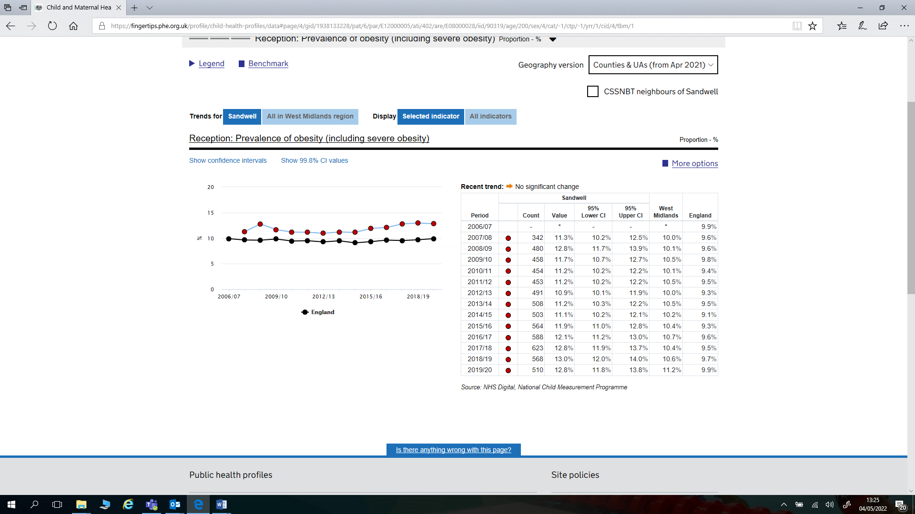

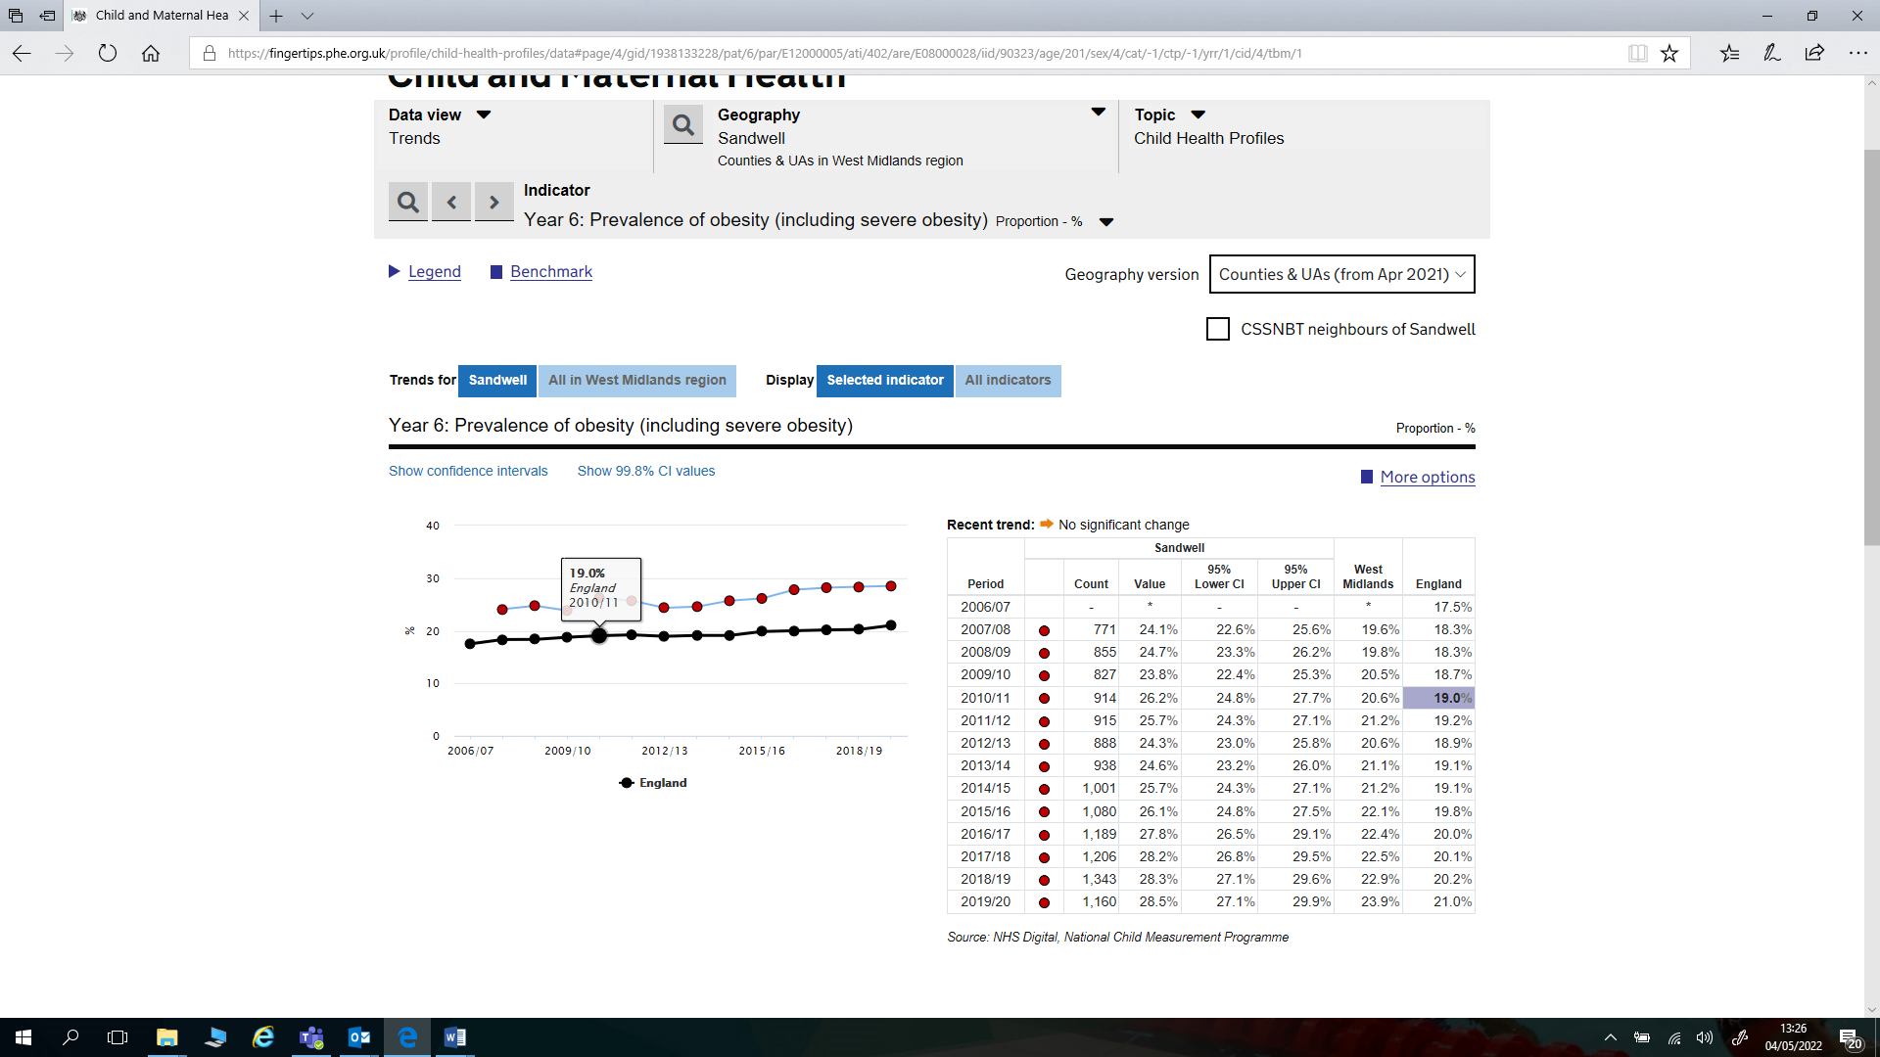**Figure 4.4: Prevalence of obesity in year 6 children**

Children’s Physical Activity:

There are many benefits of why children should exercise daily, these include stronger bones and muscles, a healthier body weight, reduced risk of longer term conditions like diabetes, better mental well-being, improved self-confidence, positive social contact and better academic attainment (Get Active Sports, 2022).

In the UK, it is recommended that children and young people aged 5 to 18 should aim for an average of at least 60 minutes of moderate or vigorous intensity physical activity a day across the week.  They should take part in a variety of types and intensities of physical activity across the week to develop movement skills, muscles and bones.  Finally, they should reduce the time spent sitting or lying down and break up long periods of not moving with some activity (NHS, 2022).

Like many socioeconomically deprived areas, Sandwell has previously seen relatively low levels of physical activity among children and young people.  More specifically, significantly less children in Sandwell were meeting the recommended levels of activity described above. However, since 2019, we have seen marked improvements in this outcome, to the point that the latest data sows Sandwell’s children and young people to be the fourth most active in the country.

**Figure 4.5: Percentage of children meeting recommended physical activity**

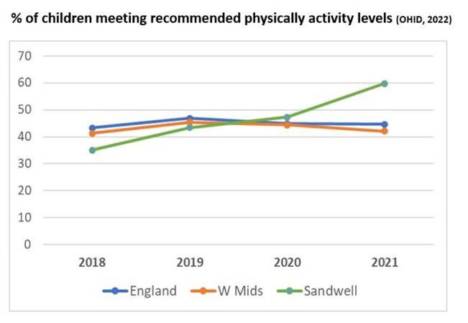

This has been achieved by making physical activity more accessible to all families, including the most economically disadvantaged.  For example, free swimming has been offered and a range of programmes have been developed in collaboration with out voluntary and community sector.  The #MoveMoreSandwell programme has coordinated joint efforts across the local system to ensure physical activity is front and centre of all agencies offer to their community.

Going forward, the 2022 Commonwealth Games will provide a once in a life-time opportunity to maintain these improvements.  The free swimming offer is to be expanded as we open up the new Sandwell Aquatic Centre and work with our new Sandwell Faith Sector Network will bring physical activity opportunities to many people in the heart of communities that traditionally face barriers against engaging in sport and physical activity.

Teenage conceptions:

Sandwell has decreased teenage conceptions remarkably by 76%. The rates in Sandwell were quite a distance above the national average, rates in Sandwell have now decreased to 16.3 under 18 conceptions per 1000 births in 2020.

Teenage pregnancy is both a contributory factor and an outcome of child poverty. Teenage parent families have at least one parent under the age of 18 with responsibility for a dependent child aged under five. These families are at increased risk of the biggest causes of poverty (worklessness and low pay); while under-fives make up 44 per cent of all children in poverty[11]. Children of teenage mothers have a 63% increased risk of being born into poverty compared to babies born to mothers in their twenties.

Children born to teenage mothers have 60% higher rates of infant mortality and are at increased risk of low birth-weight which impacts on the child's long-term health. Teenage mothers are three times more likely to suffer from post-natal depression and experience poor mental health for up to 3 years after the birth. Teenage parents and their children are at increased risk of living in poverty (ChiMat).

The reduction in numbers of teenage pregnancies is as a result of the concerted efforts of dedicated professionals and partner agencies working together to address key local issues and concerns over years. There are a number of lines of support for teenagers and advice around sex and relationships. This includes prioritising advice and guidance by commissioning Brook, a national charity with the aim to provide education and wellbeing services for young people; commissioning a PHSE lead who can link the education to services and improved access to young people’s contraception and sexual health services, targeted work with young people most at risk of conception and improved support and services for pregnant teenagers and teenage parents.

As low educational attainment is associated with a higher risk of conceiving as a teenager, then it is important to acknowledge the valuable role and achievements of staff across Learning, Early Years, Children’s Centres and Sandwell schools resulting in children achieving good levels of development, reduced numbers of young people not engaged in education, employment or training (NEET) and higher percentage of pupils achieving 5 or more GCSEs grade A-C and the positive impact this has had on young peoples aspirations and local conception rates.

**Figure 4.6: Conception rate in those under 18yrs olds.**

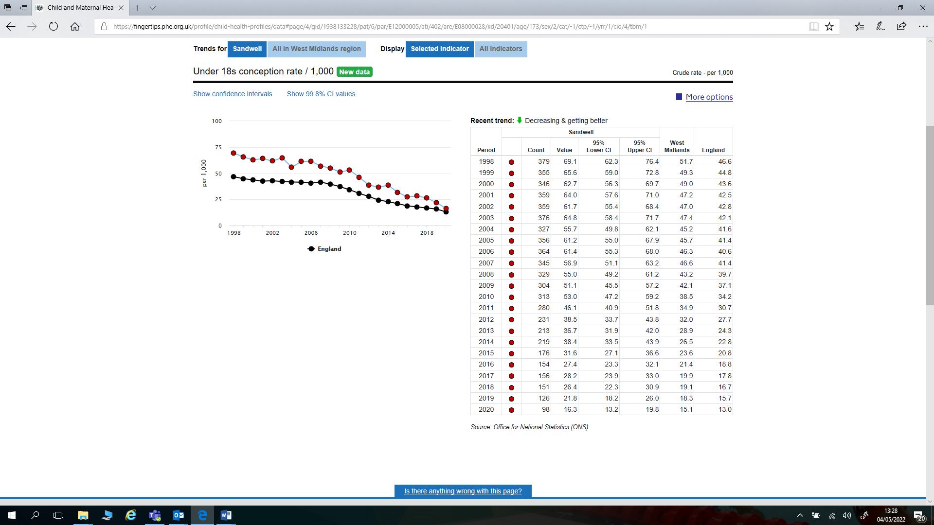

Substance Misuse:

There are many reasons why a young person may fall into drug or alcohol misuse.  These include problems at home, pressure from peers or even involvement in illicit drug distribution networks.  Young people from economically deprived areas face particular challenges in that drug and alcohol use demand and supply is often higher in those areas.

In Sandwell, the Public Health Team commission the DECCA (Drug Education, Counselling and Confidential Advice) young people's alcohol, drug and tobacco service. The services works with any young person that lives in the Sandwell area aged 18 or under and also works with any agency that work with them.

DECCA cover everything from education in mainstream schools, to education in the community all the way to working with someone who is experiencing issues with drugs such as alcohol, cannabis, tobacco, volatile substances and class A drugs.

The key services the team offer include general advice and guidance for young people and the professionals that work with them, educational harm reduction resources and sessions for schools and community organisations, training for workers and professionals, policy and procedure development, targeted brief interventions focusing on harm minimisation for those using alcohol and/or drug(s), structured treatment for any young person using alcohol and/or drug(s), substitute prescribing and a range of holistic therapies.

The latest data for 2018/19 to 2020/21 shows that hospital admissions for substance use among 15-24 year olds have reduced from 63.3 per 100,000 population to 51.9, below both the national average (81.2) and regional average (66.9).  Sandwell is the third lowest in the wider West Midlands area behind Birmingham and Dudley (see figure below).

Meanwhile alcohol admissions among under 18s continue to fall year-on-year.  In 2006/08 Sandwell was at 80.5 per 100,000 pop.  Latest data shows a rate of 18.2, again lower than the national/regional averages and the third lowest in the West Midlands behind Birmingham and Walsall (see figure below).

**Figure 4.7: Hospital Admissions due to substance misuse**

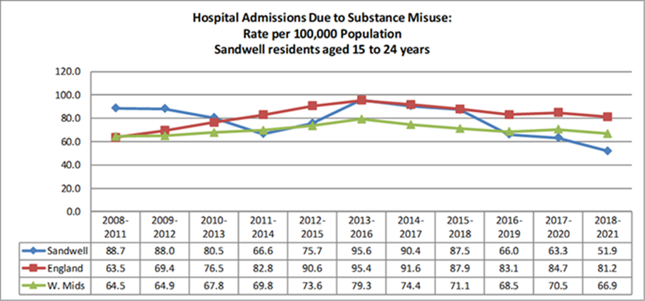

Hospital admissions caused by injuries:

Sandwell has historically had high rates of hospital admission for injuries, both accidental and those caused deliberately.  This in turn reflected inadequate levels of safety and timely intervention in areas ranging from road safety through to substance misuse and mental health.

We have seen significant improvements in this area in recent years as more investment has gone into services.  The rate of admission for injuries is now significantly lower than the national average.

More work is required in order to maintain this downward trend.  In particular, new strategic arrangements with NHS partners will enhance this work in relation to system wide issues.

**Figure 4.8: Hospital Admissions due unintentional and deliberate injuries**

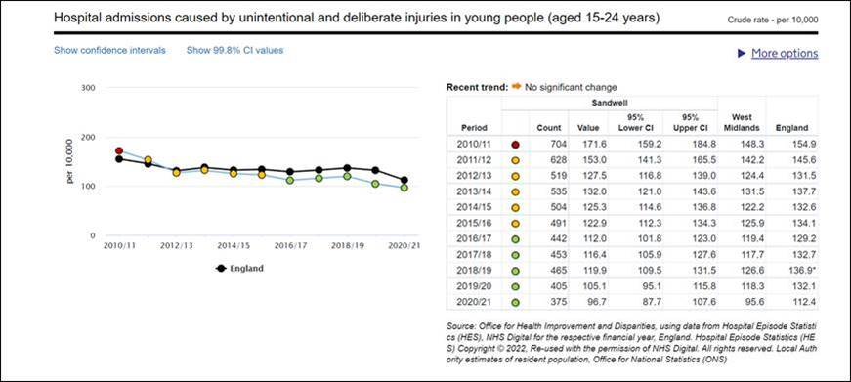

|  |  |
| --- | --- |
|  |  |

Homelessness:

There were 580 families with children affected by homelessness in 2020/21. This is slightly higher than the national average of 11.6 per 1000. The numbers of families affected by homelessness has decreased slightly from 2019/20 in Sandwell and nationally. The UN Convention on the Rights of the Child highlights the right of every child to an adequate standard of living. Children from homeless households are often the most vulnerable in society and are associated with severe poverty.

Health visitors will support families who are at all elements of levels of need. They will work with those who are homeless/in temporary accommodation. Providing advice on support they can received and safety messages such as safer sleeping. The team work together with partners to ensure there is a further strategy for displaced families.

School safeguarding leads, schools nurses and the early help system pull together to support children identified as at risk, however there is more that can be done and going forward, teams across the Council will continue to monitor and support families who are at risk of becoming homeless and those who have suddenly become homeless.

**Figure 4.9: Households with dependent children homed under homeless act.**

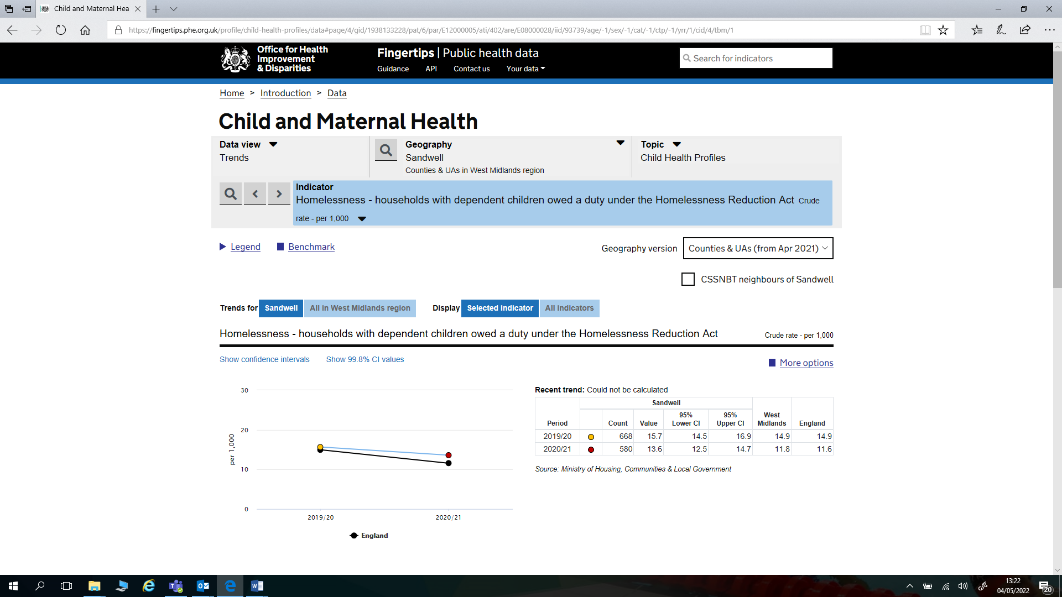

Low income families:

Over a quarter of children in Sandwell were in low income families at 28.2% which is much higher than the national figure of 15.6%. The proportion has increased in Sandwell in 19/20 which is likely to have been linked to the Pandemic.

The Marmot Review suggests that childhood poverty leads to premature mortality and poor health outcomes for adults. Reducing the numbers of children who experience poverty could improve these adult health outcomes and increase healthy life expectancy.

The Public Health team are working on rolling out a Poverty Proofing School Programme supporting a change in school culture, policies and procedures to ensure children living in poverty do not experience unnecessary disadvantage. Across childrens services, the Early Help plans set out target many areas which poverty can impact on childhood experiences.

**Figure 4.10: Children in absolute low income families**

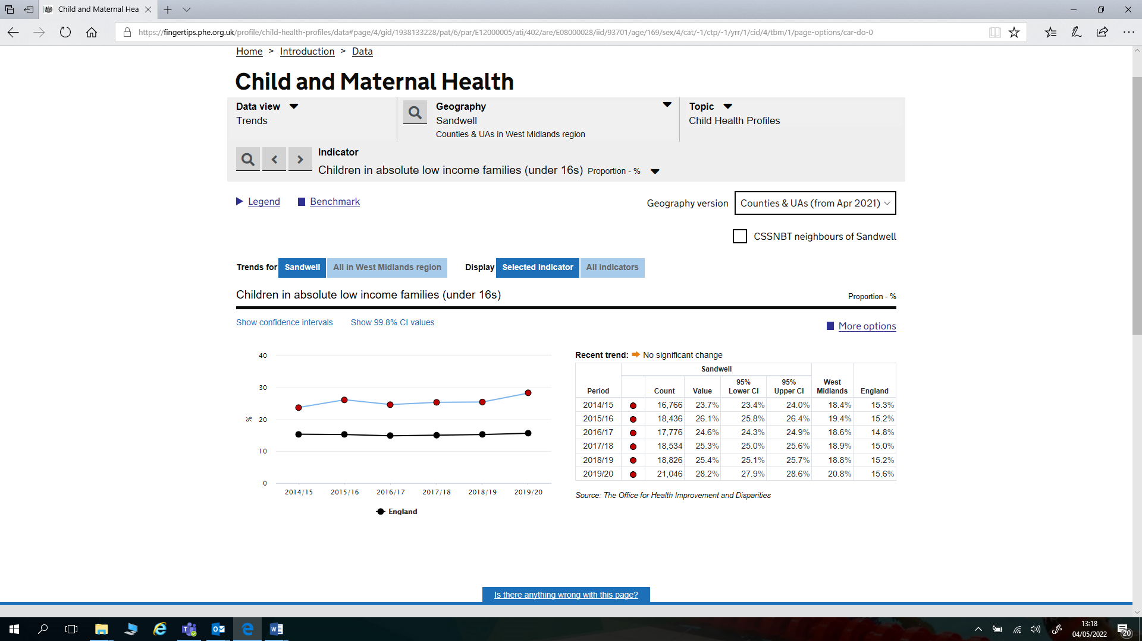

Not in Education, Employment or Training (NEET):

In Sandwell 2.9% of 16-18yr olds are not in education or training this figure is breaking from the national trend by decreasing year on year since 2016. The percentage in Sandwell is much lower than the national average of 5.5%. These young people are at greater risk of a range of negative outcomes, including poor health, depression or early parenthood. Connexions works across several services to support young people, particularly the most vulnerable, to engage in education, training and work.

Public Health has provided funding to reduce the number of Sandwell young people who are not in education, employment or training. Connexions tracks over 14,000 young people each year to enable smooth transitions at key points in the learner journey. The early identification enables us to target support where it’s required and reduce the percentage of young people whose destination is not known (NK%).

Connexions developed a new virtual offer to Young people and parents/carers including those in the vulnerable groups. Virtual careers events and online careers guidance interviews and enhanced contact via phone, text, email which included high levels of advocacy to support the progression of Children in Care whilst face to face opportunities were reduced in Covid. In addition the website was vastly improved.

Connexions staff were able to make safe and well check calls to families/young people, identify families in need of food, deliver food and study packs and deliver laptops to young people to enable them to continue their studies from home virtually.

Connexions staff staffed the Covid support line providing advice for school leadership teams.

As part of an initiative between Nando’s and Shaw Trust Connexions staff worked with partners to identify young people in need and assisted in distributing NANDOs meal vouchers to as an incentive/encouragement/reward for young people to achieve/who had achieved. This helped in enabling independence, motivating and engaging young people.

**Figure 4.11: 16-17 year olds Not in education, Employment or Training.**

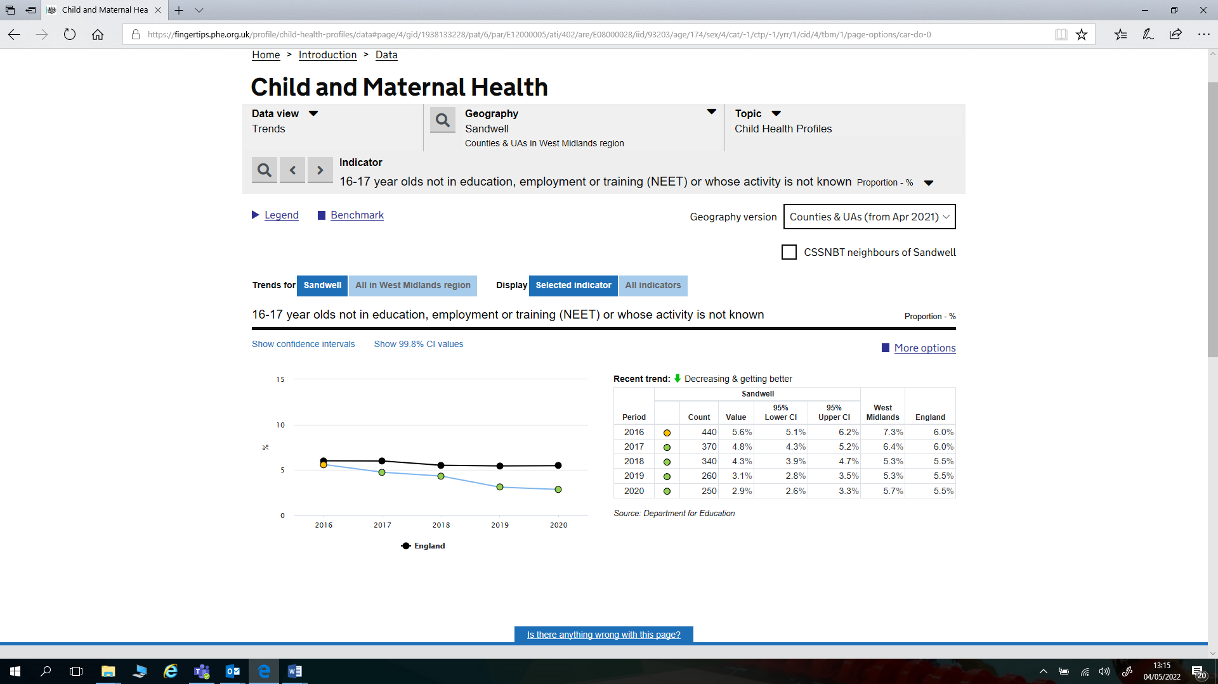

Crime:

The rate of new entrants into the youth justice system is decreasing overall meaning that less children are entering the youth justice system. Although the rate is slightly higher than the national rate, due to the deprivation in Sandwell we would expect this to be much higher. This is likely linked to the indicator above regarding children who are in Employment, Education or training; meaning that children have good options for their career and their free time and are therefore less likely to become involved in crime.

**Figure 4.12: First time entrants to the youth justice system**

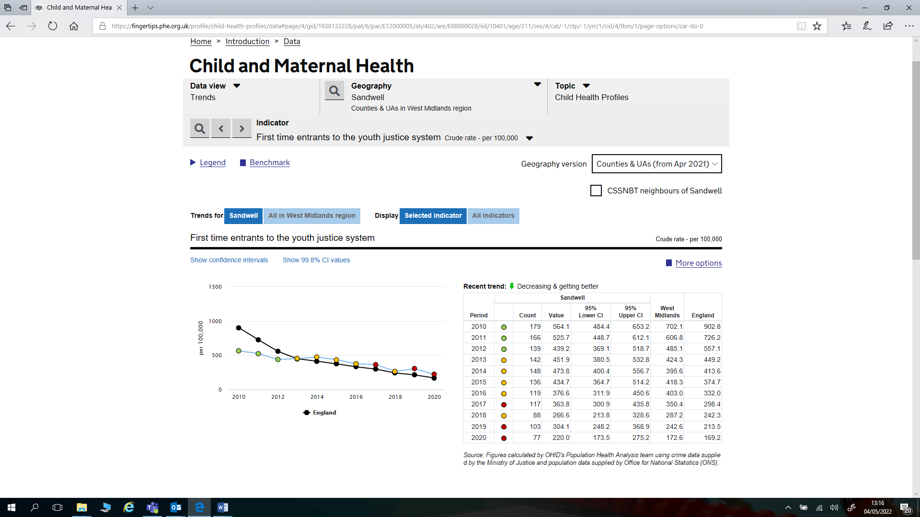

1. https://www.gov.uk/government/publications/are-you-ready-good-practice-in-school-readiness
2. https://assets.publishing.service.gov.uk/government/uploads/system/uploads/attachment_data/file/596629/EYFS_STATUTORY_FRAMEWORK_2017.pdf
3. Special educational needs in England: January 2019 (https://assets.publishing.service.gov.uk/government/uploads/system/uploads/attachment_data/file/814244/SEN_2019_Text.docx.pdf)
4. Special educational needs in England: January 2019 https://assets.publishing.service.gov.uk/government/uploads/system/uploads/attachment_data/file/814244/SEN_2019_Text.docx.pdf
5. Special educational needs in England: January 2019 https://assets.publishing.service.gov.uk/government/uploads/system/uploads/attachment_data/file/814244/SEN_2019_Text.docx.pdf
6. https://assets.publishing.service.gov.uk/government/uploads/system/uploads/attachment_data/file/695100/Education_Health_and_Care_plans_-_a_qualitative_investigation.pdf
7. data.gov.uk- Education data
8. Source: Sandwell MBC SEN Service – ONE System * 97% of ethnicities are known
9. Source: SMBC Inclusion Support – Sensory Team
10. Data is collected at a learning community level. There is a possibility that some children live outside of the designated town for the learning community.
11. DWP (2008) ‘Ending child poverty: everybody’s business’.